

|  |
| --- |
| BOOKSTORE MANAGEMENT SYSTEM |
| Software Design Document |
| v1/2 |

Lecturer: MSc. Nguyen Thi Thanh Truc

Students:

Nguyễn Nhật Long Phi 21522454

Nguyễn Anh Thư 21522647

Hoàng Văn Tú 21522737

Bùi Mạnh Hùng 21522110

**Ho Chi Minh city, 6/2023**

RECORD OF CHANGE

**\*A - Added M - Modified D – Deleted**

|  |  |  |  |  |
| --- | --- | --- | --- | --- |
| **Effective Date** | **Changed Items** | **A* M, D** | **Change Description** | **New Version** |
|  |  |  |  |  |
|  |  |  |  |  |
|  |  |  |  |  |
|  |  |  |  |  |
|  |  |  |  |  |
|  |  |  |  |  |
|  |  |  |  |  |
|  |  |  |  |  |
|  |  |  |  |  |
|  |  |  |  |  |
|  |  |  |  |  |
|  |  |  |  |  |

LECTURER’S COMMENTS

……………………………………………………………………………………………………………………………………………………………………………………………………………………………………………………………………………………………………………………………………………………………………………………………………………………………………………………………………………………………………………………………………………………………………………………………………………………………………………………………………………………………………………………………………………………………………………………………………………………………………………………………………………………………………………………………………………………………………………………………………………………………………………………………………………………………………………………………………………………………………………………………………………………………………………………………………………………………………………………………………………………………………………………………………………………………………………………………………………………………………………………………………………………………………………………………………………………………………………………………………………………………………………………………………………………………………………………………………………………………………………………………………………………………………………………………………………………………………………………………………………………………………………………………………………………………………………………………………………………………………………………………………………………………………………………………………………………………………………………………………………………………………………………………………………………………………………………

TABLE OF CONTENT

RECORD OF CHANGE 2

LECTURER’S COMMENTS 3

TABLE OF CONTENT 4

CHAPTER 1 INTRODUCTION 7

1.1. Purpose 7

1.2. Definitions, Acronyms and Abbreviations 7

1.3. References 8

1.4. Overview 8

CHAPTER 2 SYSTEM ARCHITECTURE 10

2.1. System architecture 10

2.1.1. Framework 10

2.1.2. System Architecture Model 10

2.2. Detail about MVC- Model System Architecture 11

CHAPTER 3 SCREEN FLOW 13

3.1. Introduction to the implementation environment 13

3.2. User Interface 13

3.2.1. Manager Interface 13

CHAPTER 4 PACKAGE (CLASS DIAGRAM) 32

4.1. Login 33

4.2. Manage Regulation 34

4.3. Manage Book 37

4.4. Manage Book Purchase 38

4.5. Manage Book Rental 40

4.6. Manage Customer 42

4.7. Manage Discount code 44

4.8. Manage Supplier 45

4.9. Statistics 46

4.10. Manage User 48

CHAPTER 5 DIAGRAMS 51

5.1. Sequence Diagram and Activity Diagram 51

5.1.1. Login 51

5.1.1.1. Sequence diagram 51

5.1.1.2. Activity diagram 51

5.1.2. Manage regulation 51

5.1.2.1. Sequence diagram 51

5.1.2.2. Activity diagram 55

5.1.3. Manage Book 56

5.1.3.1. Sequence diagram 57

5.1.3.2. Activity diagram 61

5.1.4. Manage Book purchase 62

5.1.4.1. Sequence diagram 63

5.1.4.2. Activity diagram 68

5.1.5. Manage Book rental 71

5.1.5.1. Sequence diagram 71

5.1.5.2. Activity diagram 75

5.1.6. Manage Customer 77

5.1.6.1. Sequence diagram 78

5.1.6.2. Activity diagram 81

5.1.7. Manage Discount code 82

5.1.7.1. Sequence diagram 82

5.1.7.2. Activity diagram 87

5.1.8. Manage Supplier 88

5.1.8.1. Sequence diagram 89

5.1.8.2. Activity diagram 92

5.1.9. Statistics 93

5.1.9.1. Sequence diagram 93

5.1.9.2. Activity diagram 95

5.1.10. Manage User 96

5.1.10.1. Sequence diagram 96

5.1.10.2. Activity diagram 100

5.2. State Diagram 102

5.2.1. Discount Code status 102

5.2.2. Invoice status 102

5.2.3. Rent status 102

5.2.4. Customer rank 103

CHAPTER 6 DATABASE 104

6.1. ERDs 104

6.2. Table description 106

6.2.1. BOOK table 106

6.2.2. CUSTOMER Table 106

6.2.3. INVOICE 107

6.2.4. INVOICE_DETAIL 108

6.2.5. RENTAL 108

6.2.6. RENTAL_DETAIL 109

6.2.7. SUPPLIER 109

6.2.8. USER 109

6.2.9. INVENTORY_REPORT 109

6.2.10. DEBT_REPORT 109

6.2.11. DISCOUNT_CODE 109

6.2.12. STATISTICS 109

6.2.13. REGULATION 109

CHAPTER 7 OTHER CONSIDERATIONS 111

CHAPTER 8 APPENDIX 112

# INTRODUCTION

## Purpose

The purpose of the Bookstore Management System Design Document is to provide a comprehensive description of the system's design. This document encompasses the following components:

* Class Descriptions: The document includes detailed descriptions of all classes within the system. It provides insights into their structure, attributes, and relationships. Class diagrams illustrate the static relationships between the classes.
* Dynamic Diagrams: The Design Document includes dynamic diagrams such as collaboration diagrams, sequence diagrams, and activity diagrams. These diagrams showcase the interactions and flow of data between different classes and components of the system.
* Detailed Class Descriptions: Each class is described in detail, highlighting its responsibilities, methods, and properties. This information enables developers and testers to understand the functionality and behavior of each class.
* Common Implementation Mechanisms: The document defines common mechanisms used during the implementation of the system. This includes guidelines, design patterns, and best practices that should be followed when developing the classes.

The intended readers of this document are the developers and testers who will be involved in the implementation and testing phases of the project. They will rely on this design document to guide their development tasks, ensuring consistency and adherence to the system's design.

It is important to note that this document provides a detailed description of the design aspects of the Bookstore Management System. It outlines the scope of the document, its limitations, and serves as a reference for the development and testing teams throughout the project lifecycle.

## Definitions, Acronyms and Abbreviations

* MVC: Model – View – Controller
* UI: User Interface

## References

|  |  |
| --- | --- |
| [1] | FPT Software, "Software_Design_Document_Template". |

This document is mainly wrote follow with these documents

|  |  |
| --- | --- |
| **Report number** | **Title** |
| RP-0 | Project Introduction |
| RP-1 | Software Requirement Specification *for Bookstore Management System* |
| RP-2 | Software Design Document *for Bookstore Management System* |
| RP-3 | Vision and Scope Document *for Bookstore Management System* |
| RP-4 | Business Rules *for Bookstore Management System* |
| RP-5 | Test Report |
| RP-6 | User Guide |

## Overview

The following paragraphs will briefly summarize chapters mentioned in this document

1. **Introduction**

This section introduces the purpose of the document, defines key terms and abbreviations, lists references, and provides an overview of the document's contents.

1. **System Architecture**

This section outlines the overall architecture of the system, including its components and their interactions.

1. **Screen Flow**

The screen flow section explains how users navigate through the system's interfaces.

1. **Common Package and Mechanism**

This section covers a common package that contains shared classes and functionalities. It also discusses error and exception handling, logging, tracing, debugging, performance optimization mechanisms, and multilingual processing.

1. **Diagrams**

This section includes specific diagrams related to customer management, such as adding and updating customers.

1. **Packages**

This section presents various packages within the system, providing details about their class diagrams, external interfaces, and relevant classes.

1. **Database**

This section includes Entity Relationship Diagrams (ERDs) and specific table details related to the system's database.

1. **Other Considerations**

This section addresses any additional considerations or aspects not covered in previous sections.

1. **Appendix**

The appendix contains supplementary materials, such as additional diagrams, code snippets, or references.

# SYSTEM ARCHITECTURE



## System architecture

* + 1. Framework
* The web application is built using the ReactJS framework for the frontend
* The backend uses Node.js with Express.js framework for server-side development
* MySQL is employed as the database management system to handle data storage and retrieval
  + 1. System Architecture Model

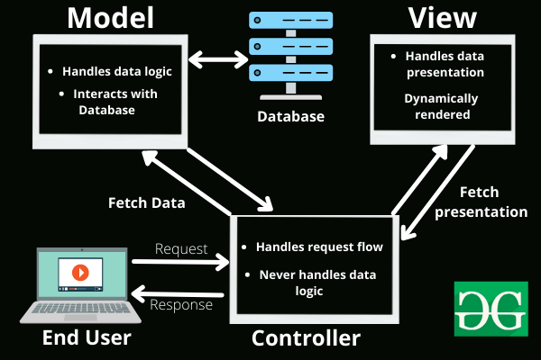The application follows the Model-View-Controller (MVC) architecture pattern, provide a clear separation of concerns and facilitating efficient development and maintenance

Figure 1. MVC architecture [1]

## Detail about MVC- Model System Architecture

The Model-View-Controller(MVC) widely adopted for developing web applications as it promotes a clear separation of responsibilities between different components

***MVC components:***

M(Model)

* The Model component handles business logic and data handling processes
* It interacts with the MySQL database to perform operations, data manipulation, and retrieval
* The Model responds to request sent by the Controller and sends data back to the Controller or other models

V(View)

* The View component focuses on presenting data to the end user
* In ReactJS, the View is implemented using reusable components that render UI elements based on the data received from the Controller or state management (Redux)
* The View transmits user demands to the Presenter or Model through the Controller

C(Controller)

* The Controller acts as the main part of the system, receiving requests from other elements (Models, Views).
* It gathers appropriate information and facilitates communication between the Model and View components.
* The primary objective of the Controller is to separate business logic from the UI layer.
* In the ReactJS application, the Controller functionality is often implemented using Redux to manage application state and handle interactions between components.

The use of MVC in ReactJS with MySQL provides several advantages. It offers a clear division of responsibilities, making it easier for developers to understand and extend the codebase. It also ensures that business logic is separated from UI, enhancing testability and maintainability.



# SCREEN FLOW

## Introduction to the implementation environment

## User Interface

* + 1. Manager Interface

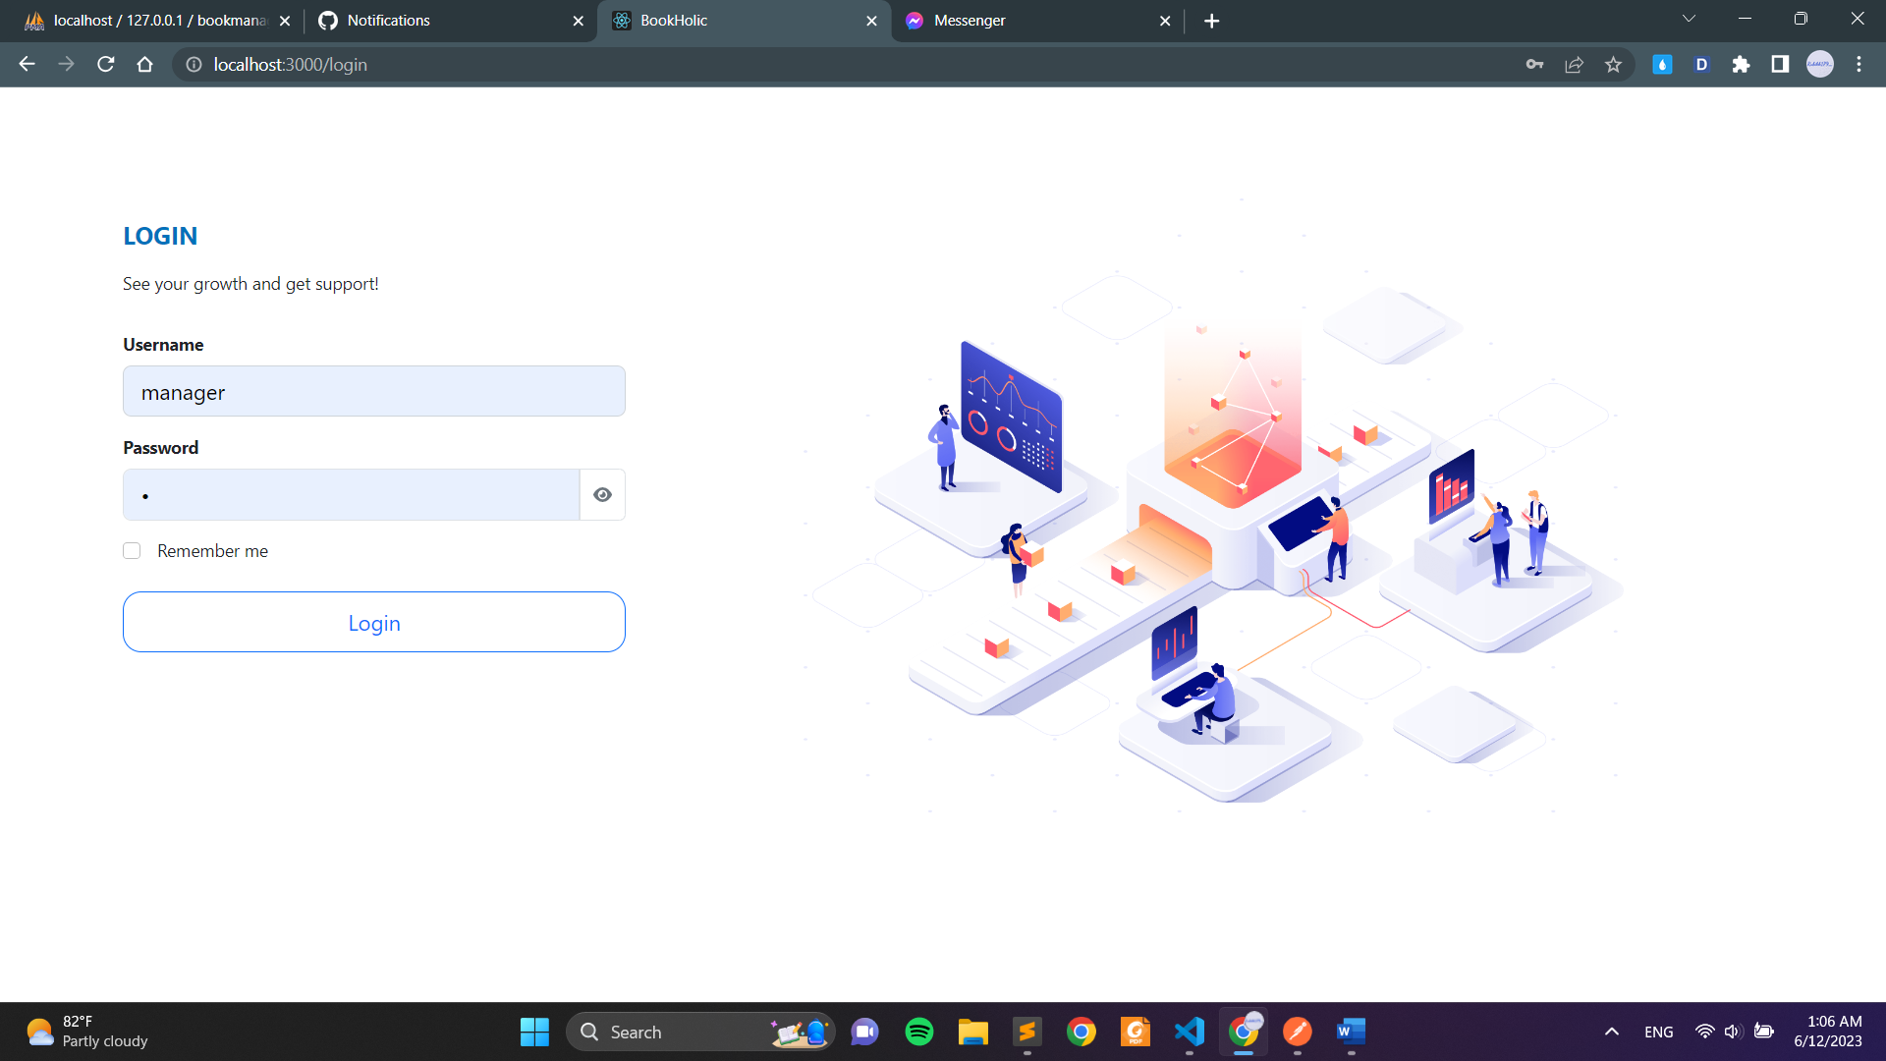

**Picture 1. User login page**

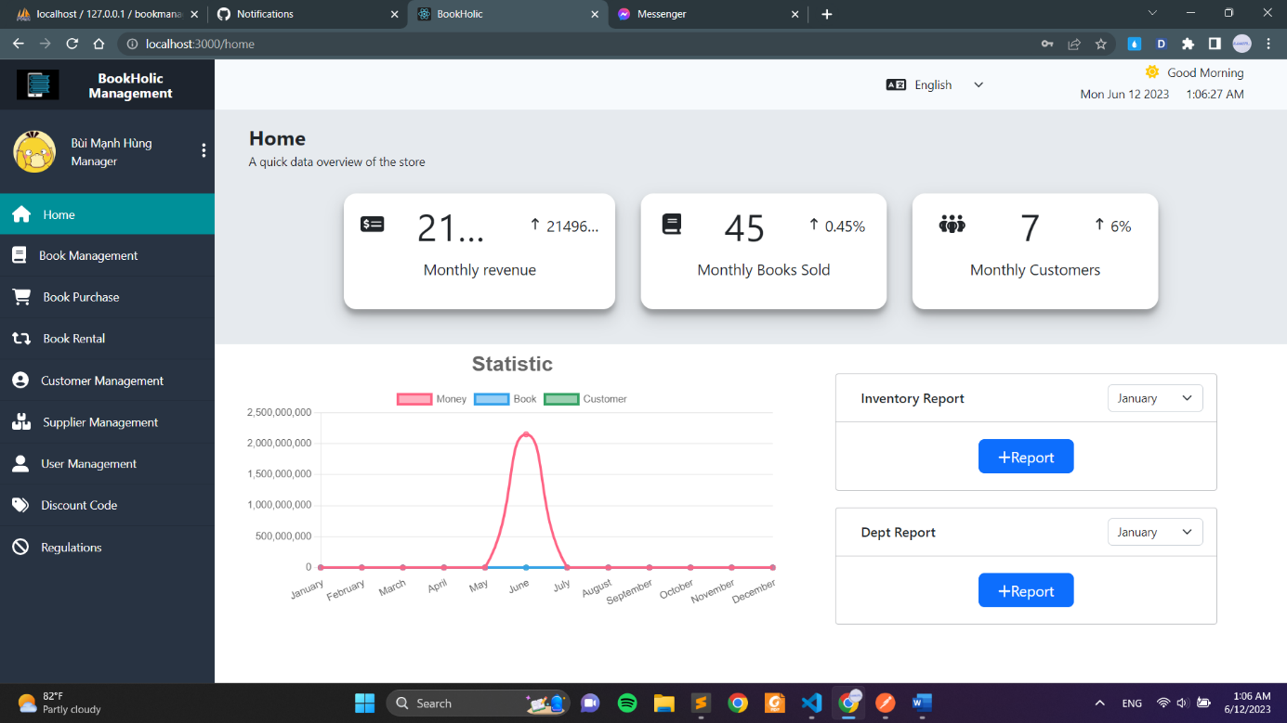

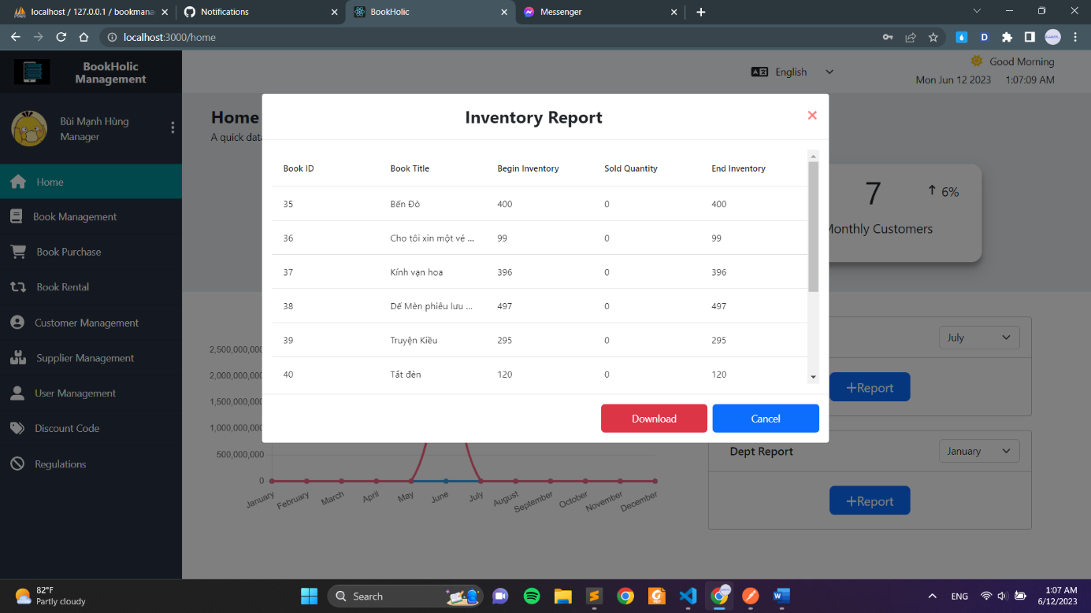**Picture 2. User dashboard page**

**Picture 3. Inventory report page when click ‘Report’**

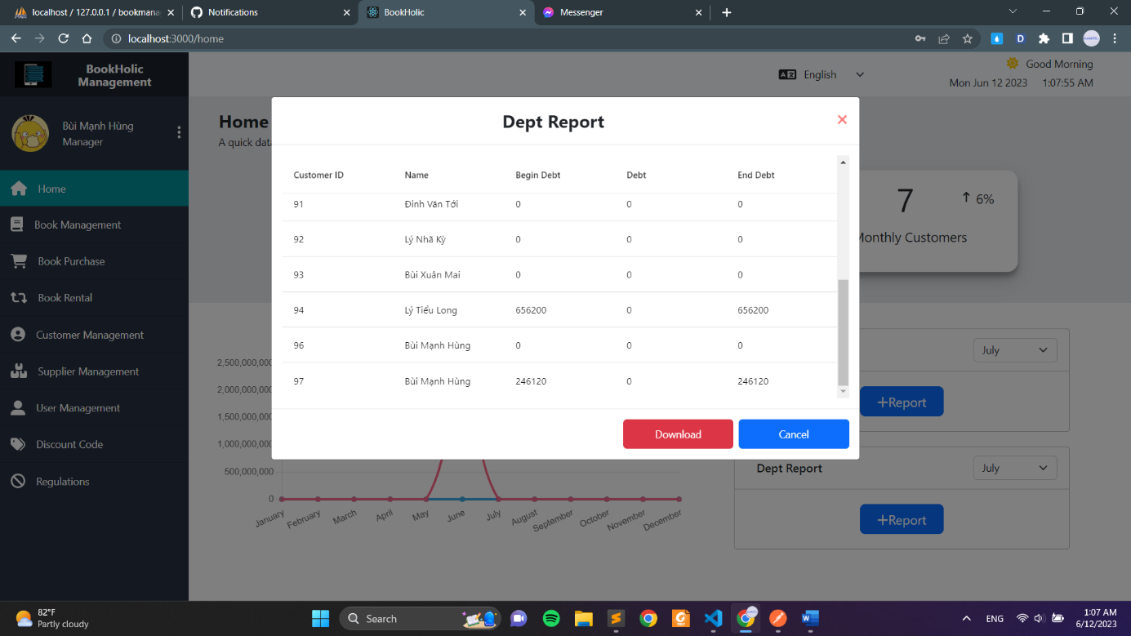

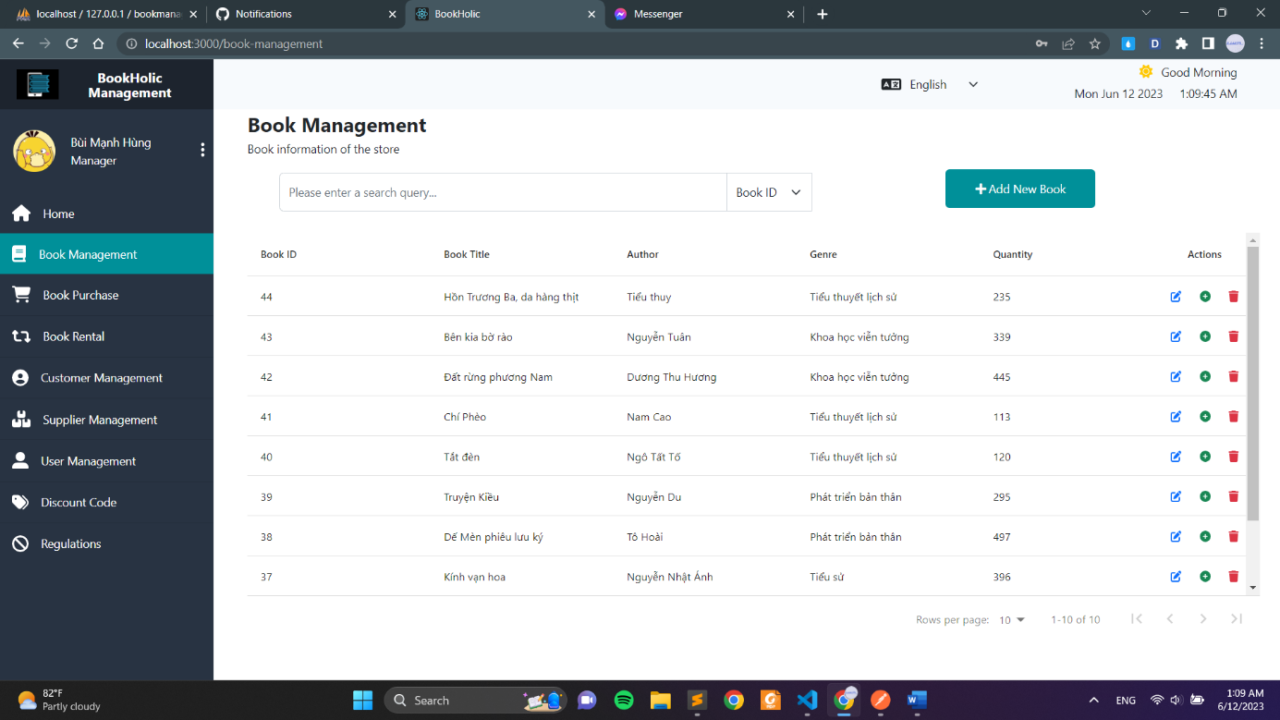**Picture 4. Debt report page when click ‘Report’**

**Picture 5. Book Management**

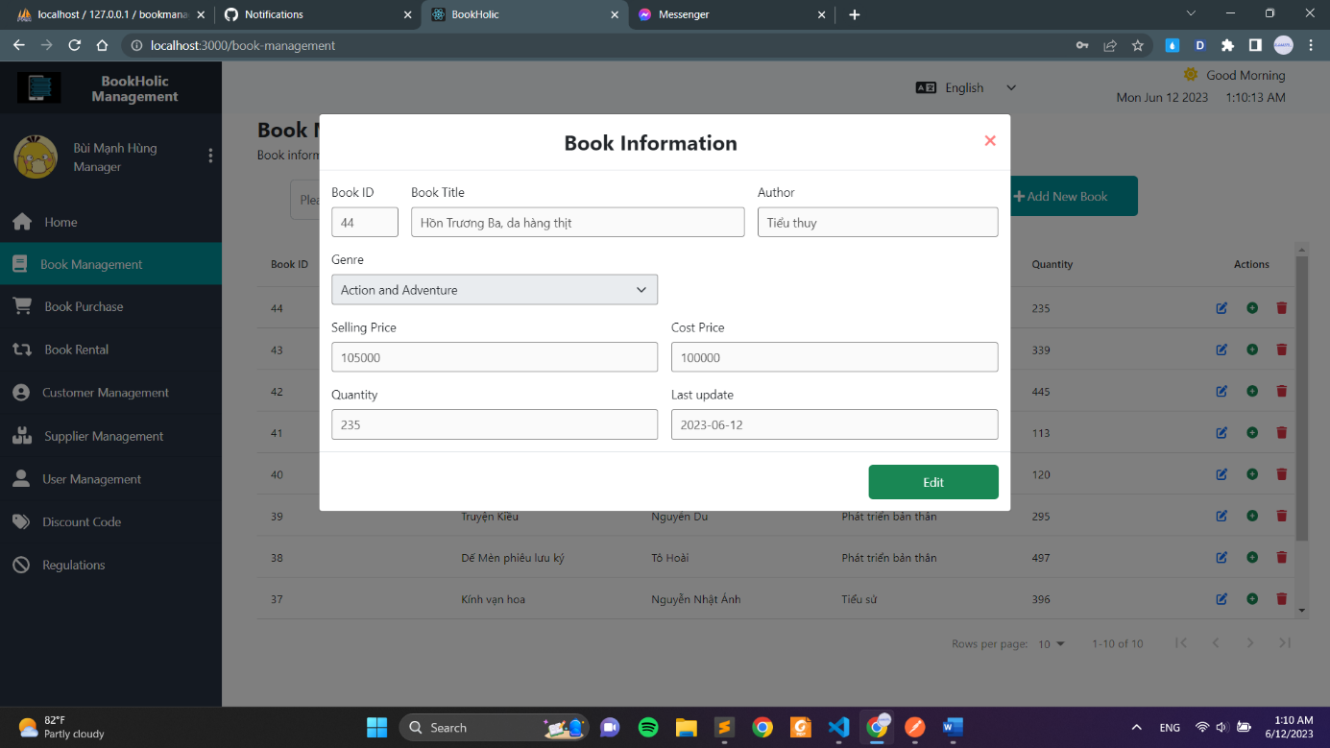

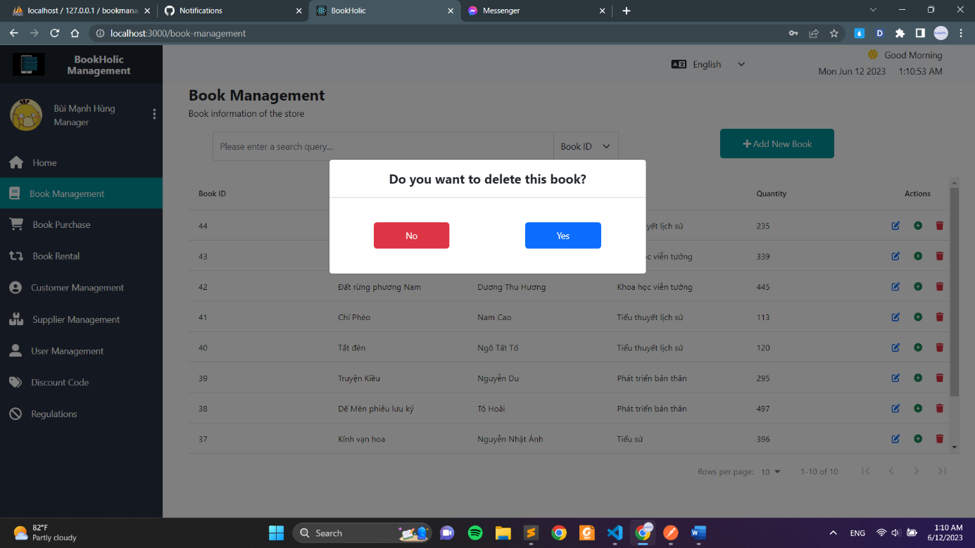**Picture 6. Book Information form**

**Picture 7. Book Managerment after clicking ‘Delete’**

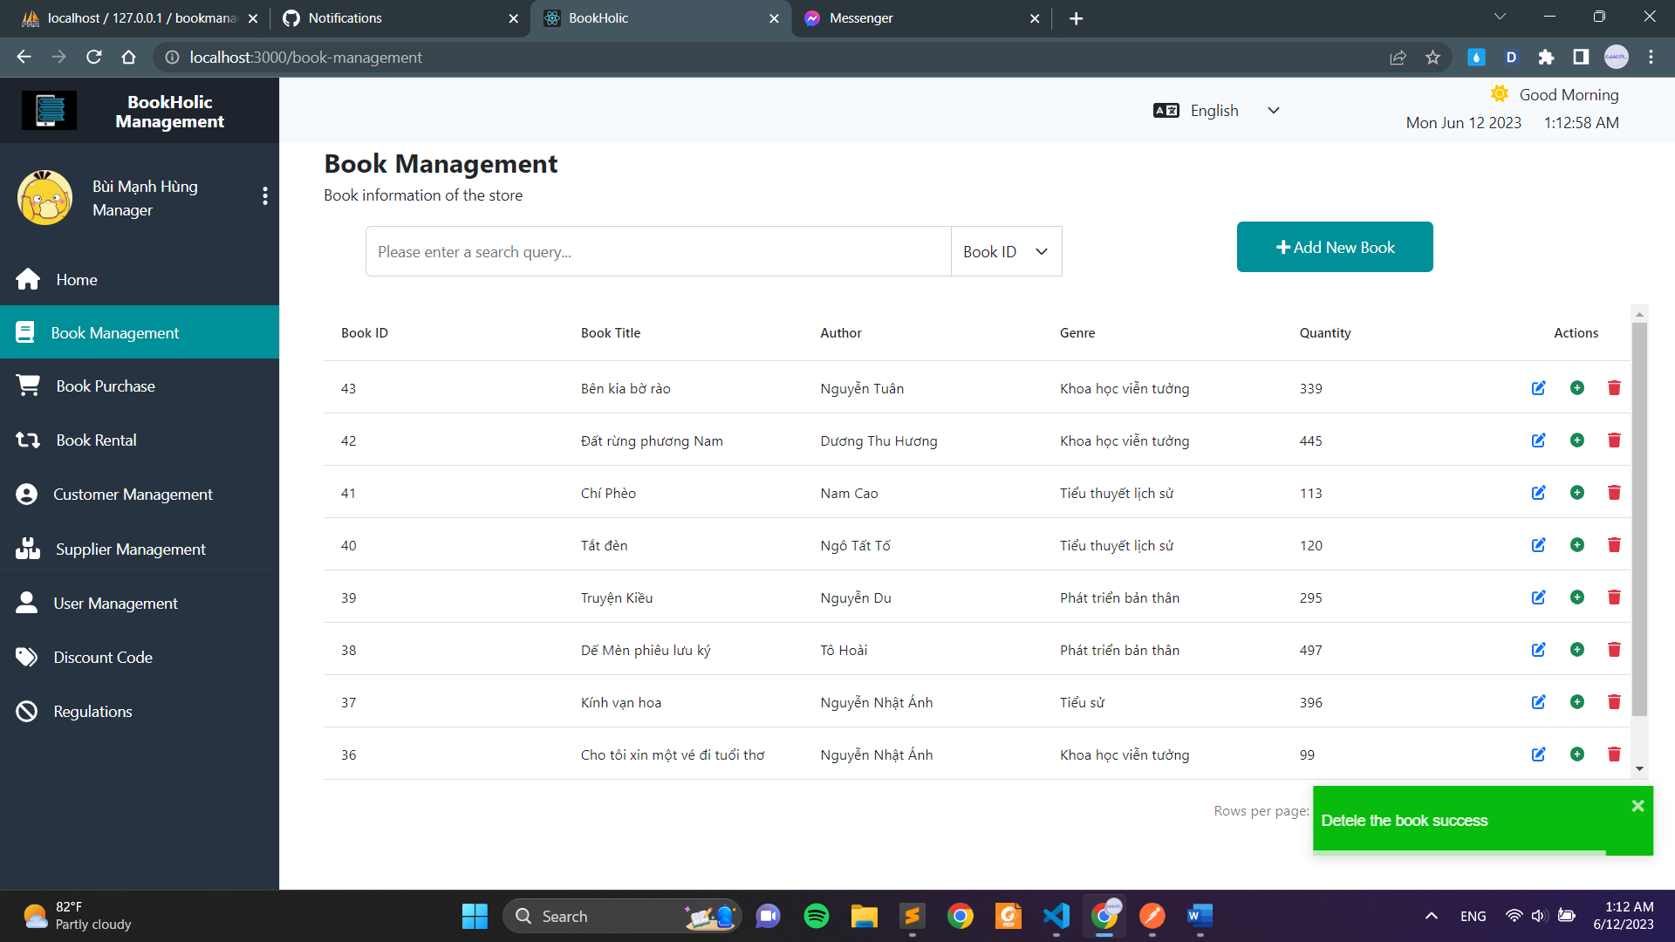

**Picture 8. Delete successful notification**

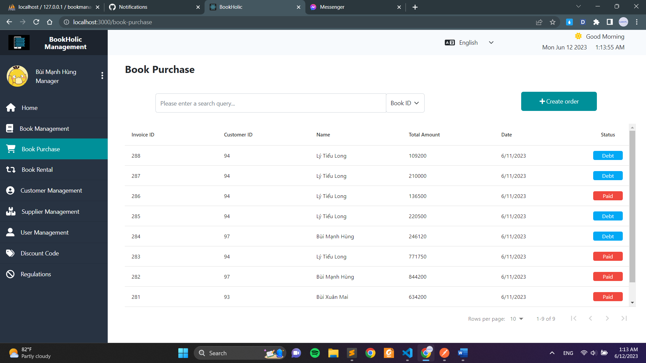

**Picture 9. Book Purchase page**

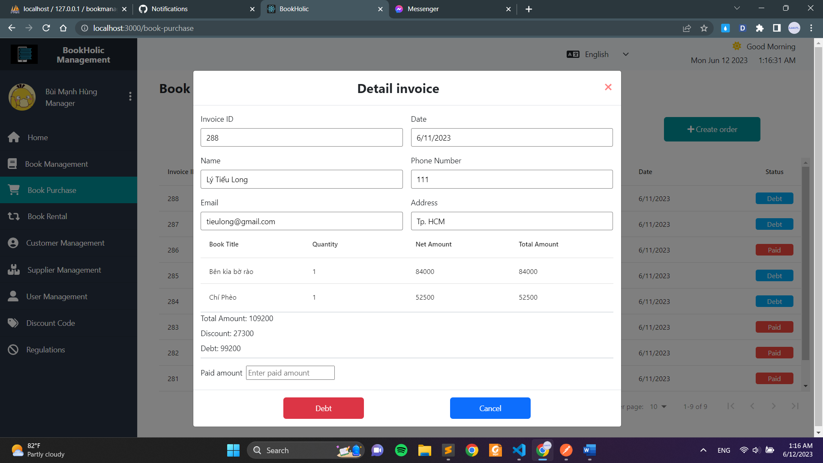

**Picture 10. Detail Invoice form for unpaid orders**

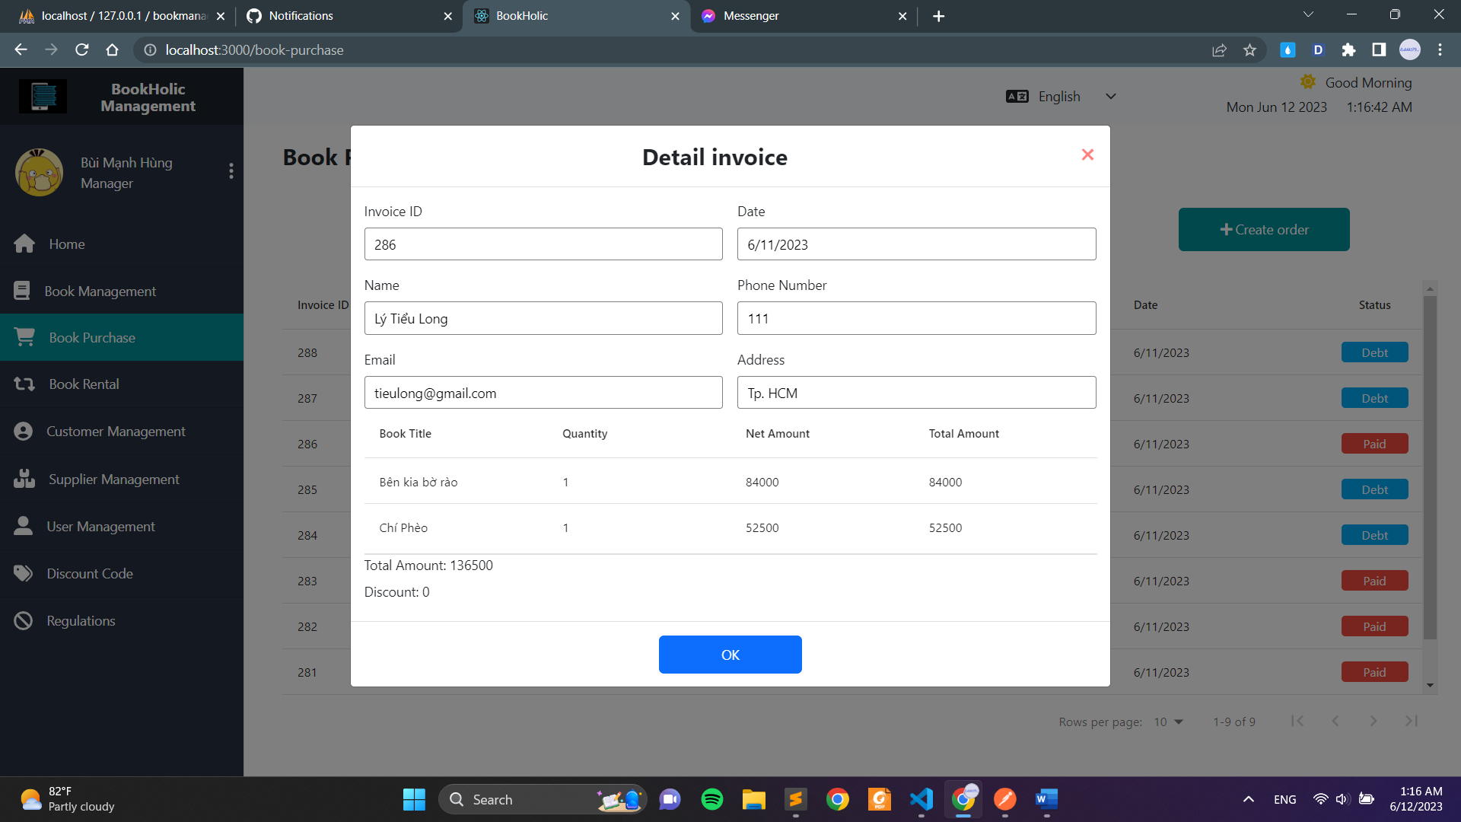

**Picture 11. Detail Invoice form for paid orders**

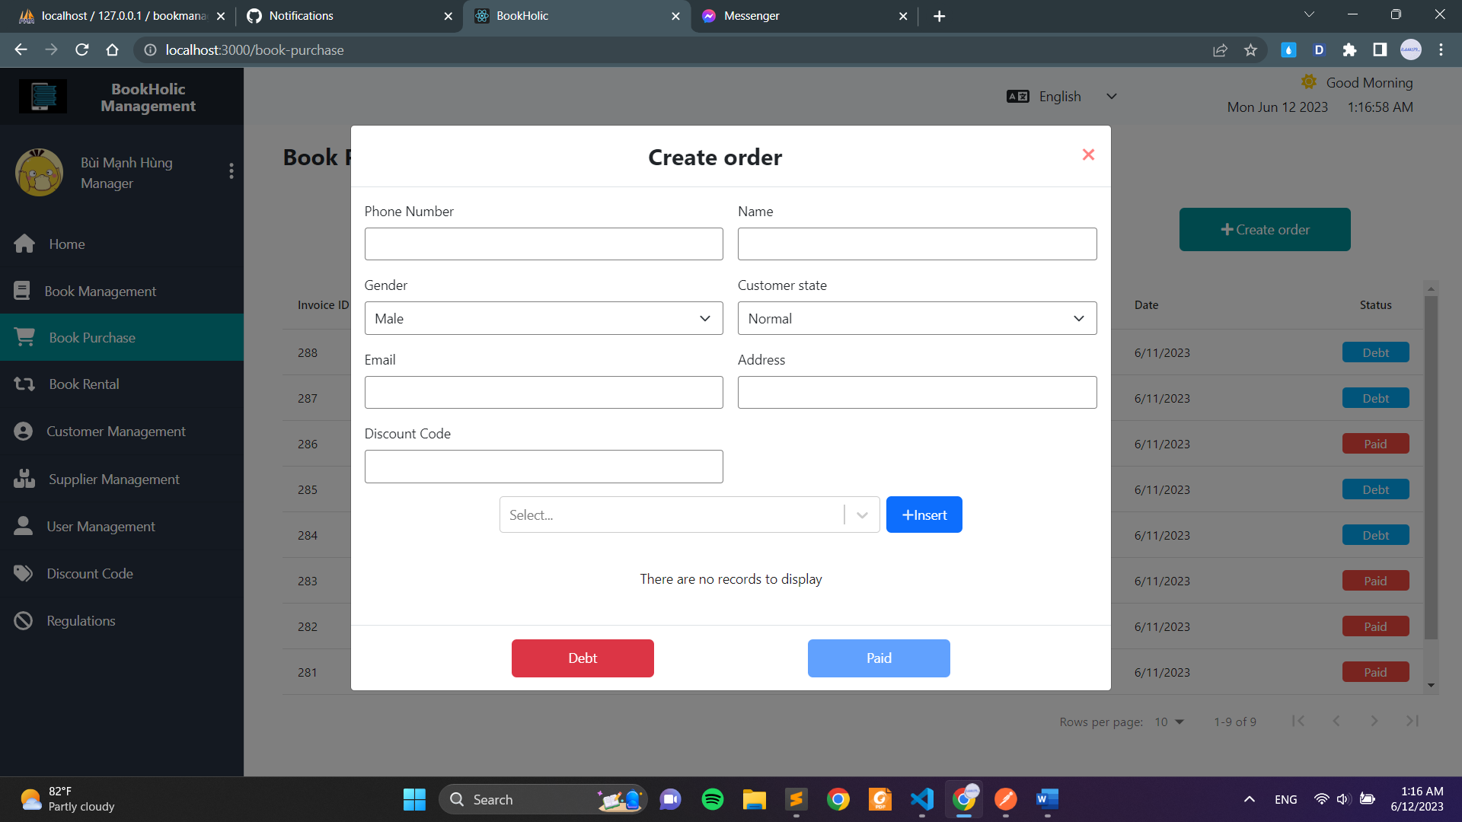

**Picture 12. Create order form**

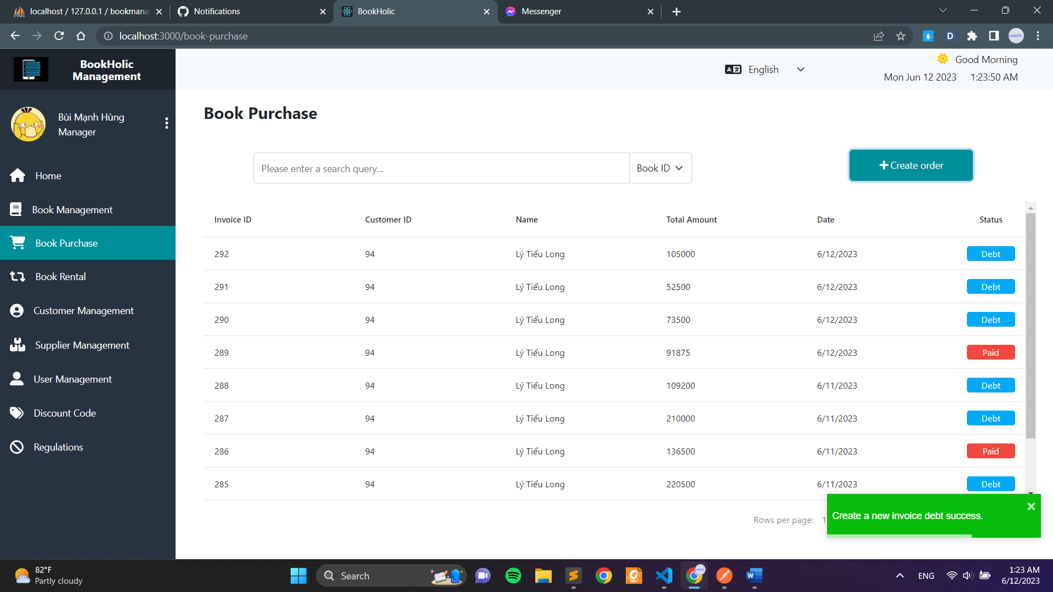

**Picture 13. Debt successful notification**

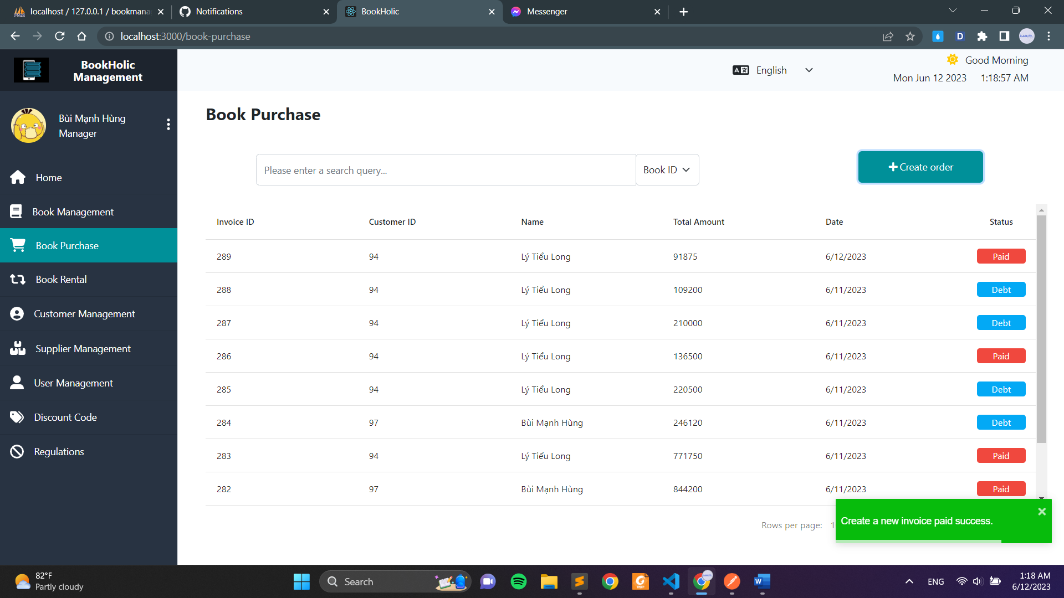

**Picture 14. Paid successful notification**

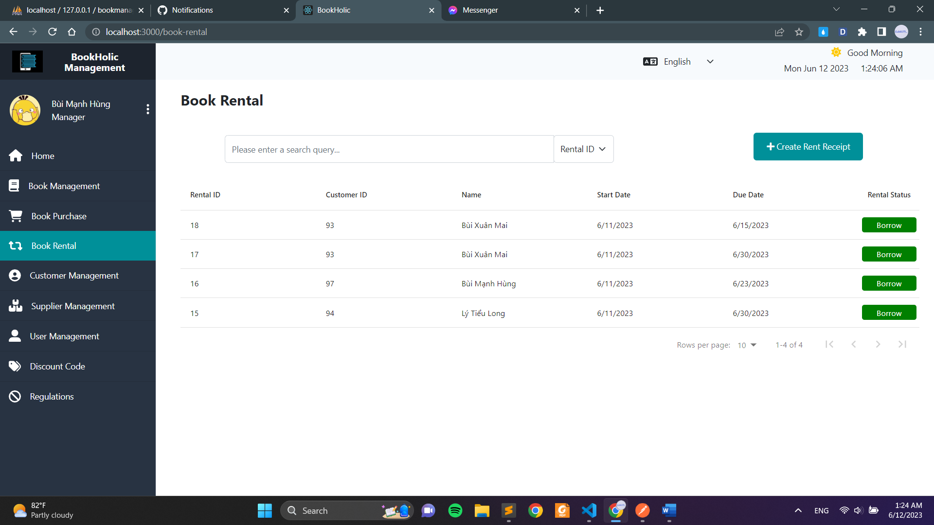

**Picture 15. Book rental page**

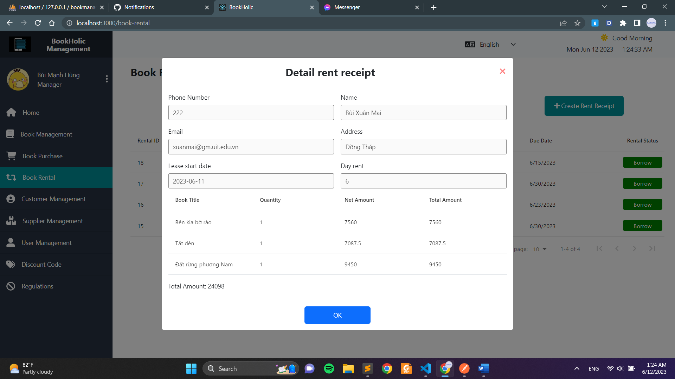

**Picture 16. Detail rent reciept form for unpaid orders**

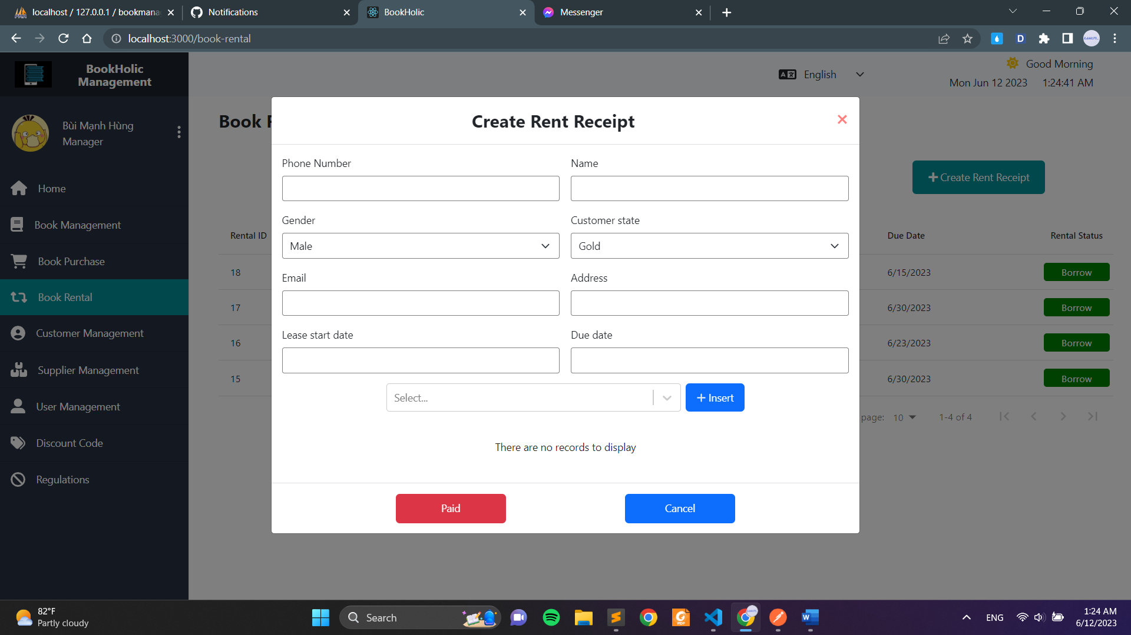

**Picture 17. Create rent receipt form**

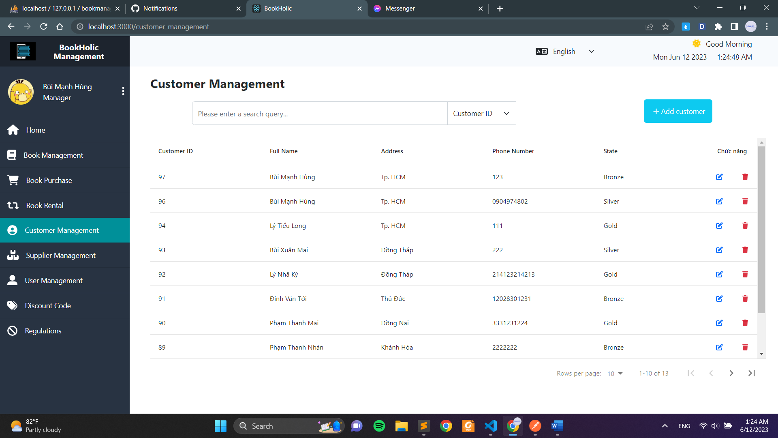

**Picture 18. Customer management page**

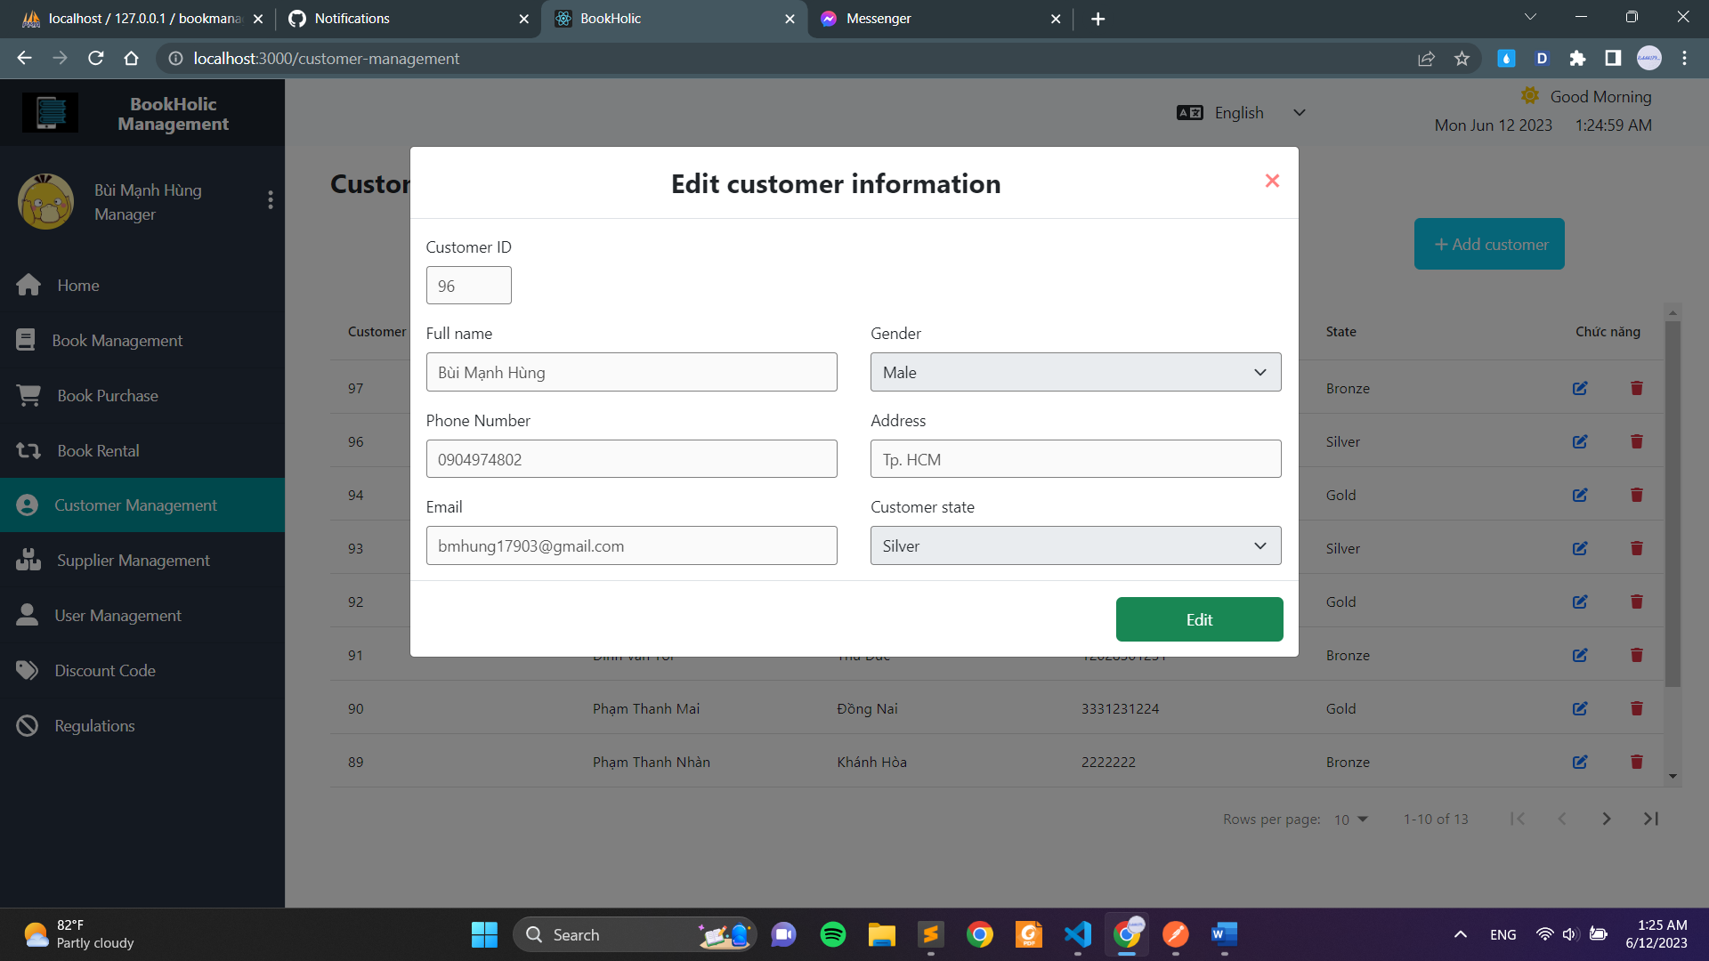

**Picture 19. View full detail page**

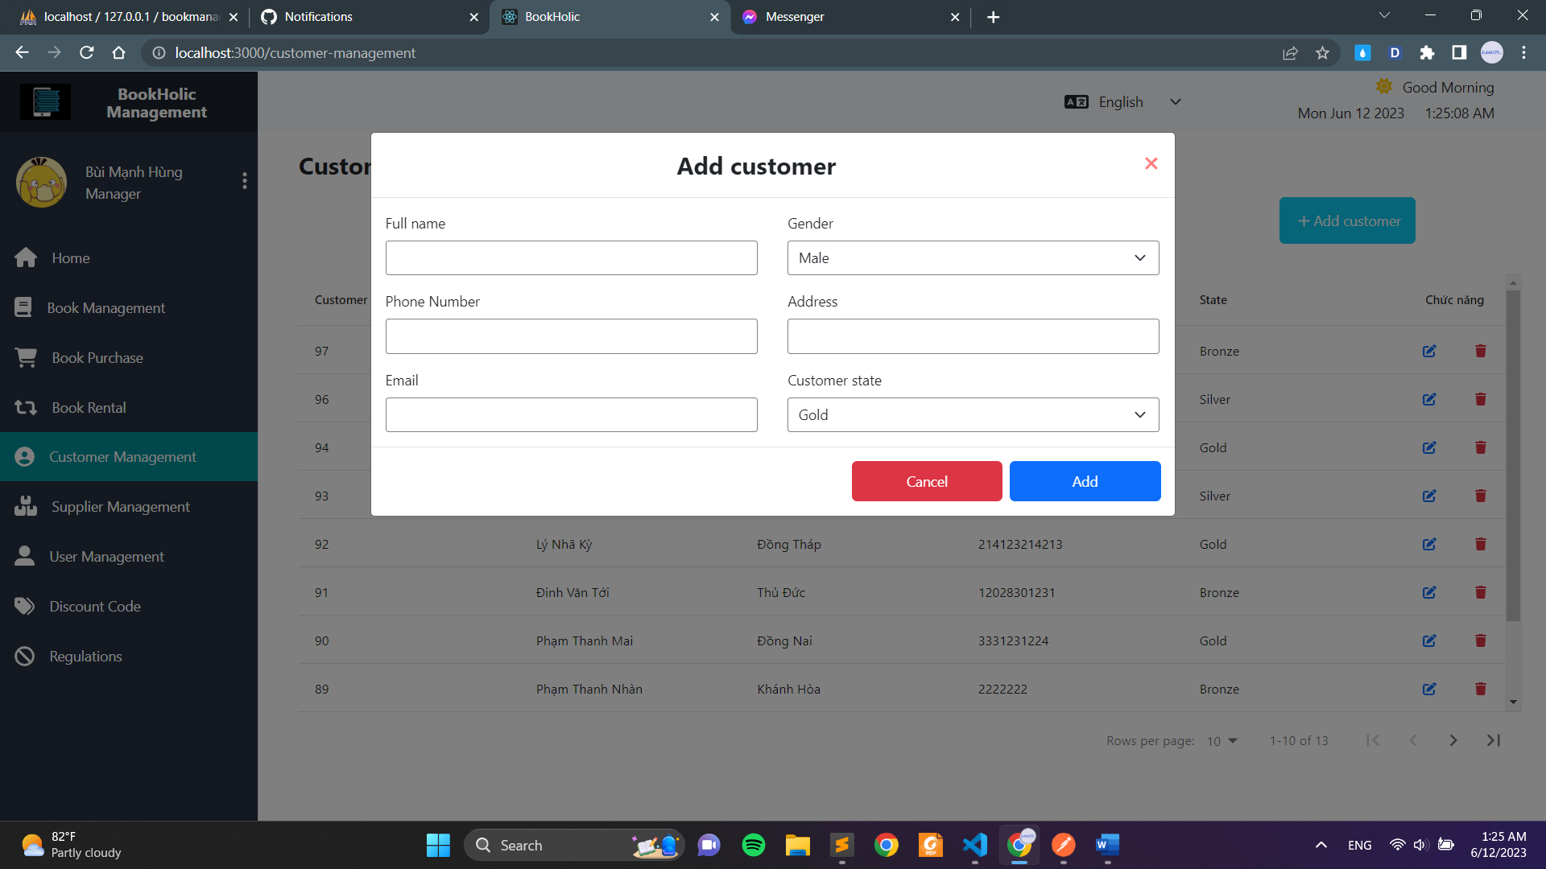

**Picture 20. Add customer page**

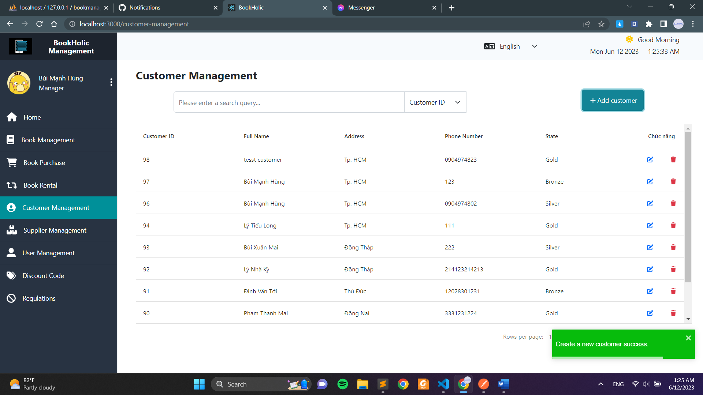

**Picture 21. Add customer successful notification**

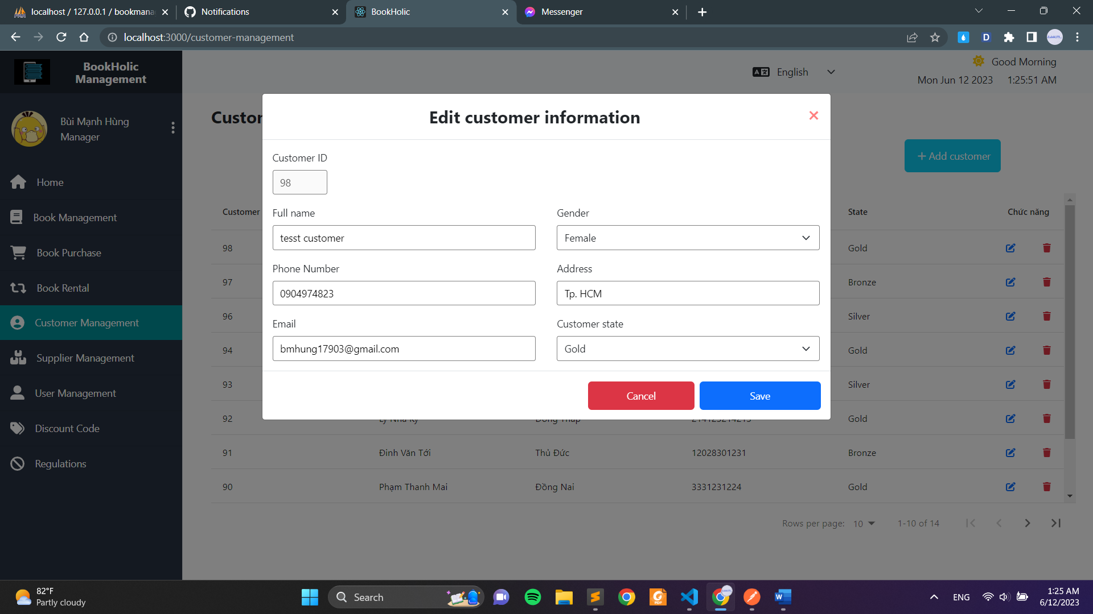

**Picture 22. Edit customer page**

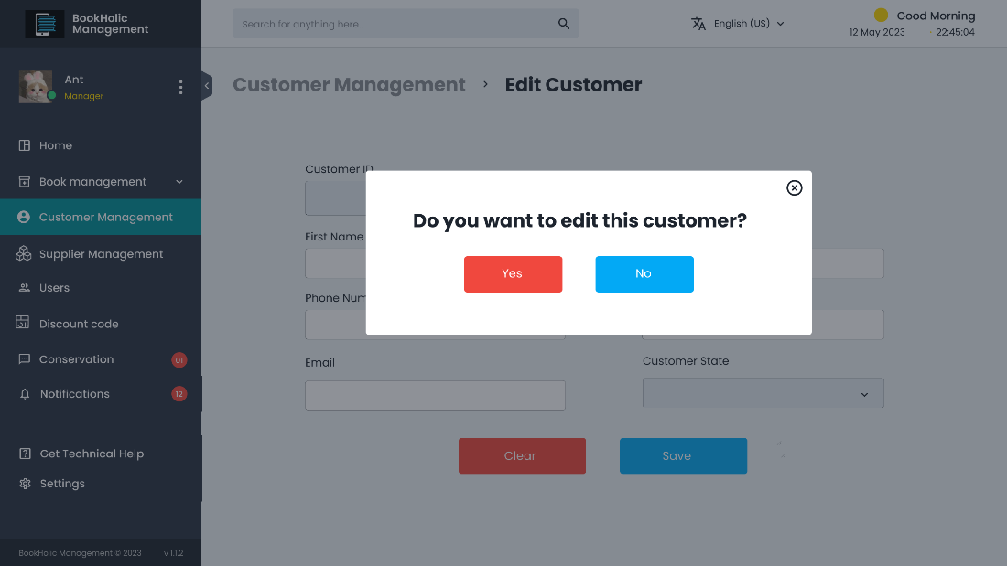

**Picture 23. Edit customer confirm**

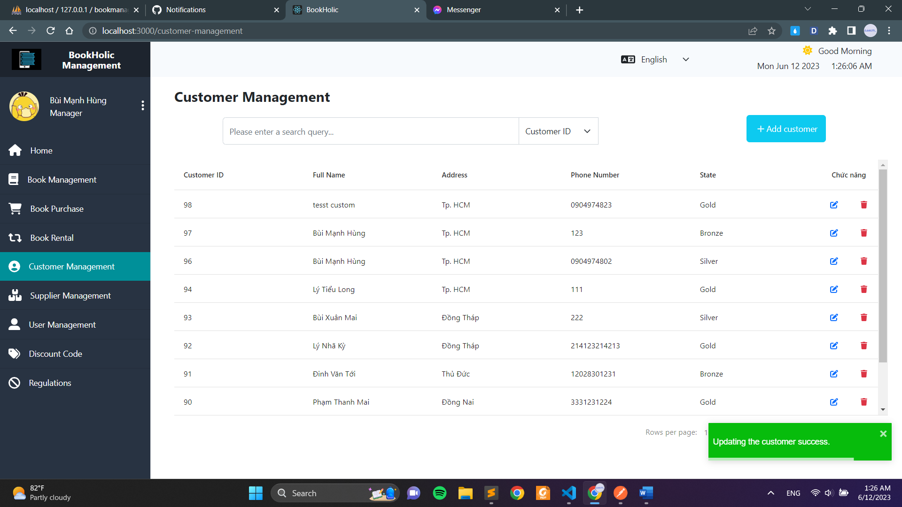

**Picture 24. Edit customer successful notification**

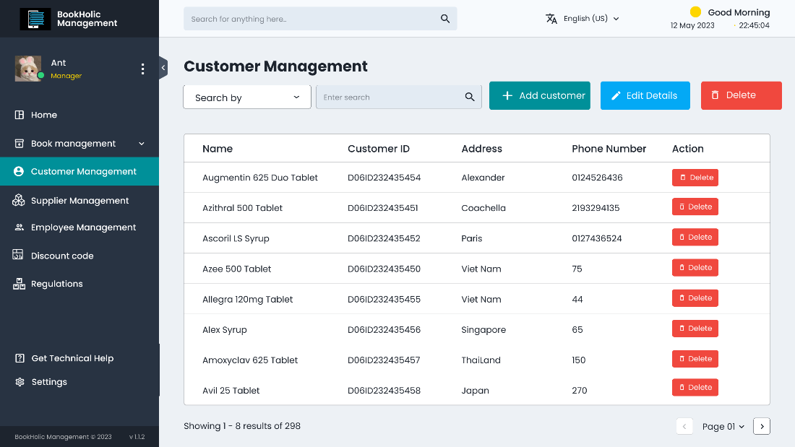

**Picture 25. Delete customer**

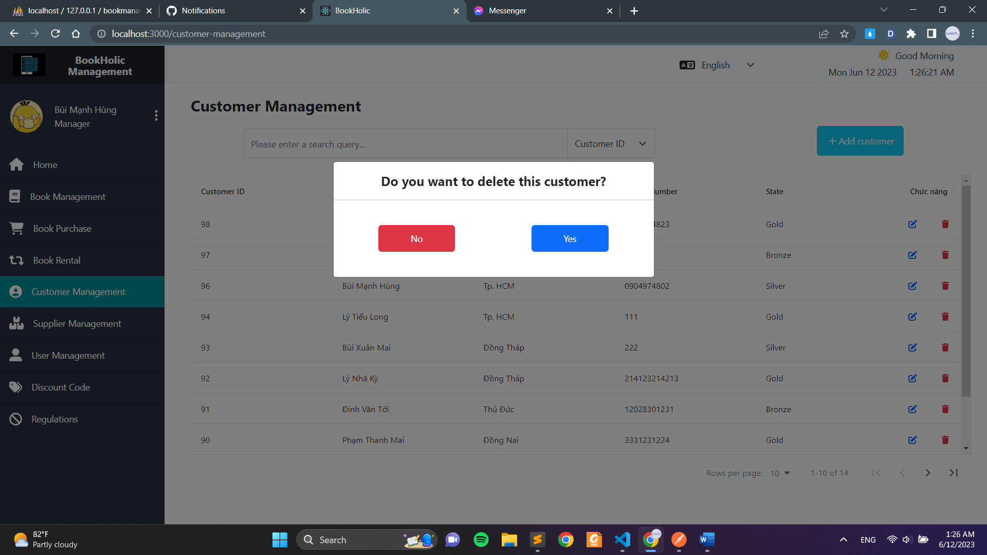

**Picture 26. Delete customer confirm**

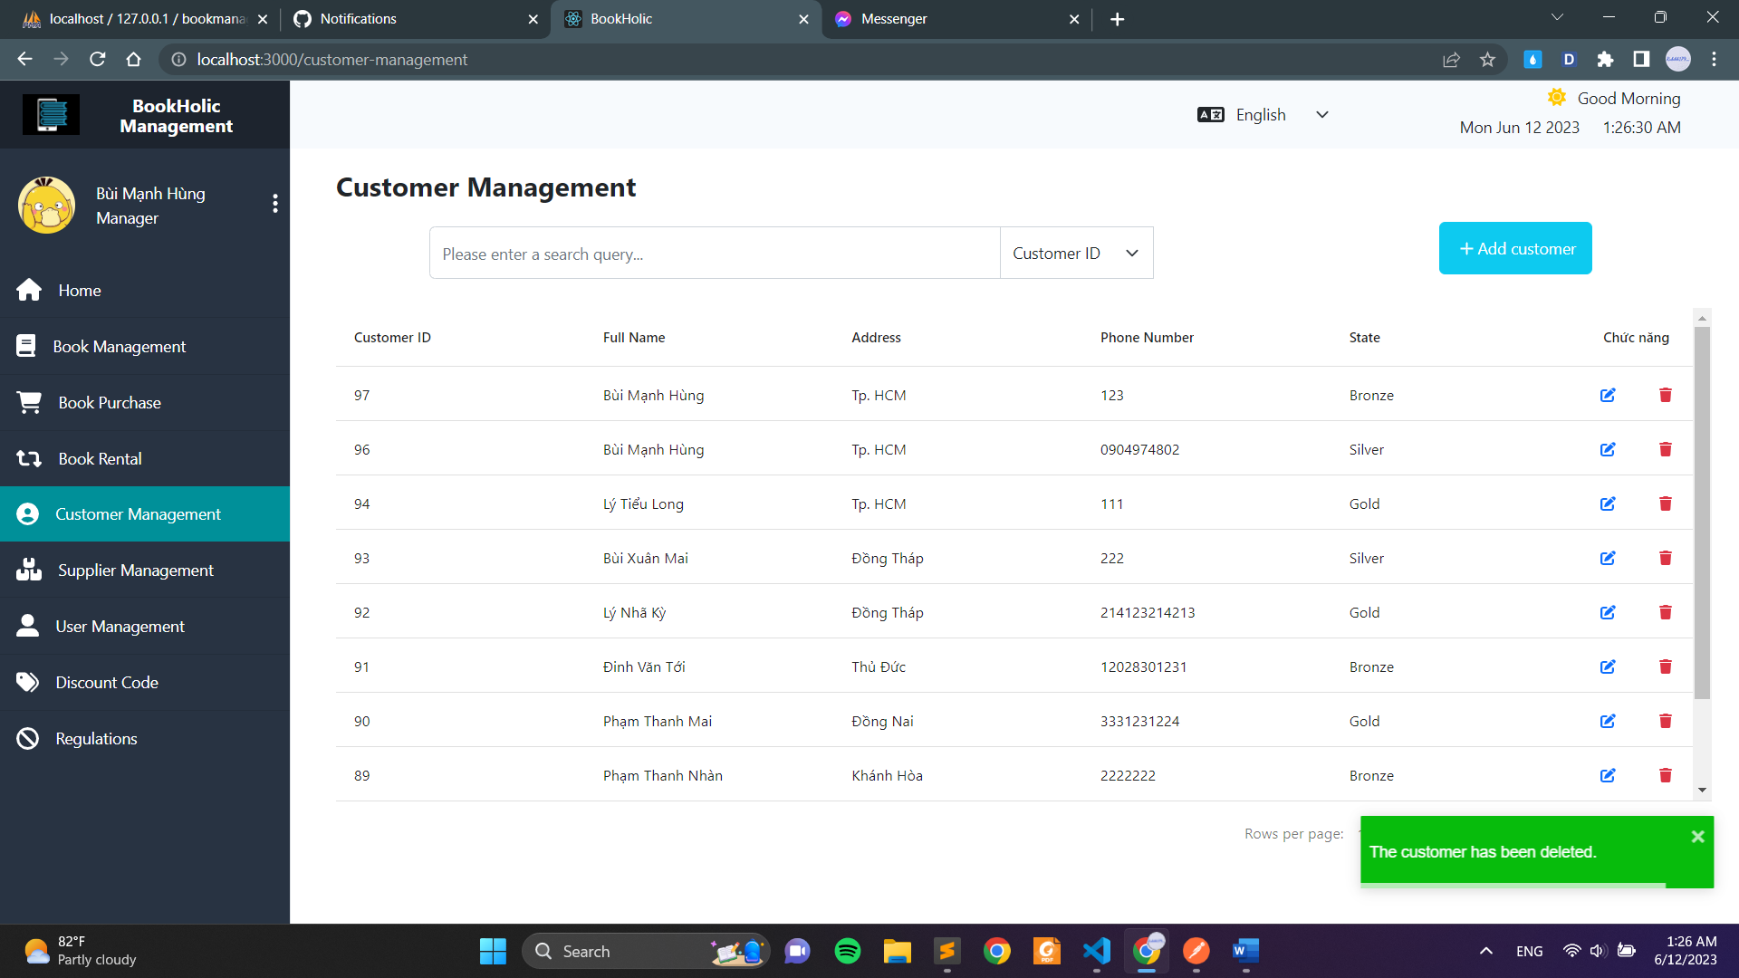

**Picture 27. Delete customer successful notification**

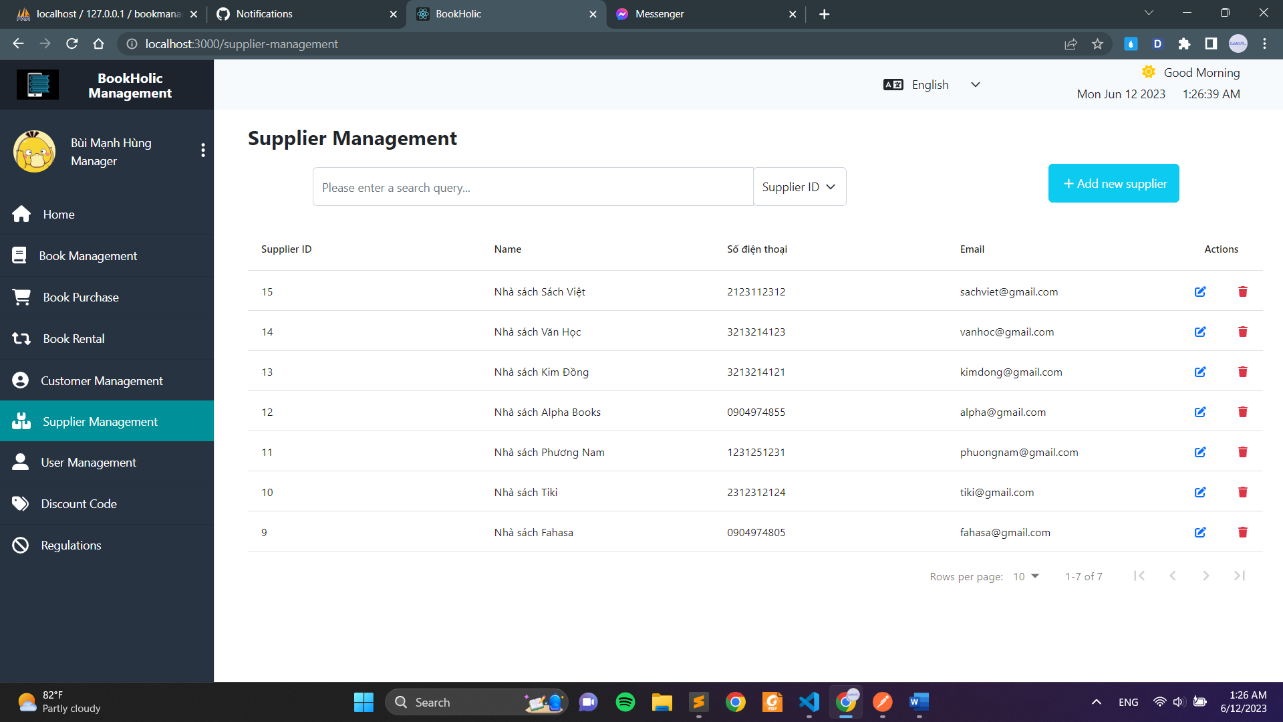

**Picture 28. Supplier Management page**

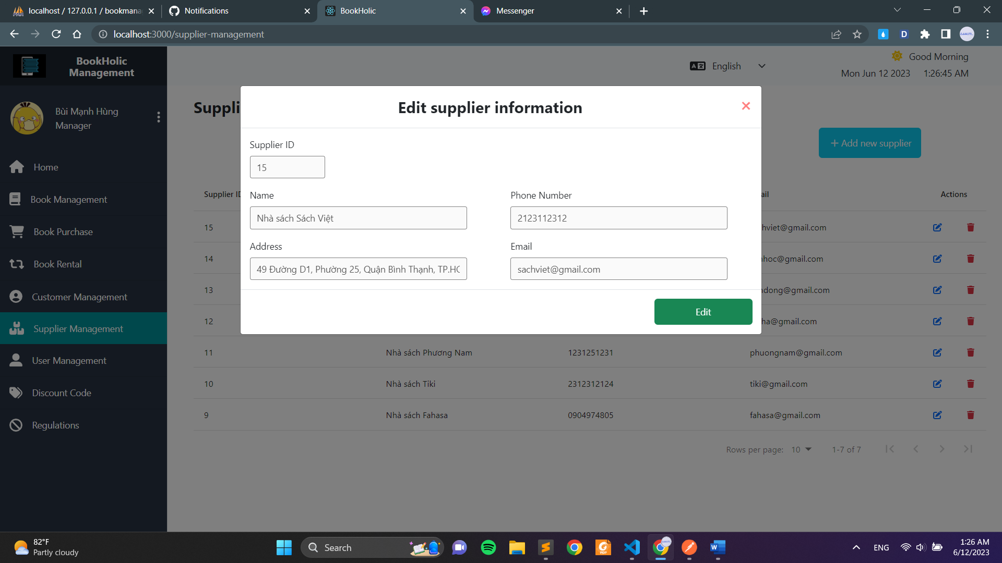

**Picture 29. View full detail**

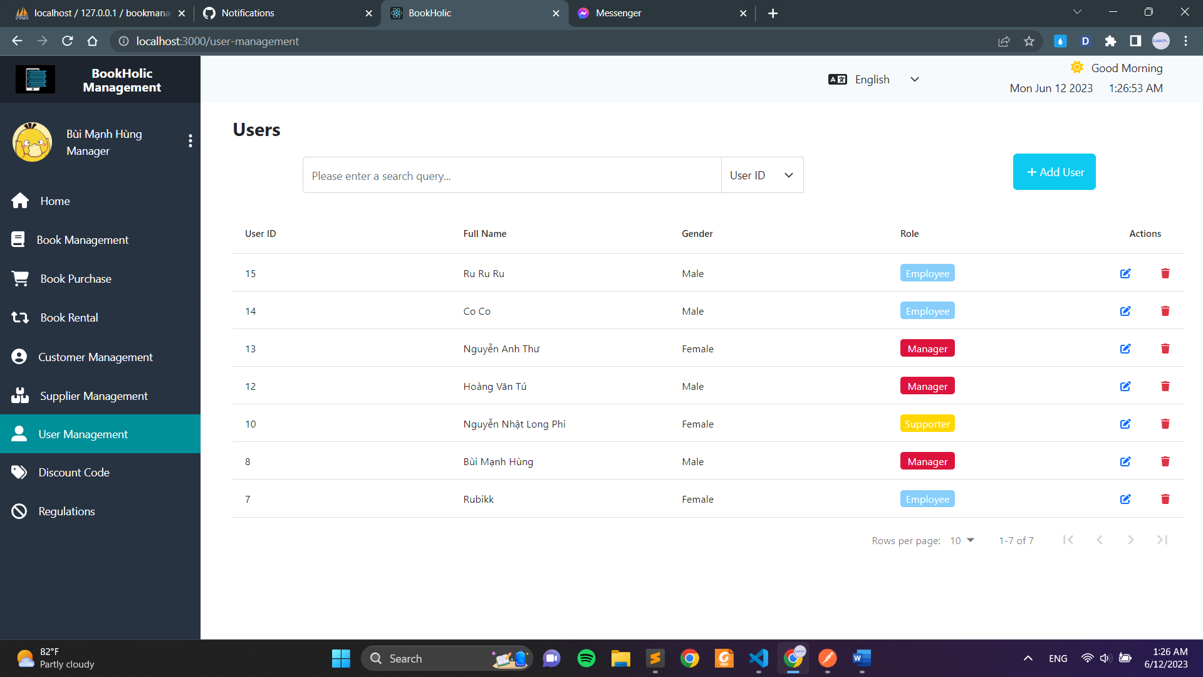

**Picture 30. Employee management**

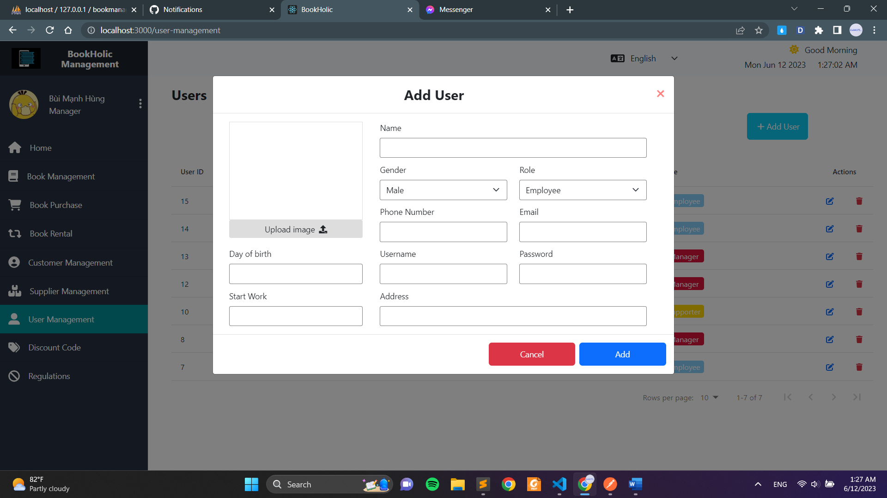

**Picture 31. Add user page**

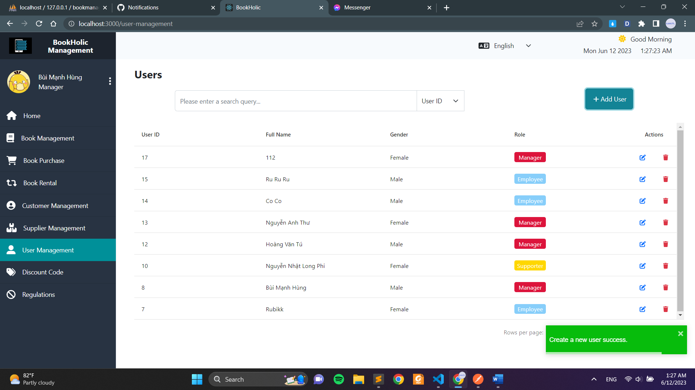

**Picture 32. Add user successful notification**

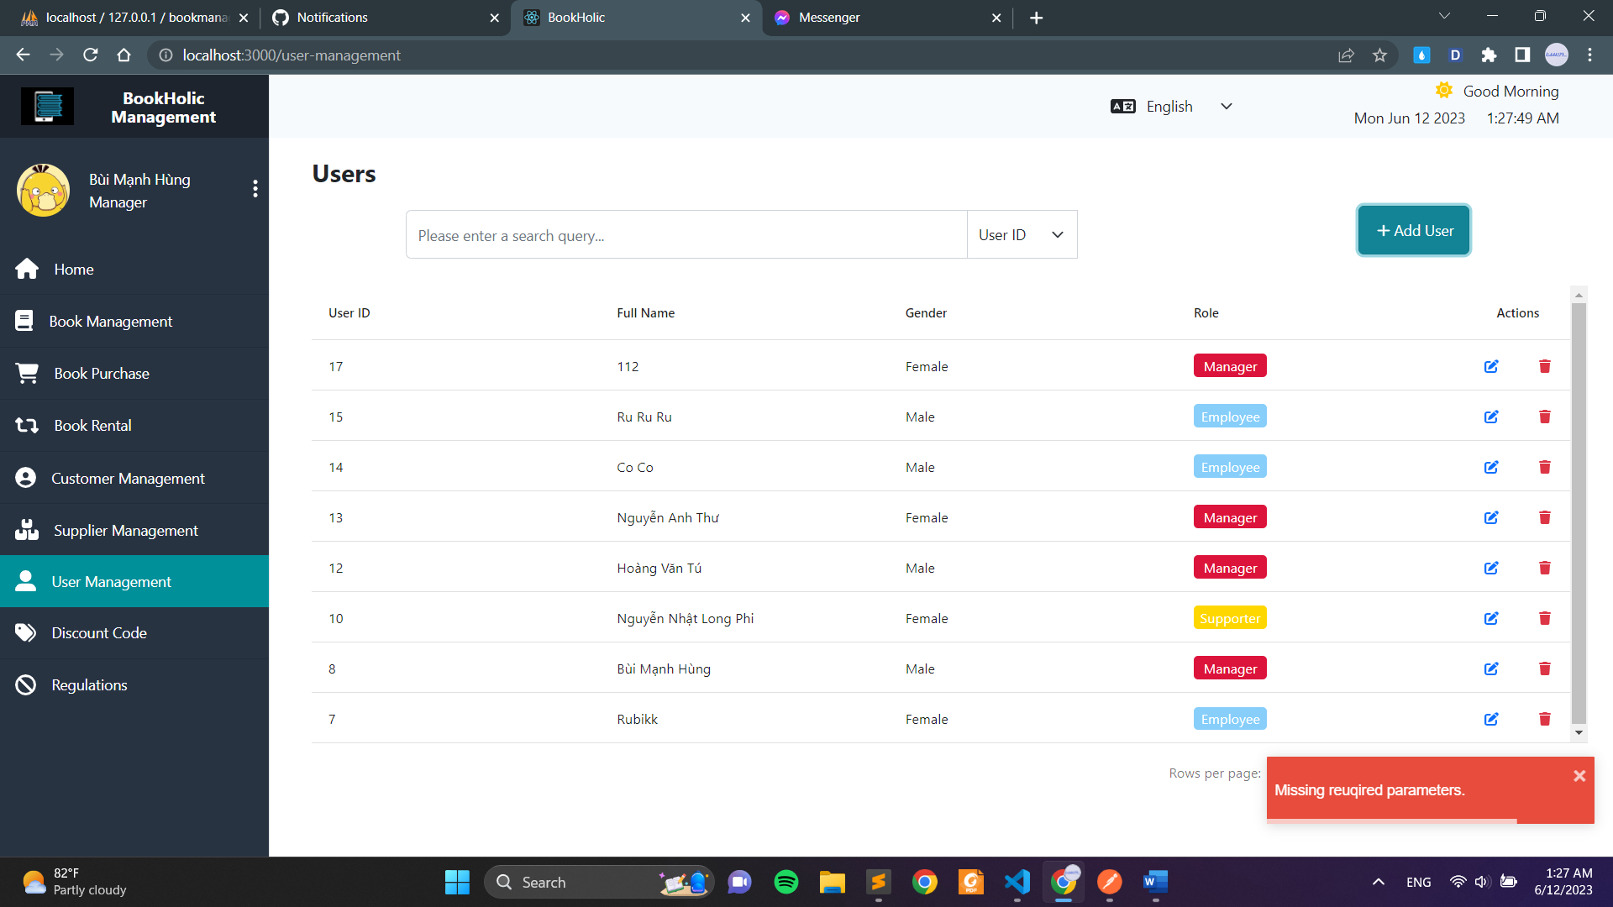

**Picture 33. Add user error notification**

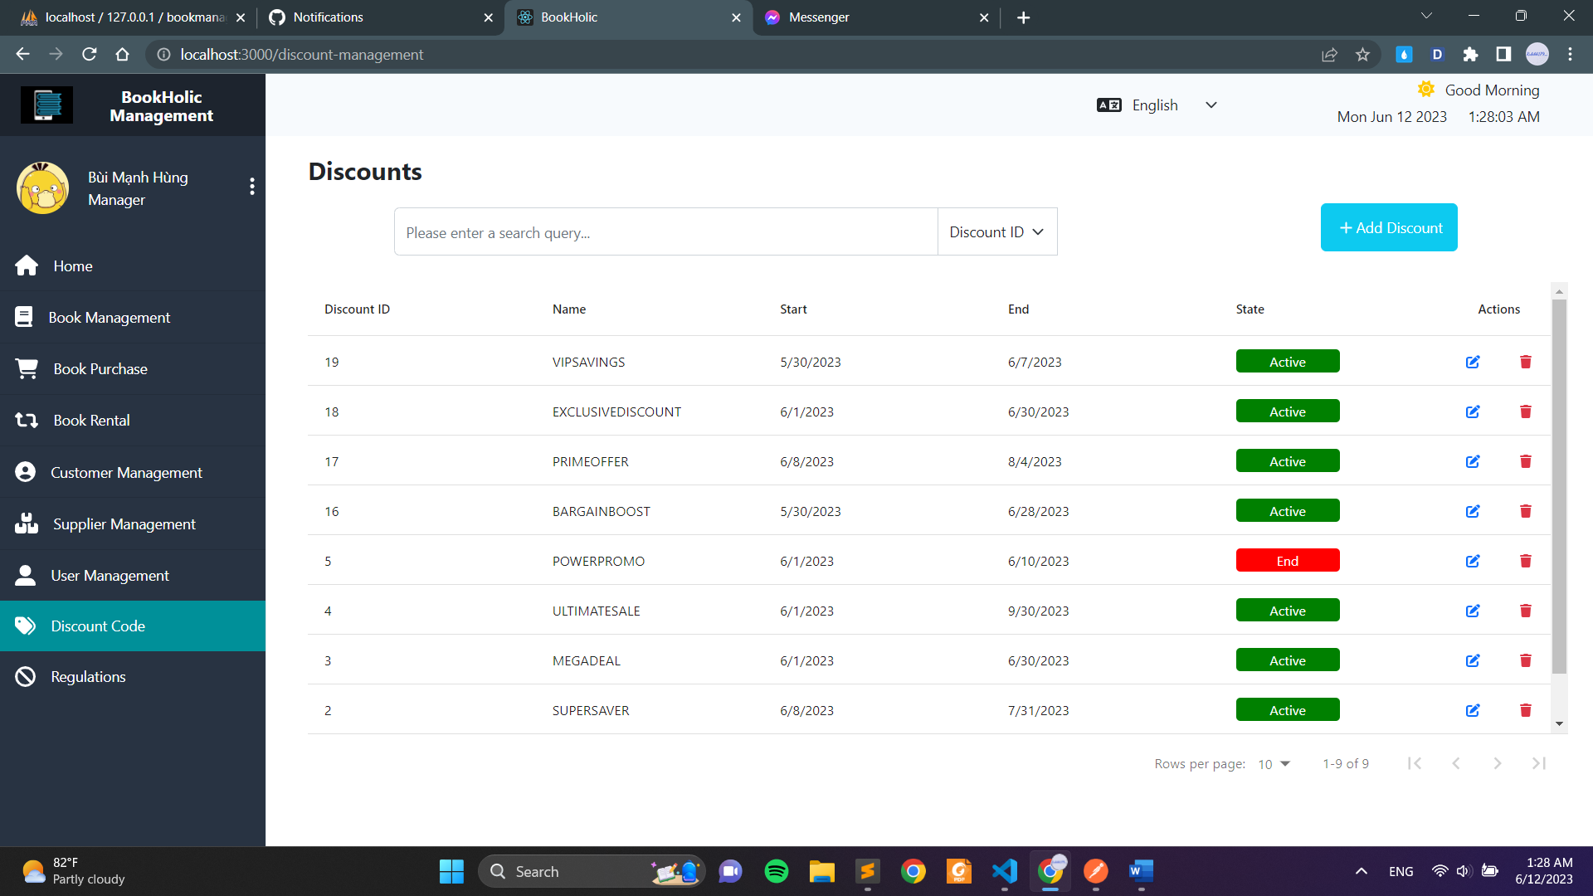

**Picture 34. Discount code page**

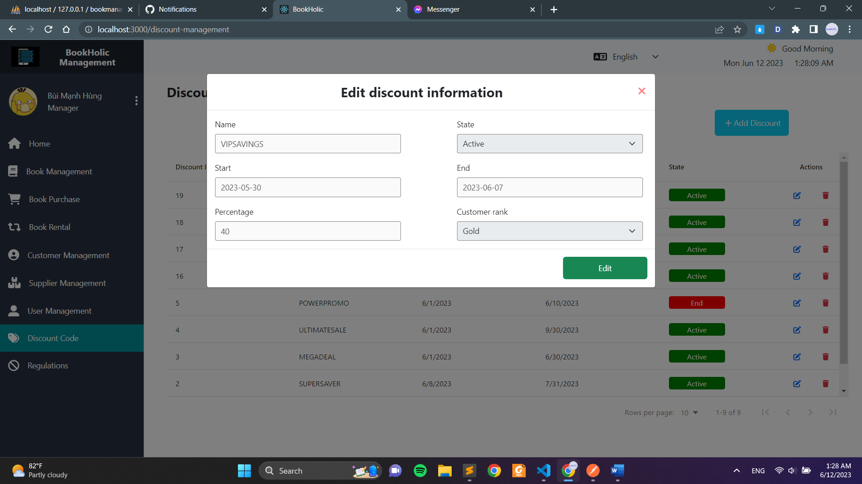

**Picture 35. Detail voucher form**

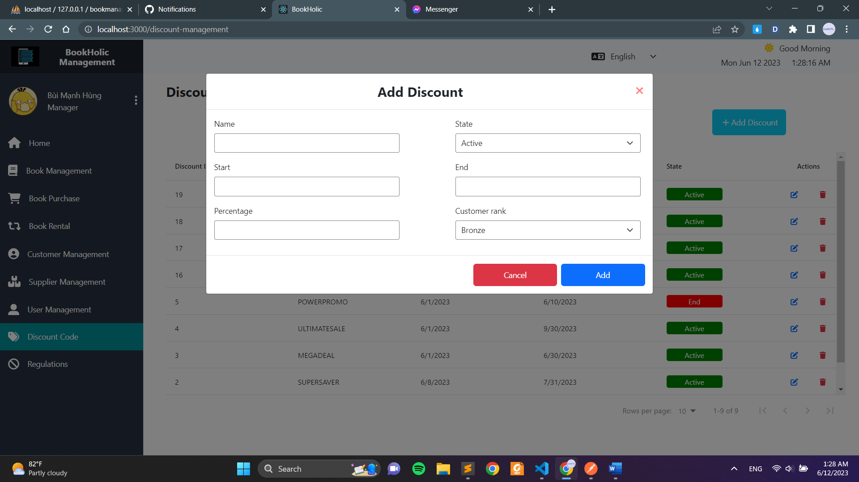

**Picture 36. Add voucher form**

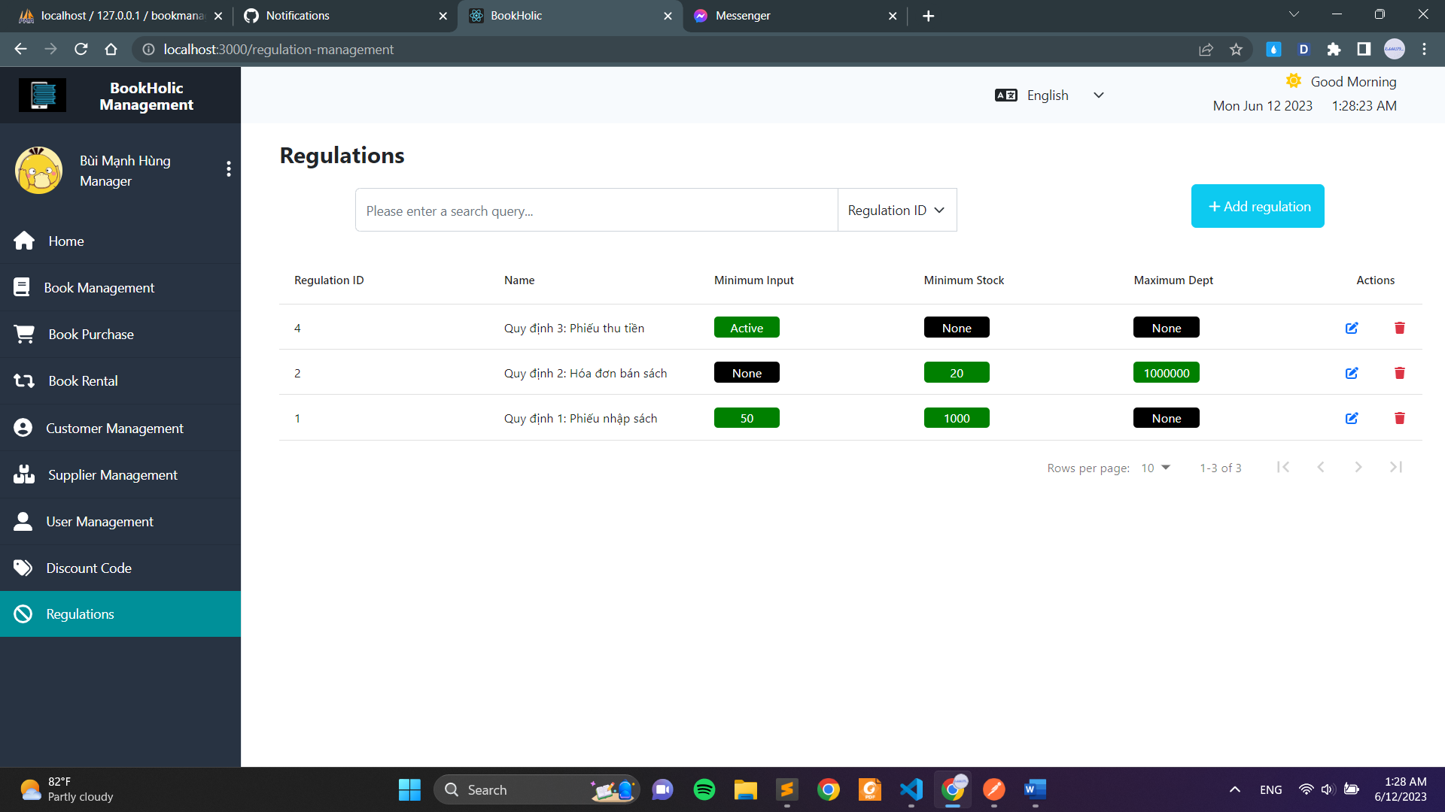

**Picture 37. Regulations page**

# PACKAGE (CLASS DIAGRAM)



|  |  |  |
| --- | --- | --- |
| No. | Class name | Description |
| 1 | Login | Contains User information to authenticate to access the system |
| 2 | Manage Regulation | Contains regulation information: RegulationID, Name, Minimum Input, Minimum Stock, Maximun Debt… |
| 3 | Manage Book | Contains book information: BookID, Title, Author name,… |
| 4 | Manage Book Purchase | Contains Invoice information: InvoiceID, CustomerID, DCID, Total amount, Paid amount,… |
| 5 | Manage Book Rent | Contains Rent invoice information: RentID, CustomerID, Total price,… |
| 6 | Manage Customer | Contains customer information: CiustomerID, name, address, phone number… |
| 7 | Manage Discount code | Contains Discount code information: DCID, Title, Start date, End date,.. |
| 8 | Manange Supplier | Contains Supplier information: SupplierID, name, email… |
| 9 | Statistics | Contains Statistical information and Report information |
| 10 | Manage User | Contains user information: UserID, UserName, Password,… |

## Ảnh có chứa văn bản, biên lai, Phông chữ, tài liệu Mô tả được tạo tự độngLogin

|  |  |  |
| --- | --- | --- |
| **Login** | | |
| **Attribute** | **Variable** | **Meaning** |
| UserID | User ID generated by system |
| Username | User name for user to login to the system |
| Password | Password of user |
| Name | Full name of user |
| Gender | Gender of user |
| Phone number | Phone number of user |
| Email | Email of user |
| Address | Address of user |
| Birthday | Birthday of user |
| Image | Image for setting avatar of user |
| DateOfEmployment | The date that employee started working |
| Role | Role of user – to limit the functions that user can access |
| **Operation** | **Function** | **Meaning** |
| Login | Request to login to the database |
| GetAllUsers(UserID) | Get list of system’s User to show on User Management Page |
| CreateNewUser | Request database to create a new User. Validation function is prerequisite for this function |
| EditUser | Request database to make a change to an exsisted user. Validation function is prerequisite for this function |
| DeleteUser | Request database to delete the selected user. |

## Manage Regulation

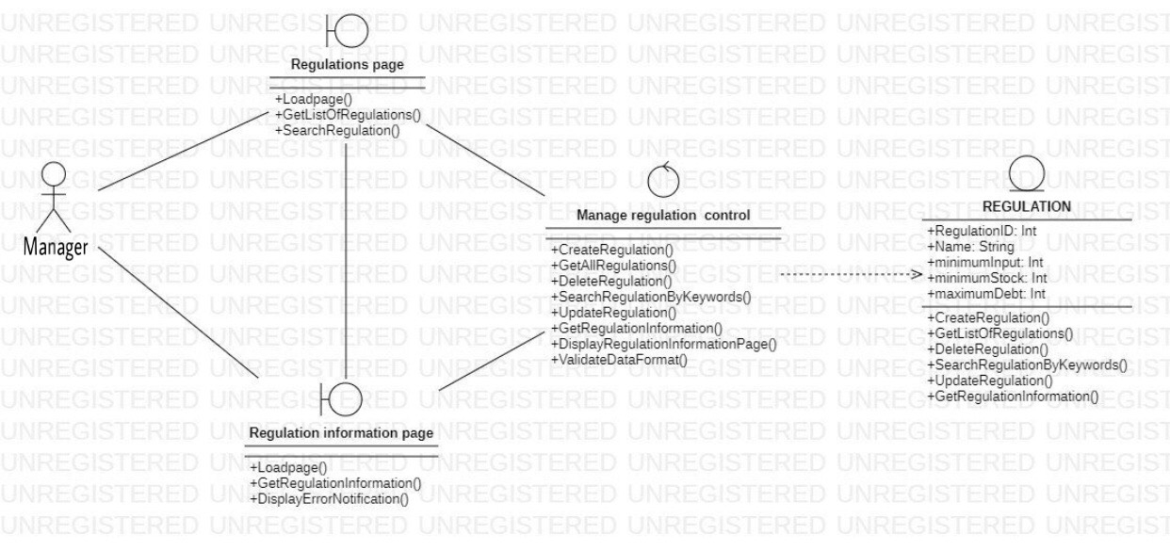

|  |  |  |
| --- | --- | --- |
| **Manage Regulation** | | |
| **Attribute** | **Variable** | **Meaning** |
| RegulationID | Regulation ID generated by system |
| Name | Name of regulation |
| MinimumInput | Minimum quantity of books to import |
| MinimumStock | Minimum quantity of stock |
| MaximumDebt | Maximum amount of debt |
| **Operation** | **Function** | **Meaning** |
| CreateRegulation | Request database to create a new regulation after validate. |
| GetAllRegulations | Get list of regulations to show on Regulation Management Page |
| UpdateRegulation | Request database to make a change to an existed regulation . Validation function is prerequisite for this function |
| DeleteRegulation | Request database to delete the selected regulation. |
| SearchRegulationByKeywords | Search regulations related to keyword for displaying on the regulation management page |

|  |  |  |
| --- | --- | --- |
| **Manage Regulation Controller** | | |
| Operation | Function | Meaning |
| CreateRegulation | Request database to create a new regulation after validate. |
| GetAllRegulations | Get list of regulations to show on Regulation Management Page |
| UpdateRegulation | Request database to make a change to an existed regulation . Validation function is prerequisite for this function |
| DeleteRegulation | Request database to delete the selected regulation. |
| DisplayRegulationInformationPage | This function is triggered when the manager clicks on a regulation. Display the regulation information page related to the selected regulation. |
| ValidateDataFormat | Validate the input data is in the correct format or not |

## Ảnh có chứa văn bản, biểu đồ, ảnh chụp màn hình, số Mô tả được tạo tự độngManage Book

|  |  |  |
| --- | --- | --- |
| **Manage Book** | | |
| **Attribute** | **Variable** | **Meaning** |
| BookID | Book ID generated by system |
| Title | Name of the book |
| Genre | Genre of the book |
| authorName | Name of the author |
| Cost_price | Price when import book |
| Selling_price | Price when sell books |
| Stock | Quantity of books available in stock |
| DateOfEntry | The date when the book was imported |
| **Operation** | **Function** | **Meaning** |
| GetAllBook(BookID) | Get list of system’s Book to show on Book Management Page |
| CreateNewBook | Request database to create a new Book. Validation function is prerequisite for this function |
| EditBook | Request database to make a change to an exsisted book. Validation function is prerequisite for this function |
| DeleteBook | Request database to delete the selected book. |

## Manage Book Purchase

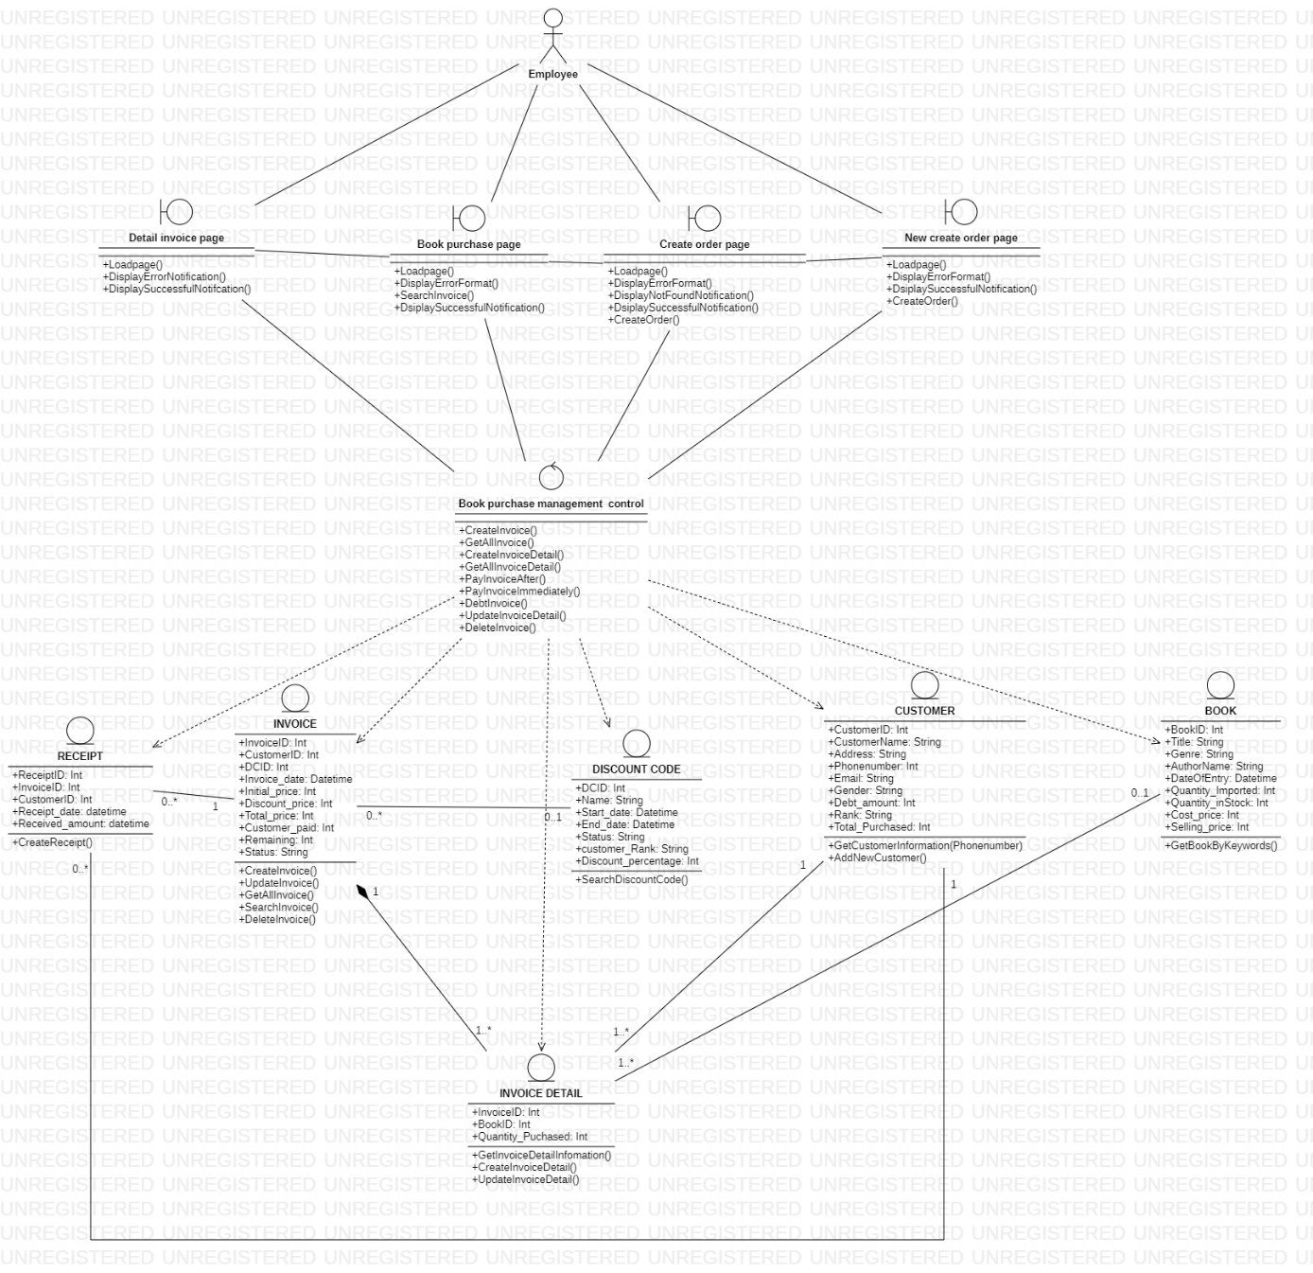

|  |  |  |
| --- | --- | --- |
| **Invoice** | | |
| **Attribute** | **Variable** | **Meaning** |
| InvoiceID: Integer | Invoice ID generated by system automatically |
| CustomerID: Integer | Customer ID generated by system |
| DCID: Integer | Discount Code ID |
| Invoice_date: Datetime | The creation date of invoice |
| Initial_price: Integer | The starting price of invoice |
| Discount_price: Integer | The discount price of invoice |
| Total_price: Integer | Total invoice value |
| **Operation** | **Function** | **Meaning** |
| AddNewInvoice() | Store new invoice after validation |
| UpdateInvoice() | Update invoice after changing information |
| GetListOfInvoices() | Request database get list of invoices |
| SearchInvoice() | Search invoices related to keyword |
| **Invoice Detail** | | |
| **Attribute** | **Variable** | **Meaning** |
| InvoiceID: Integer | Invoice ID generated by system |
| BookID: Integer | Book ID generated by system |
| Quantity_Puchased: Integer | Quantity of books purchased |
| **Operation** | **Function** | **Meaning** |
| GetInvoiceDetailInfomation() | Request database get information of selected invoice |
| **Receipt** | | |
| **Attribute** | **Variable** | **Meaning** |
| ReceiptID: Integer | Receipt ID generated by system |
| InvoiceID: Integer | Invoice ID generated by system |
| CustomerID: Integer | Customer ID generated by system |
| Receipt_date: datetime | Date of receipt |
| Received_amount: datetime | Amount received |
| **Operation** | **Function** | **Meaning** |
| AddNewReceipt() | Store new receipt after validation |
| **Book purchase management control** | | |
| **Attribute** | **Variable** | **Meaning** |
| InvoiceID: Integer | Invoice ID generated by system |
| BookID: Integer | Book ID generated by system |
| Quantity_Puchased: Integer | Quantity of books purchased |
| **Operation** | **Function** | **Meaning** |
| GetListOfInvoice() | Request database get list of invoices |
| SearchDiscountCode() | Return discount code ID related |
| CreateOrder() | Request database store invoice, receipt after validate |
| CalculateCostOfInvoice() | Calculate cost of invoice |
| GetInvoiceDetailInformation() | Request database get invoice datail information |

## Manage Book Rental

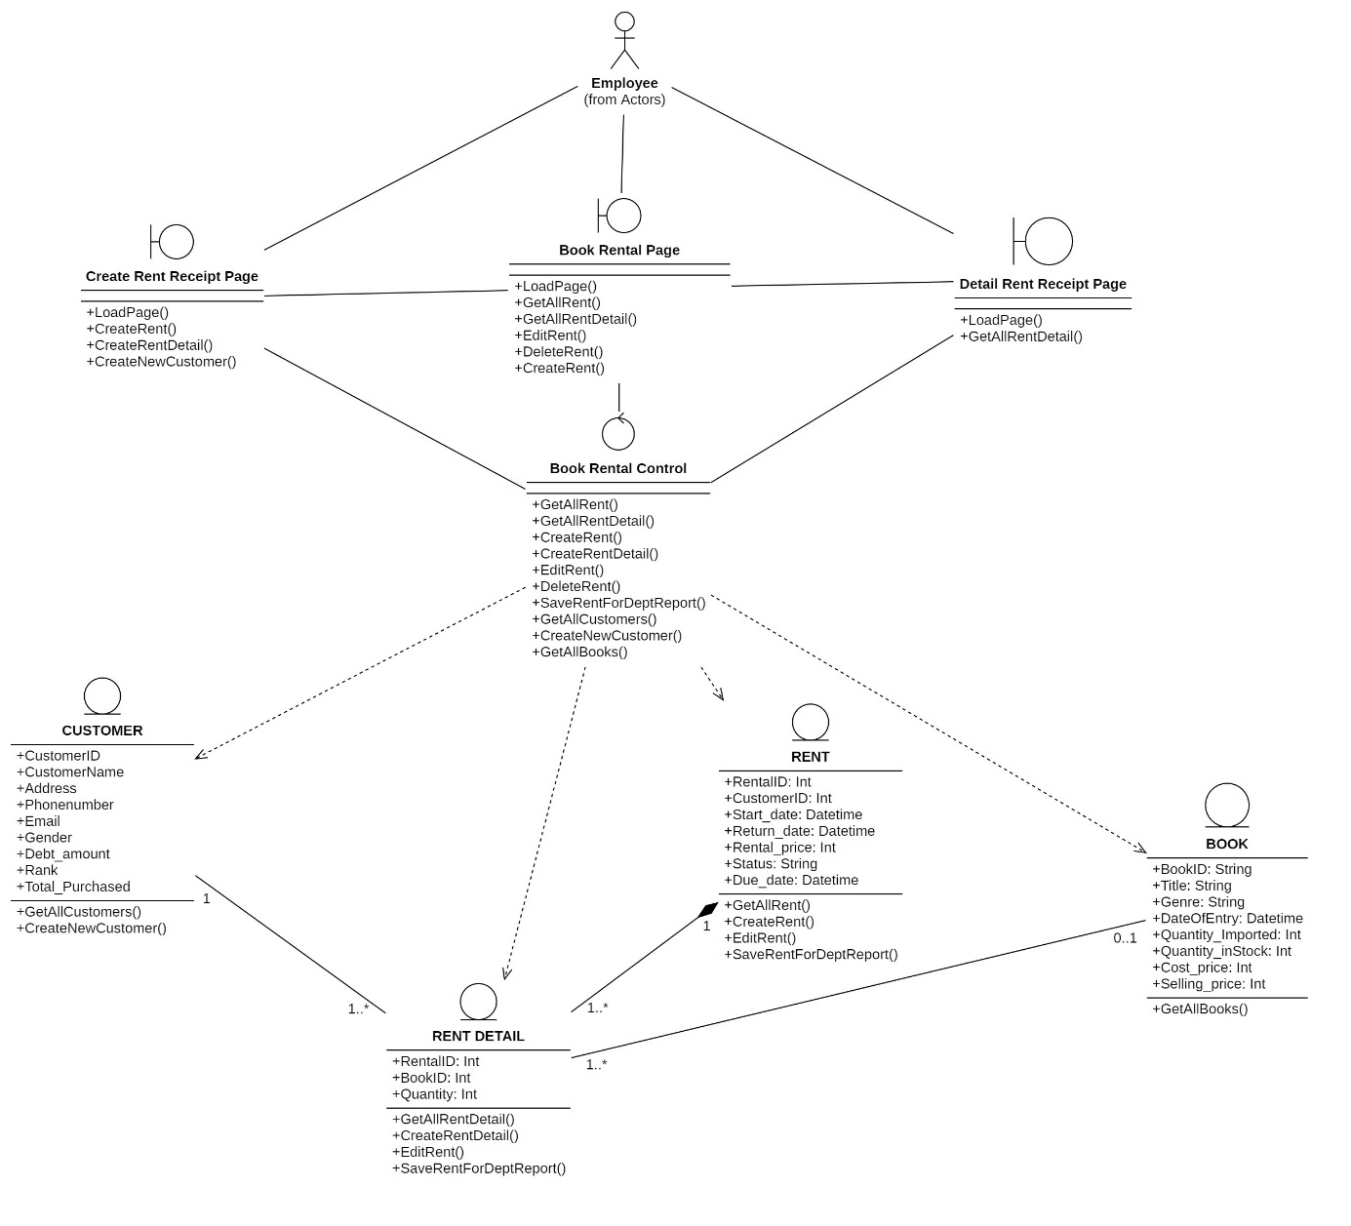

|  |  |  |
| --- | --- | --- |
| **Manage Book Rental** | | |
| **Attribute** | **Variable** | **Meaning** |
| RentalID | Rental ID generated by system |
| CustomerID | Customer ID generated by system |
| Start_date | Date which customer starts to rent book |
| Return_date | Date which customer must to return book |
| Rental_price | Price of rent receipt |
| Status | Status of rent receipt: not returned or returned |
| Due_date | Date which customer returns book |
| **Operation** | **Function** | **Meaning** |
| GetAllRent(req, res) | Get list of rents or get particular rent based on rentId |
| GetAllRentDetail(req, res) | Get list of rent detail or get particular rent detail based on rentId |
| CreateRent(req, res) | Create new rent with attributes |
| CreateRentDetail(req, res) | Create new rent detail with attributes |
| SaveRentForDeptReport(req, res) | Update rent transaction to DeptReport database |

## Ảnh có chứa văn bản, biểu đồ, số, Phông chữ Mô tả được tạo tự độngManage Customer

|  |  |  |
| --- | --- | --- |
| **Manage Customer** | | |
| **Attribute** | **Variable** | **Meaning** |
| BookID | Book ID generated by system |
| Title | Name of the book |
| Genre | Genre of the book |
| authorName | Name of the author |
| Cost_price | Price when import book |
| Selling_price | Price when sell books |
| Stock | Quantity of books available in stock |
| DateOfEntry | The date when the book was imported |
| **Operation** | **Function** | **Meaning** |
| GetAllBook(BookID) | Get list of system’s Book to show on Book Management Page |
| CreateNewBook | Request database to create a new Book. Validation function is prerequisite for this function |
| EditBook | Request database to make a change to an exsisted book. Validation function is prerequisite for this function |
| DeleteBook | Request database to delete the selected book. |

## Ảnh có chứa văn bản, biểu đồ, ảnh chụp màn hình, Phông chữ Mô tả được tạo tự độngManage Discount code

|  |  |  |
| --- | --- | --- |
| **Manage Book** | | |
| **Attribute** | **Variable** | **Meaning** |
| BookID | Book ID generated by system |
| Title | Name of the book |
| Genre | Genre of the book |
| authorName | Name of the author |
| Cost_price | Price when import book |
| Selling_price | Price when sell books |
| Stock | Quantity of books available in stock |
| DateOfEntry | The date when the book was imported |
| **Operation** | **Function** | **Meaning** |
| GetAllBook(BookID) | Get list of system’s Book to show on Book Management Page |
| CreateNewBook | Request database to create a new Book. Validation function is prerequisite for this function |
| EditBook | Request database to make a change to an exsisted book. Validation function is prerequisite for this function |
| DeleteBook | Request database to delete the selected book. |

## Ảnh có chứa văn bản, biểu đồ, ảnh chụp màn hình, Phông chữ Mô tả được tạo tự độngManage Supplier

|  |  |  |
| --- | --- | --- |
| **Manage Book** | | |
| **Attribute** | **Variable** | **Meaning** |
| BookID | Book ID generated by system |
| Title | Name of the book |
| Genre | Genre of the book |
| authorName | Name of the author |
| Cost_price | Price when import book |
| Selling_price | Price when sell books |
| Stock | Quantity of books available in stock |
| DateOfEntry | The date when the book was imported |
| **Operation** | **Function** | **Meaning** |
| GetAllBook(BookID) | Get list of system’s Book to show on Book Management Page |
| CreateNewBook | Request database to create a new Book. Validation function is prerequisite for this function |
| EditBook | Request database to make a change to an exsisted book. Validation function is prerequisite for this function |
| DeleteBook | Request database to delete the selected book. |

## Statistics

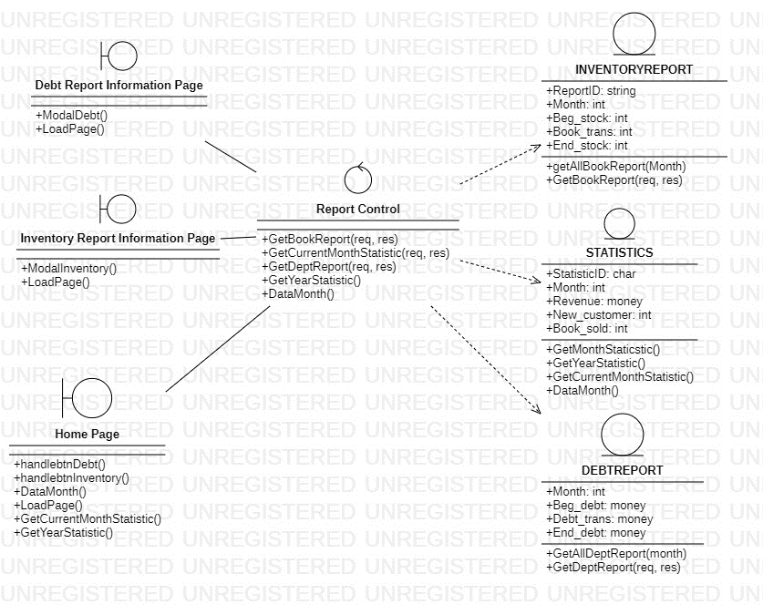

|  |  |  |
| --- | --- | --- |
| **Statistics** | | |
| **Operation** | **Function** | **Meaning** |
| getAllDeptReport(Month) - DEBTREPORT | Get all debt reporting data for a particular month. |
| getAllBookReport(Month) - inventory | Get all inventory reporting data for a particular month. |
| GetDeptReport(req, res) - DEBTREPORT | Process claims and return debt reports. |
| GetBookReport(req, res) - INVENTORYREPORT | Process claims and return inventory reports. |
| handlebtnDebt() - Homepage | The function is called when the user clicks the button to generate the debt report. |
| handlebtnInventory()- Homepage | The function is called when the user clicks the button to generate the inventory report. |
| GetMonthStaticstic() - Statistic | Get monthly statistical information. |
| DataMonth() - Homepage | Displays statistical data for a specific time period. |
| GetYearStatistic() - Statistic | Get annual statistics. |
| GetCurrentMonthStatistic() - Statistic | Get current monthly statistics information. |
|  | ModalInventory() - InventoryInformationPage | Displays a modal containing information about books in the system. |
|  | ModalDebt()- DebtInformationPage | Display a modal containing information about debt in the system. |

## Manage User

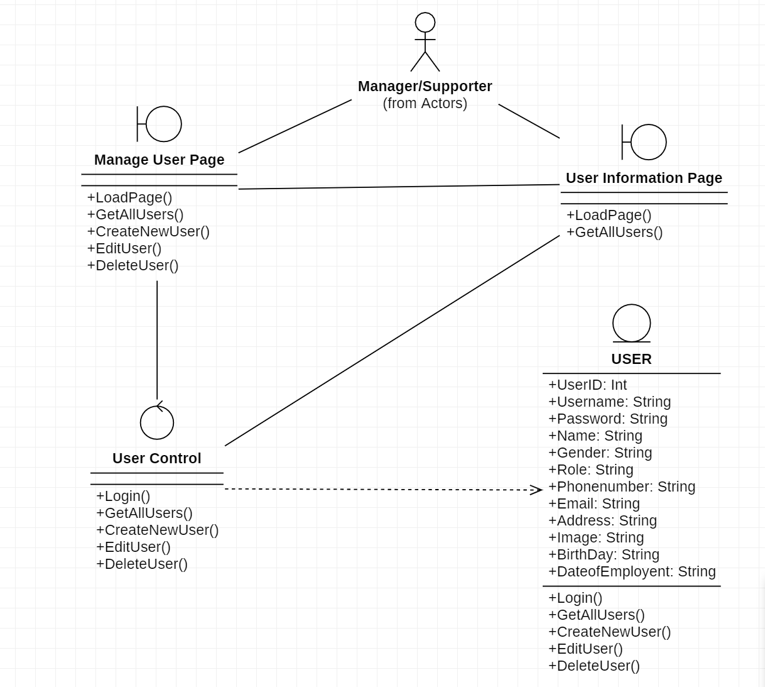

|  |  |  |
| --- | --- | --- |
| **Manage User** | | |
| **Attribute** | **Variable** | **Meaning** |
| UserID | User ID generated by system |
| Username | User name for user to login to the system |
| Password | Password of user |
| Name | Full name of user |
| Gender | Gender of user |
| Phone number | Phone number of user |
| Email | Email of user |
| Address | Address of user |
| Birthday | Birthday of user |
| Image | Image for setting avatar of user |
| DateOfEmployment | The date that employee started working |
| Role | Role of user – to limit the functions that user can access |
| **Operation** | **Function** | **Meaning** |
| Login | Request to login to the database |
| GetAllUsers(UserID) | Get list of system’s User to show on User Management Page |
| CreateNewUser | Request database to create a new User. Validation function is prerequisite for this function |
| EditUser | Request database to make a change to an exsisted user. Validation function is prerequisite for this function |
| DeleteUser | Request database to delete the selected user. |

# DIAGRAMS



## Sequence Diagram and Activity Diagram

* + 1. Login
       1. 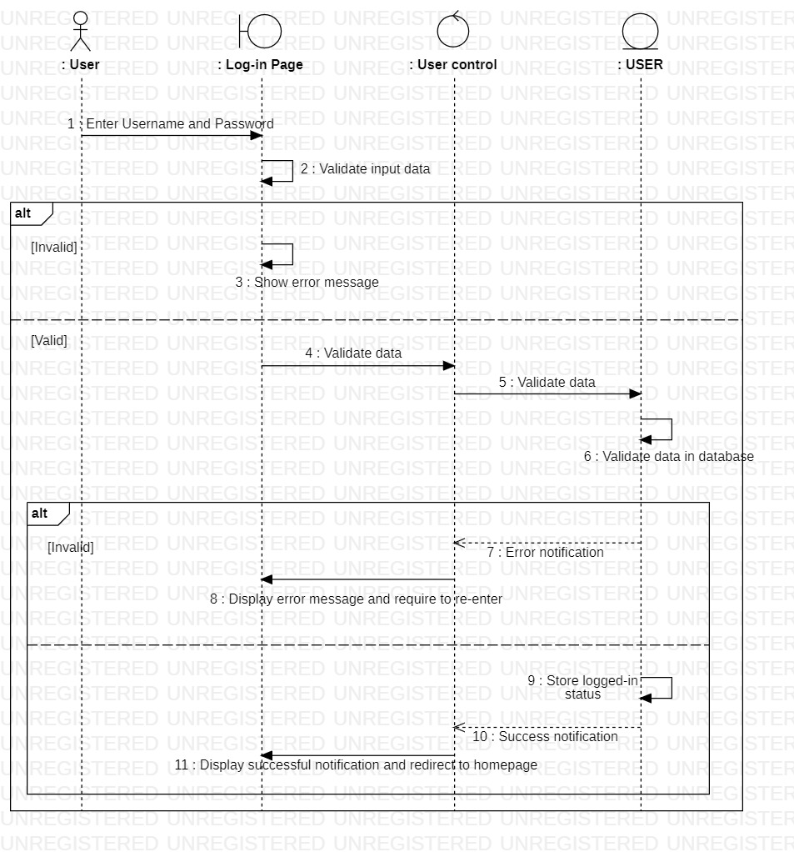Sequence diagram
       2. 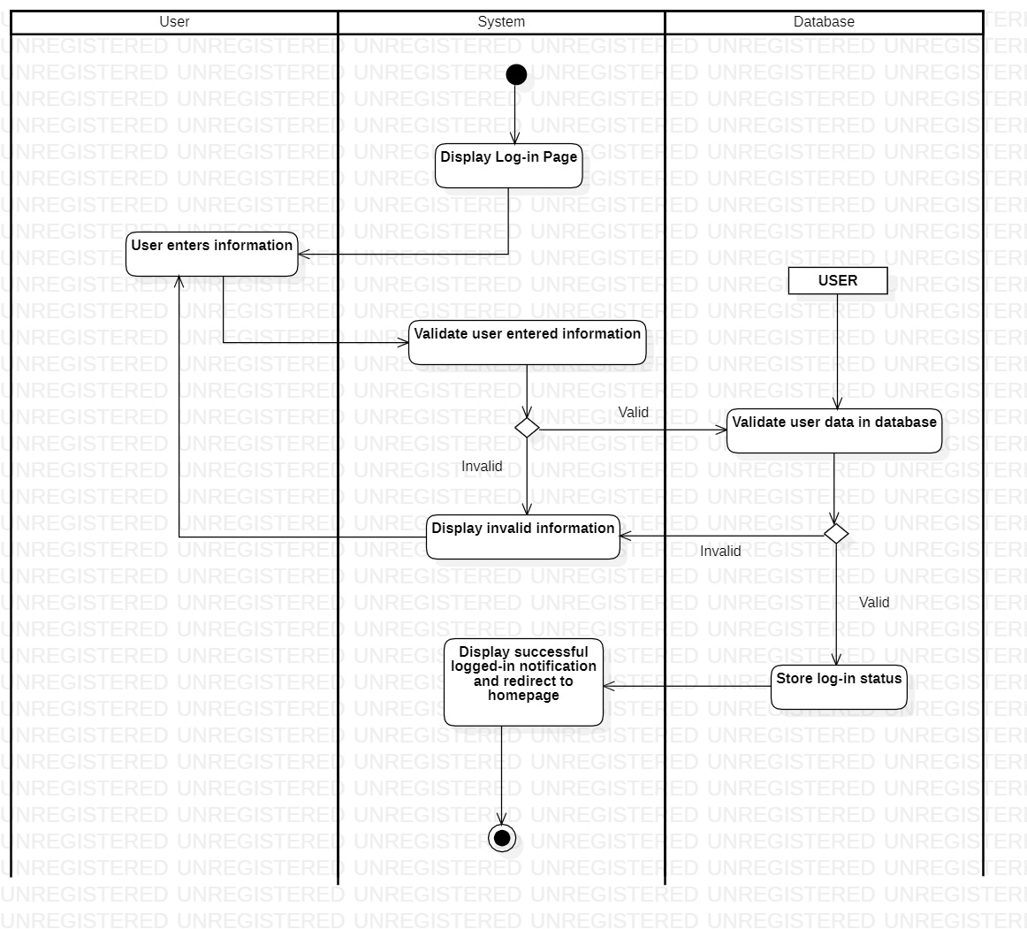Activity diagram
    2. Manage regulation
       1. Sequence diagram

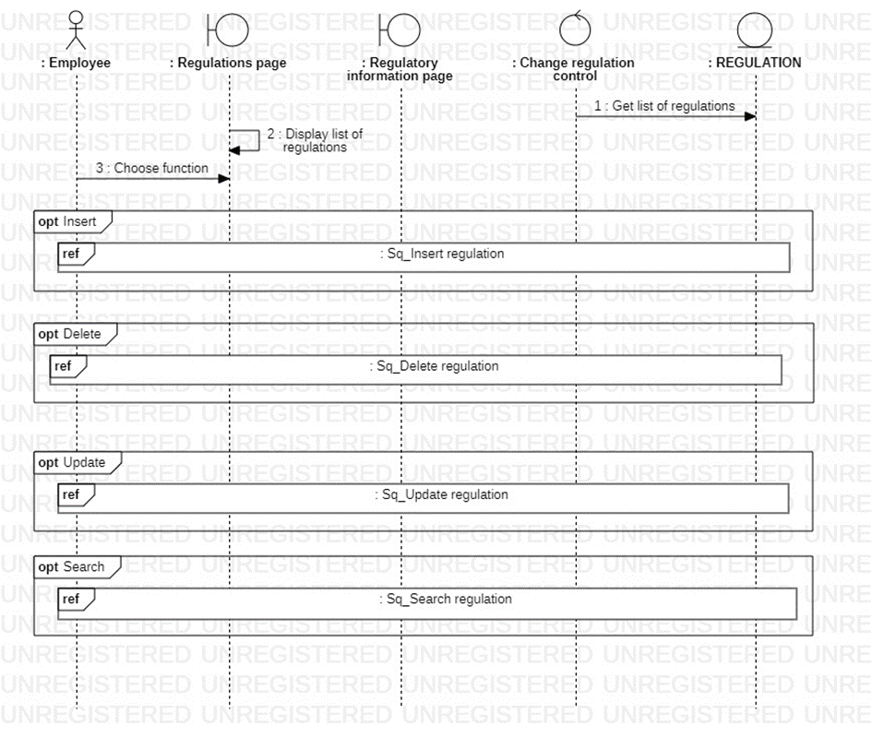

* + - * 1. Add regulation

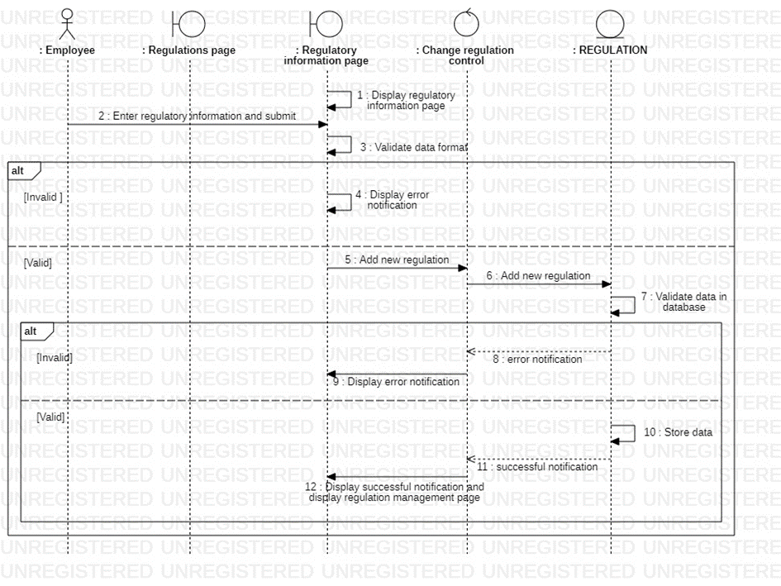

* + - * 1. Update regulation

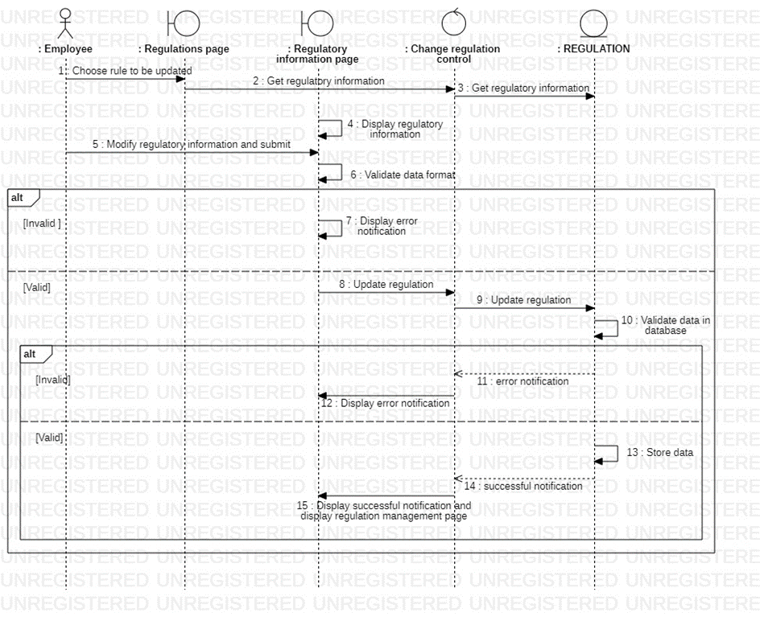

* + - * 1. Delete regulation

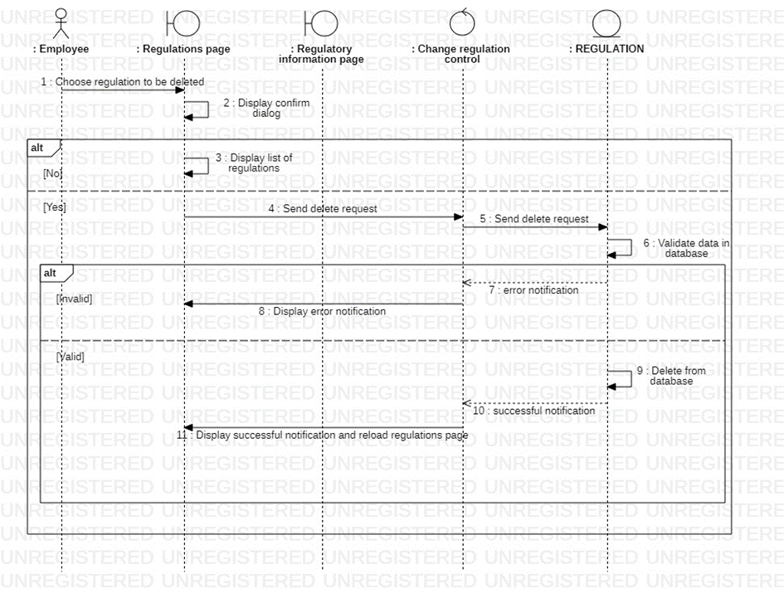

* + - * 1. Search regulation

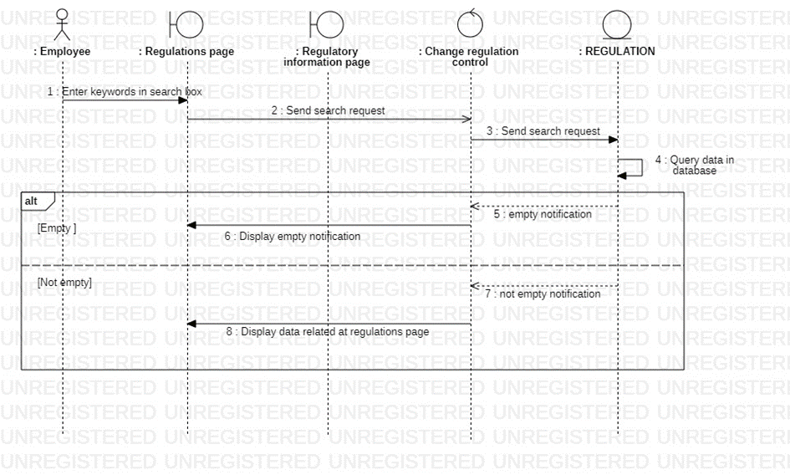

* + - 1. Activity diagram

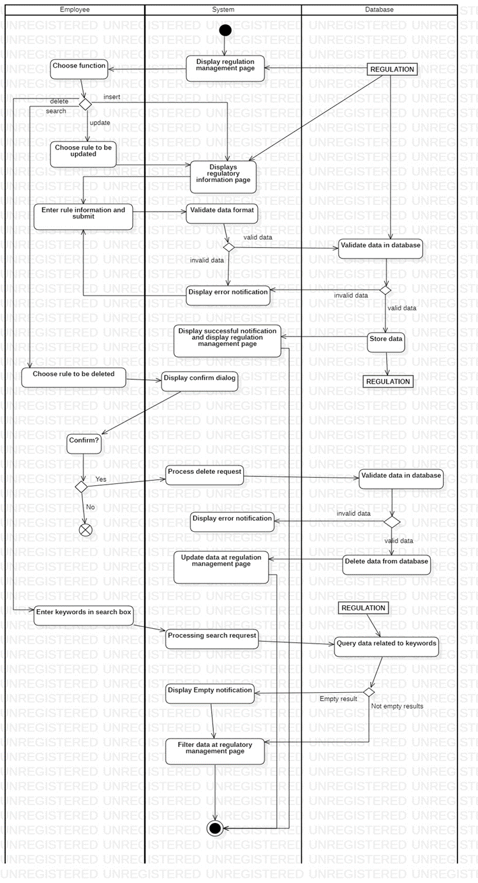

* + 1. Manage Book
       1. Sequence diagram

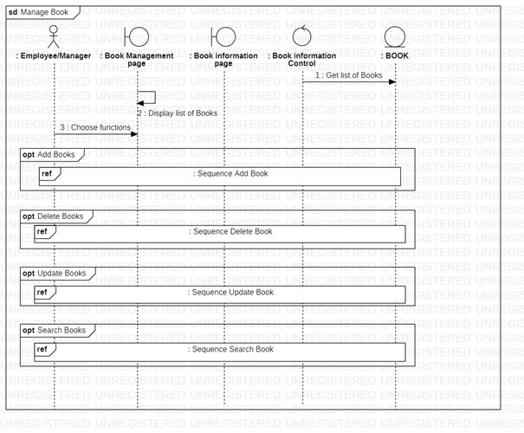

* + - * 1. Add book

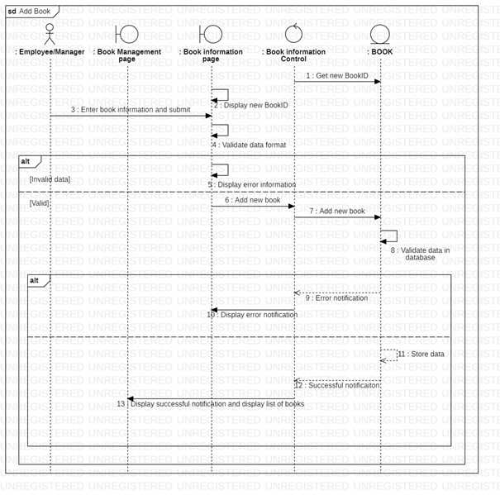

* + - * 1. Update book

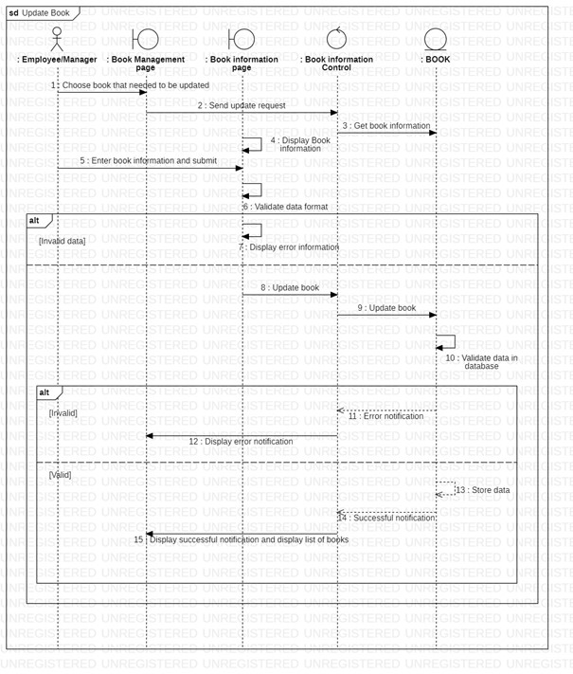

* + - * 1. Delete book

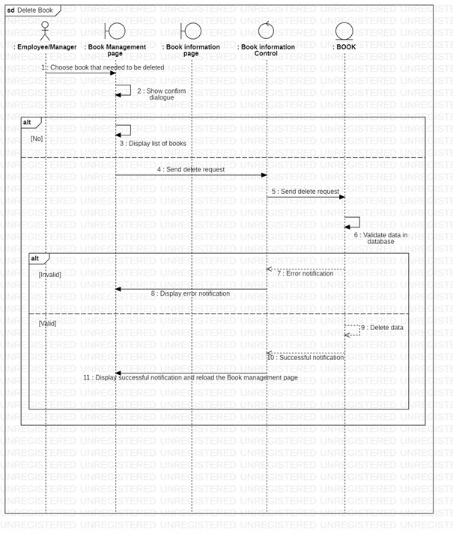

* + - * 1. Search book

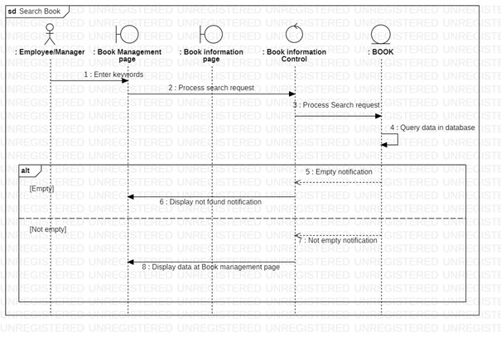

* + - 1. Activity diagram

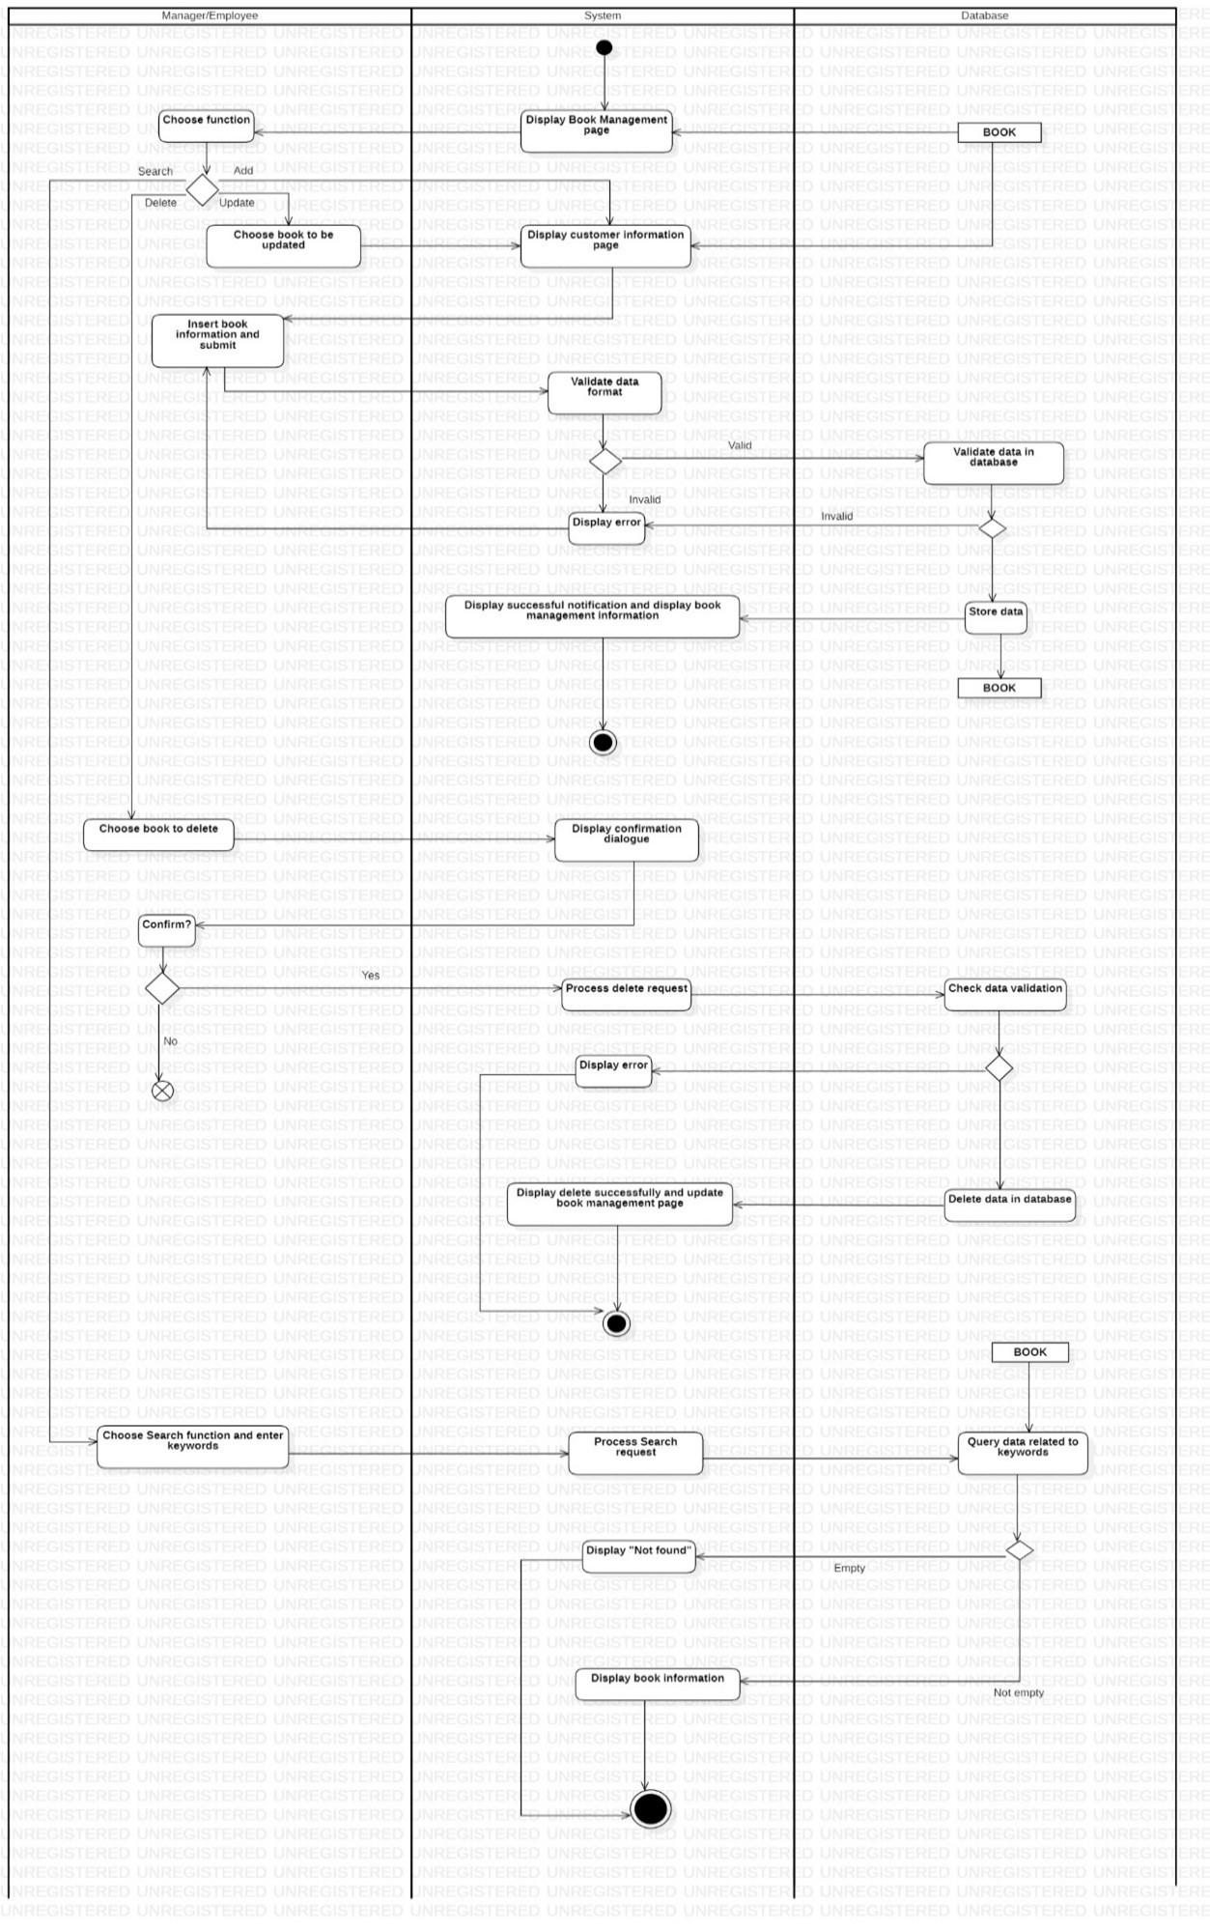

* + 1. Manage Book purchase
       1. Sequence diagram

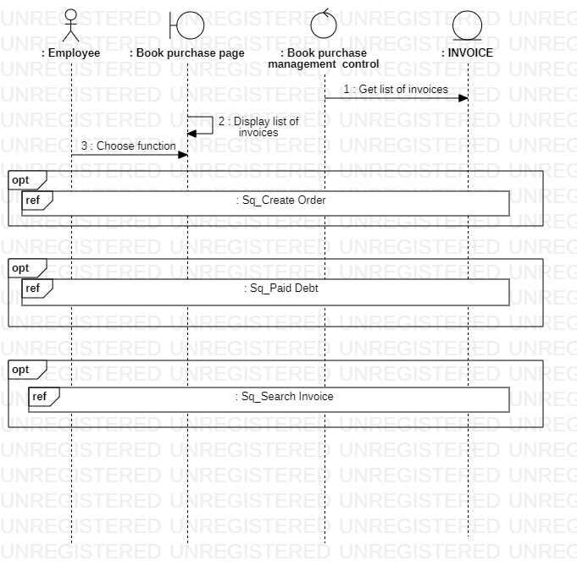

* + - * 1. Create Order

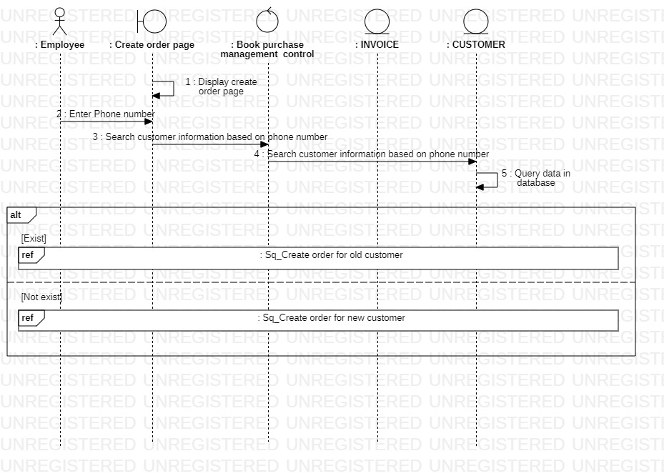

* + - * 1. Old customer

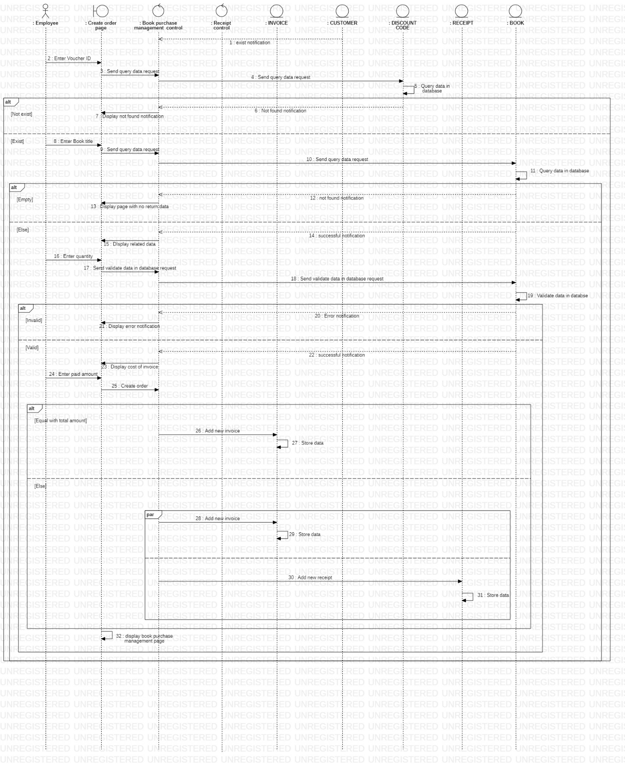

* + - * 1. New customer

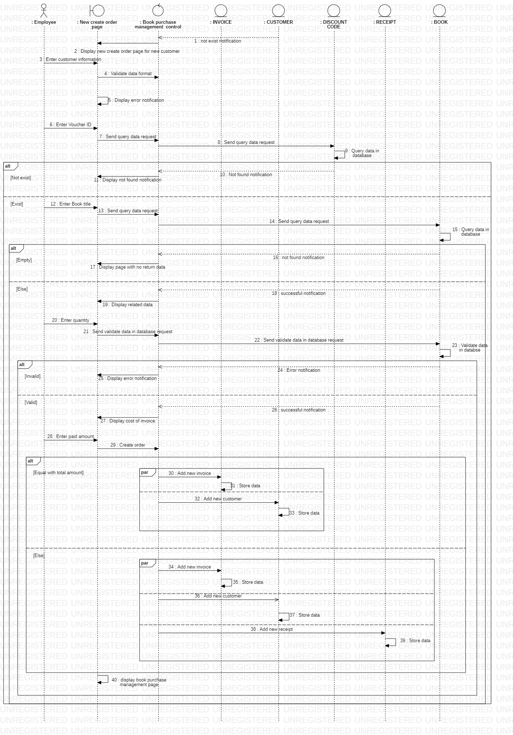

* + - * 1. Pay Debt

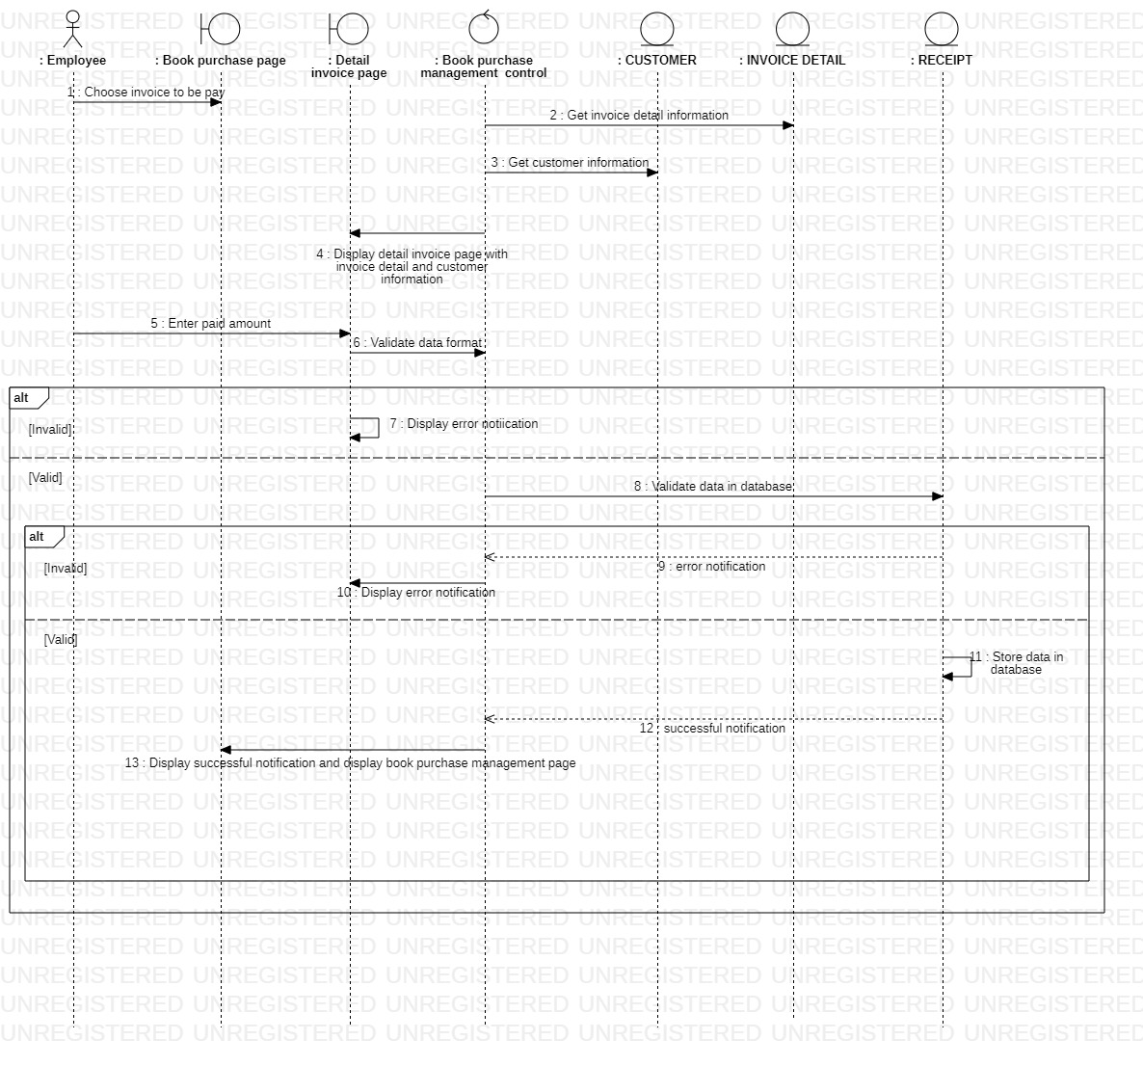

* + - * 1. Search Order

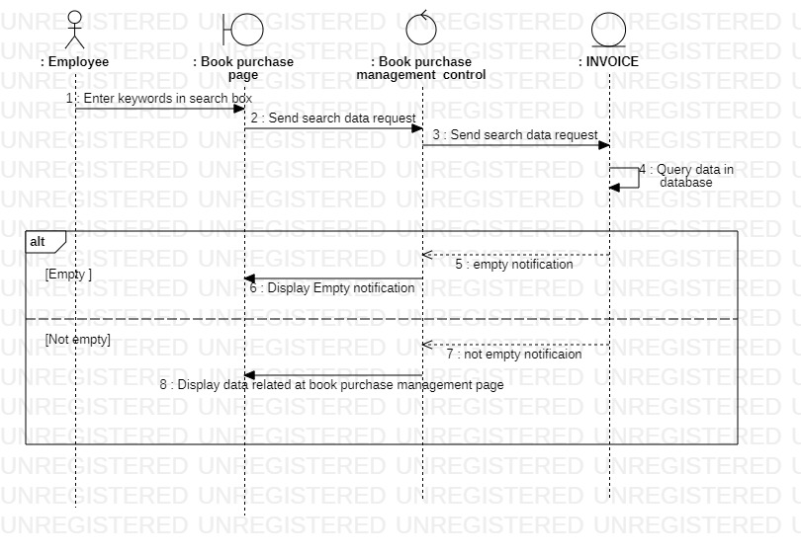

* + - 1. Activity diagram

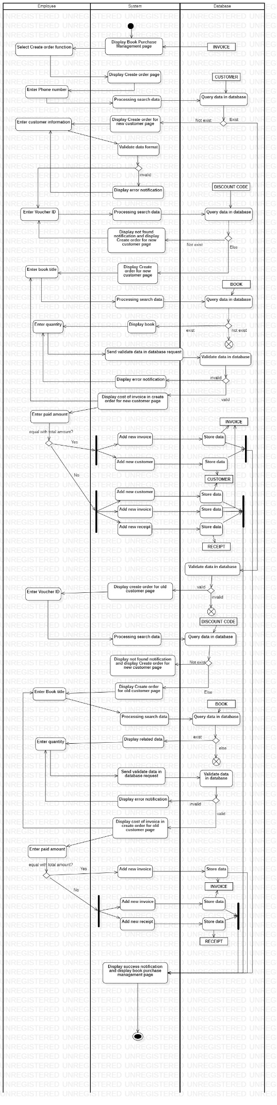

* + 1. Manage Book rental
       1. Sequence diagram

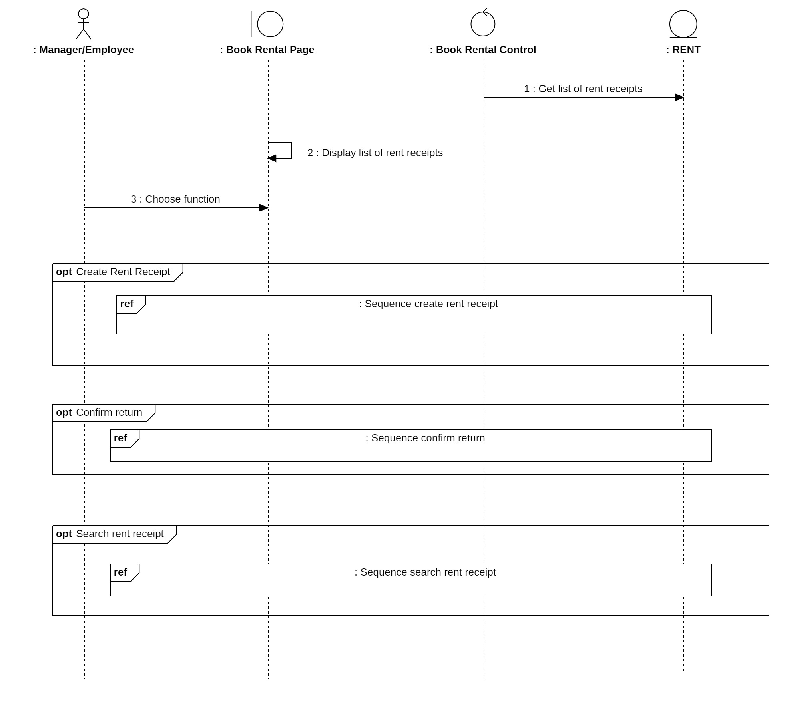

* + - * 1. Create Rent Receipt

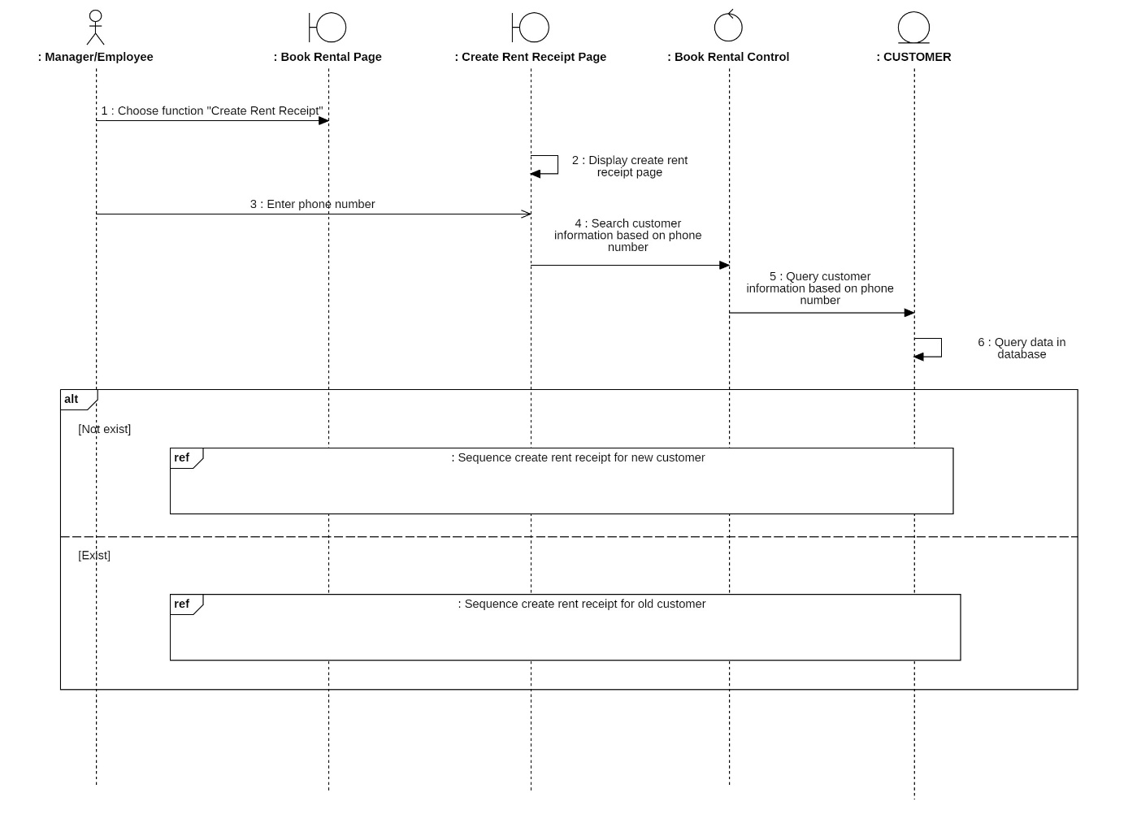

New customer

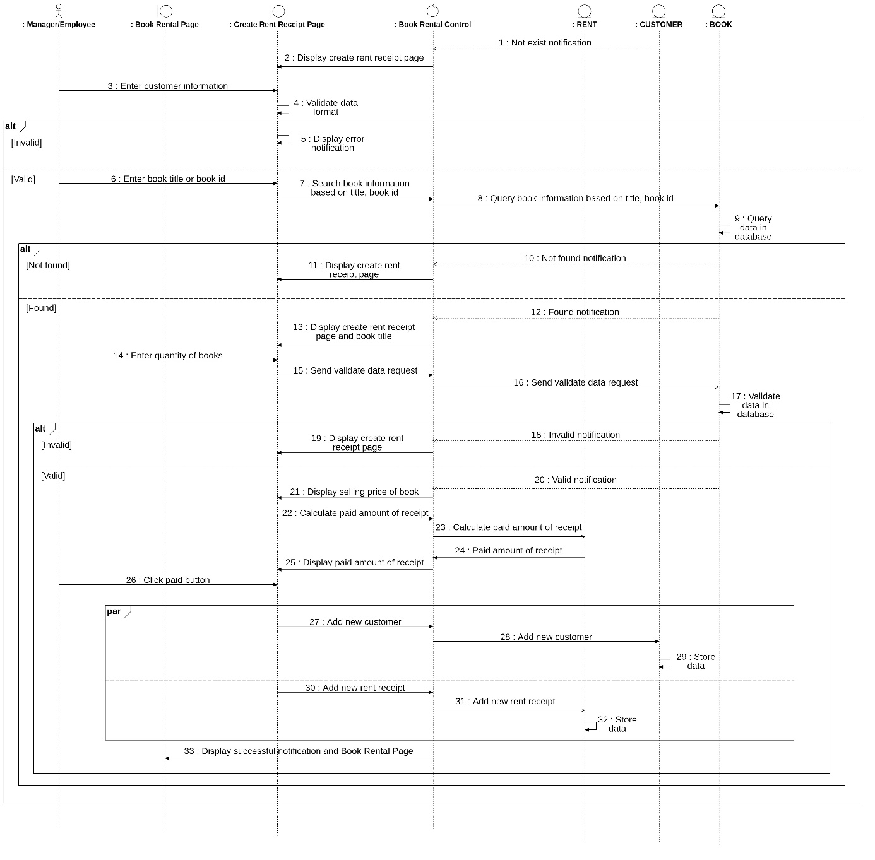

Old customer

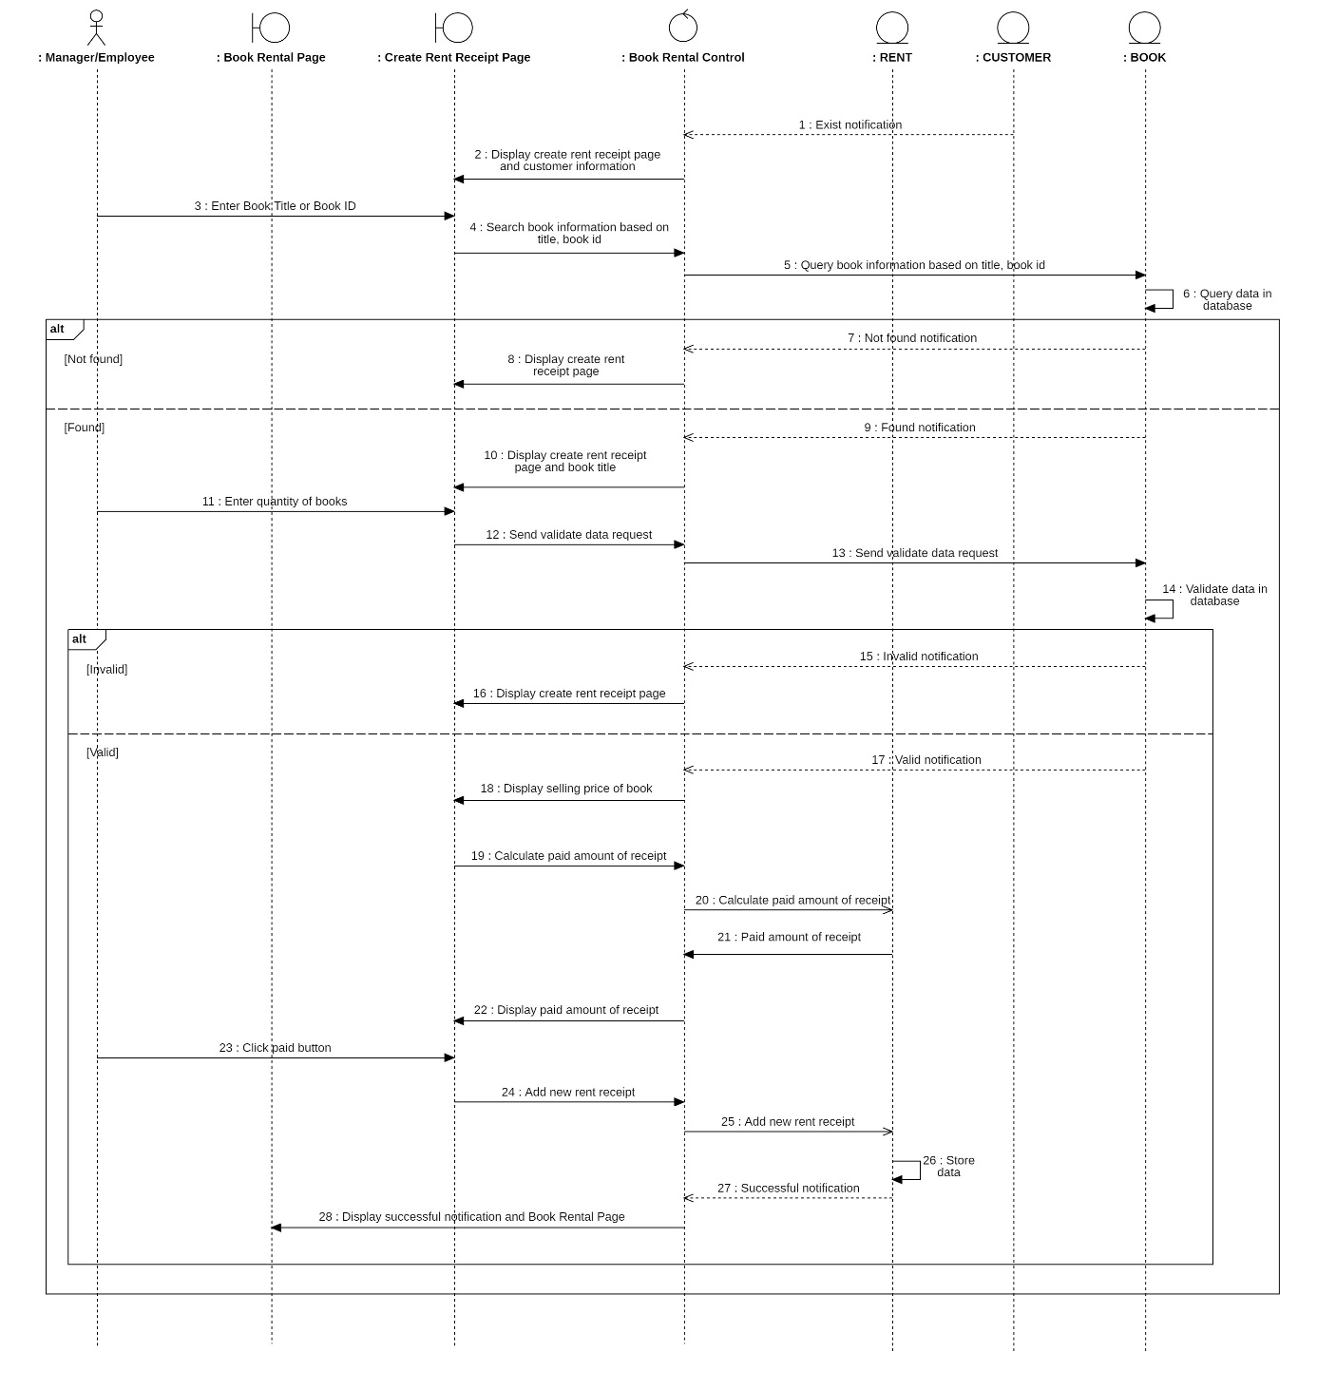

* + - * 1. Confirm return

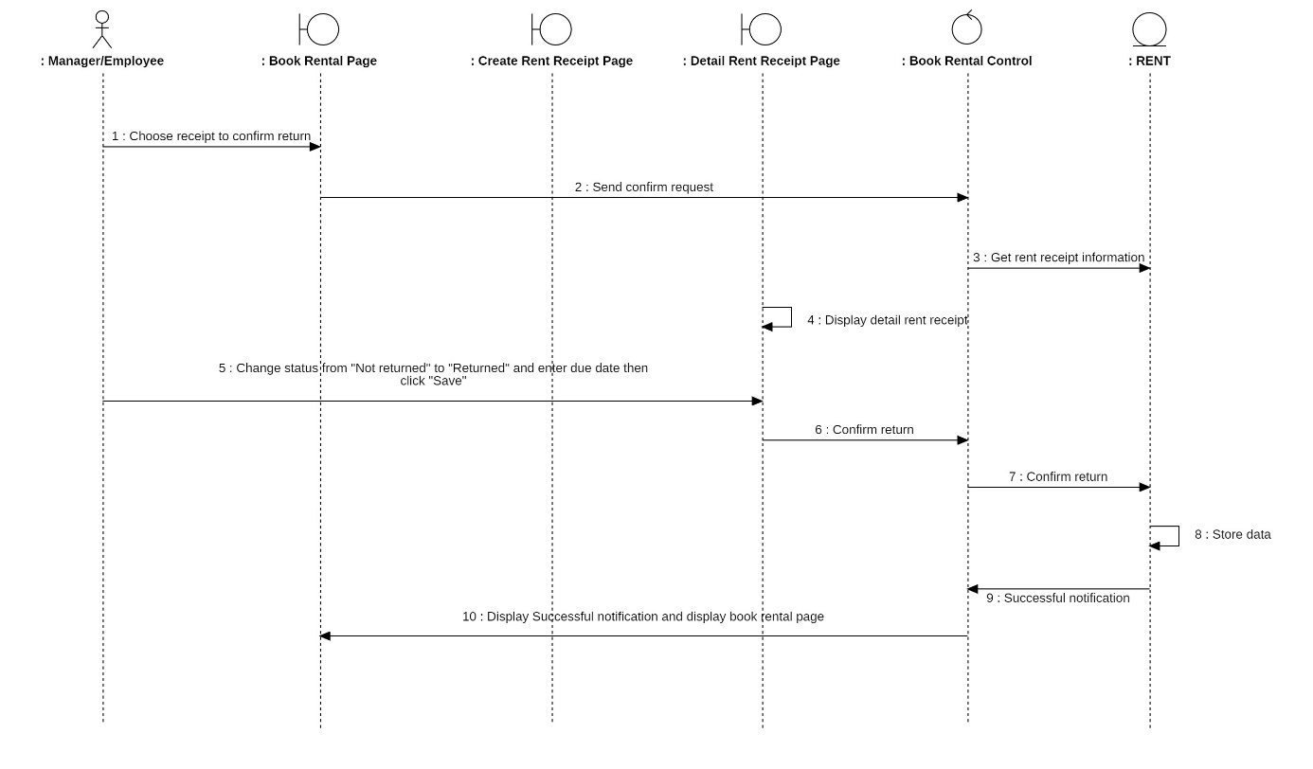

* + - * 1. Search Rent Receipt

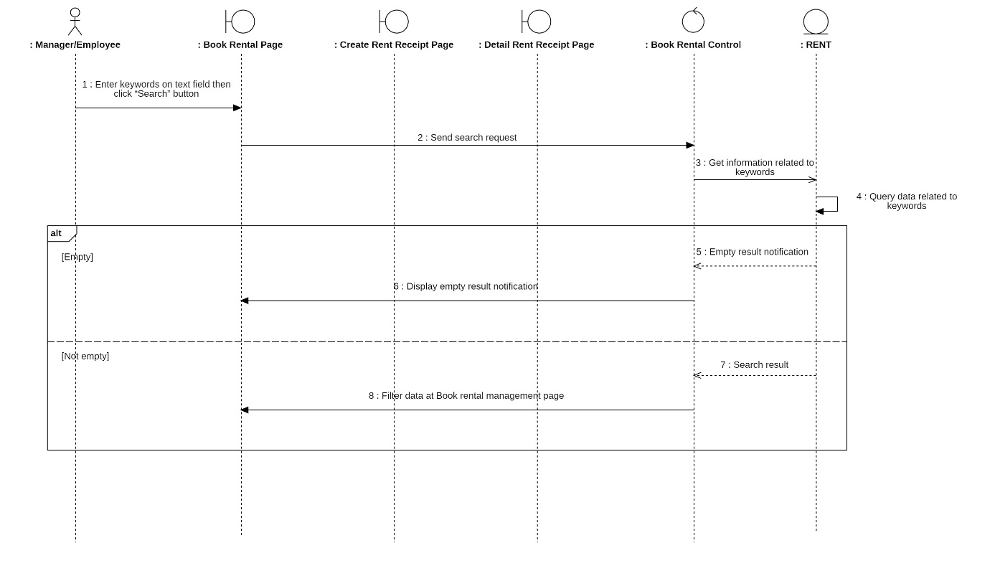

* + - 1. Activity diagram

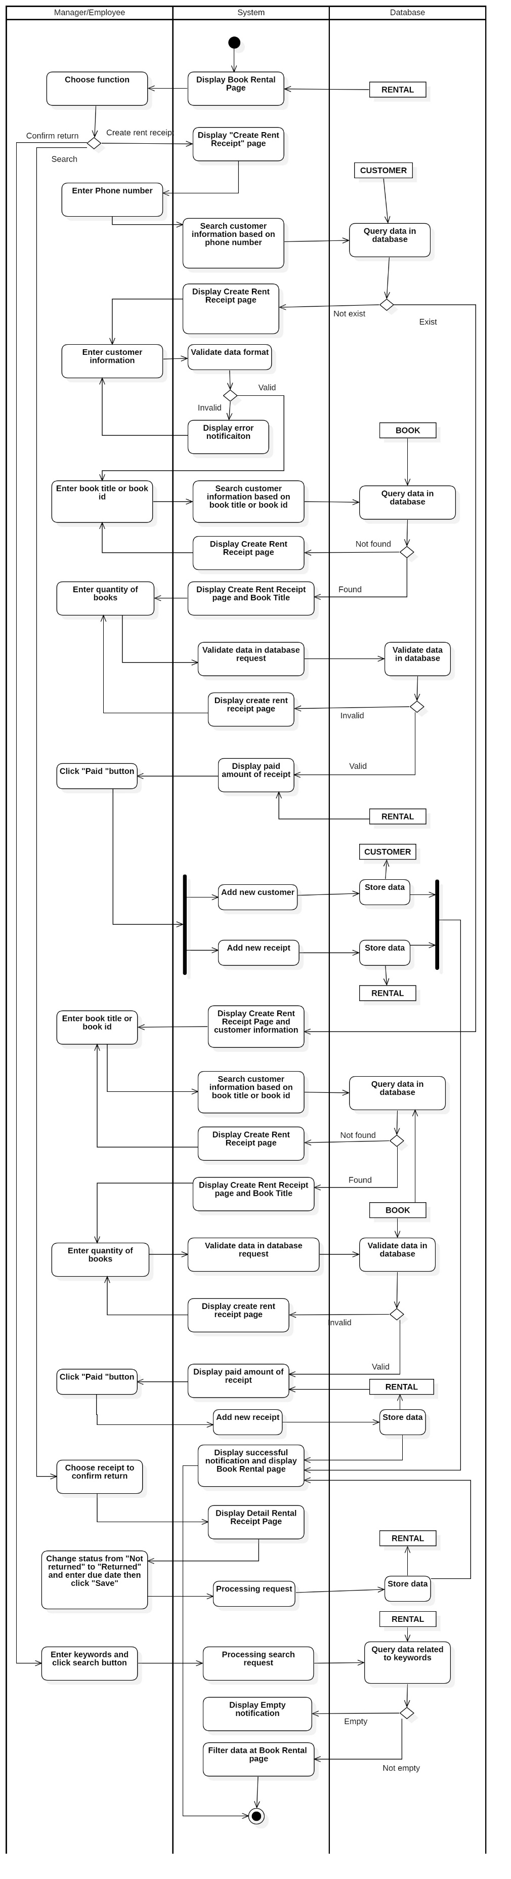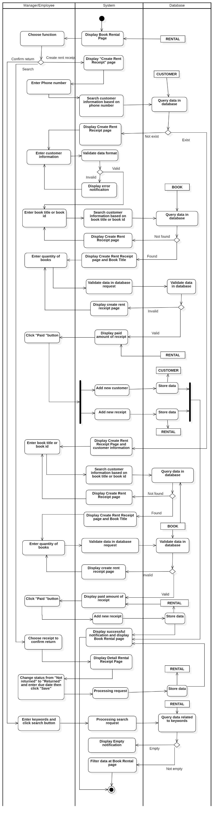

* + 1. Manage Customer
       1. Sequence diagram

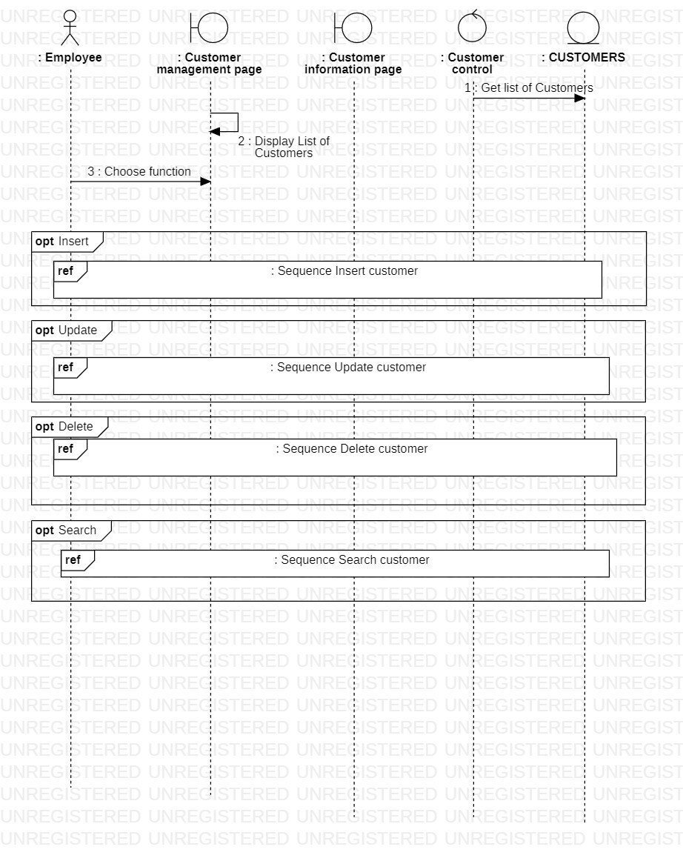

* + - * 1. Add customer

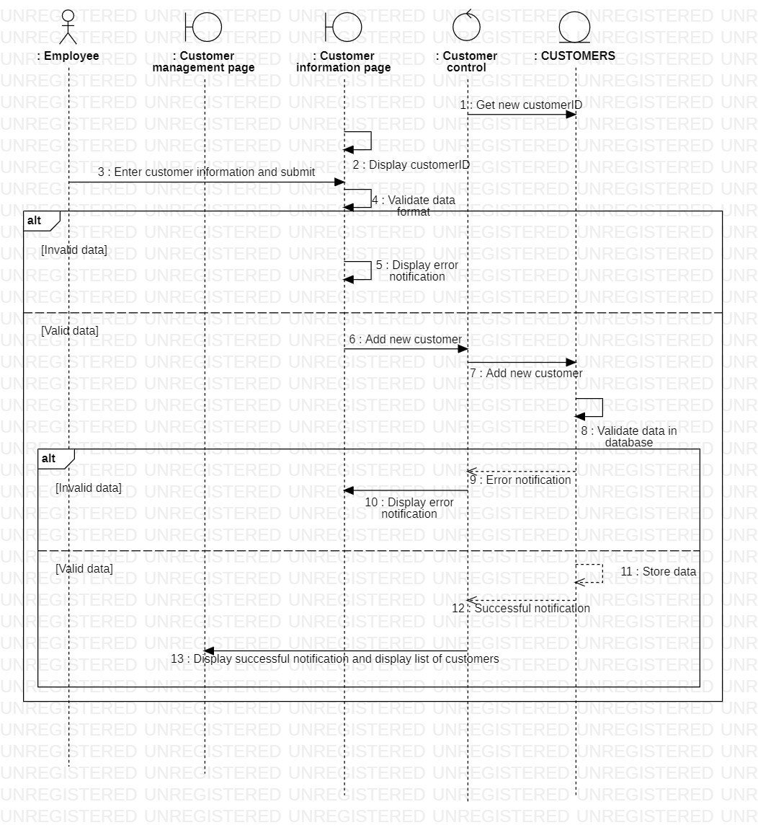

* + - * 1. Update customer

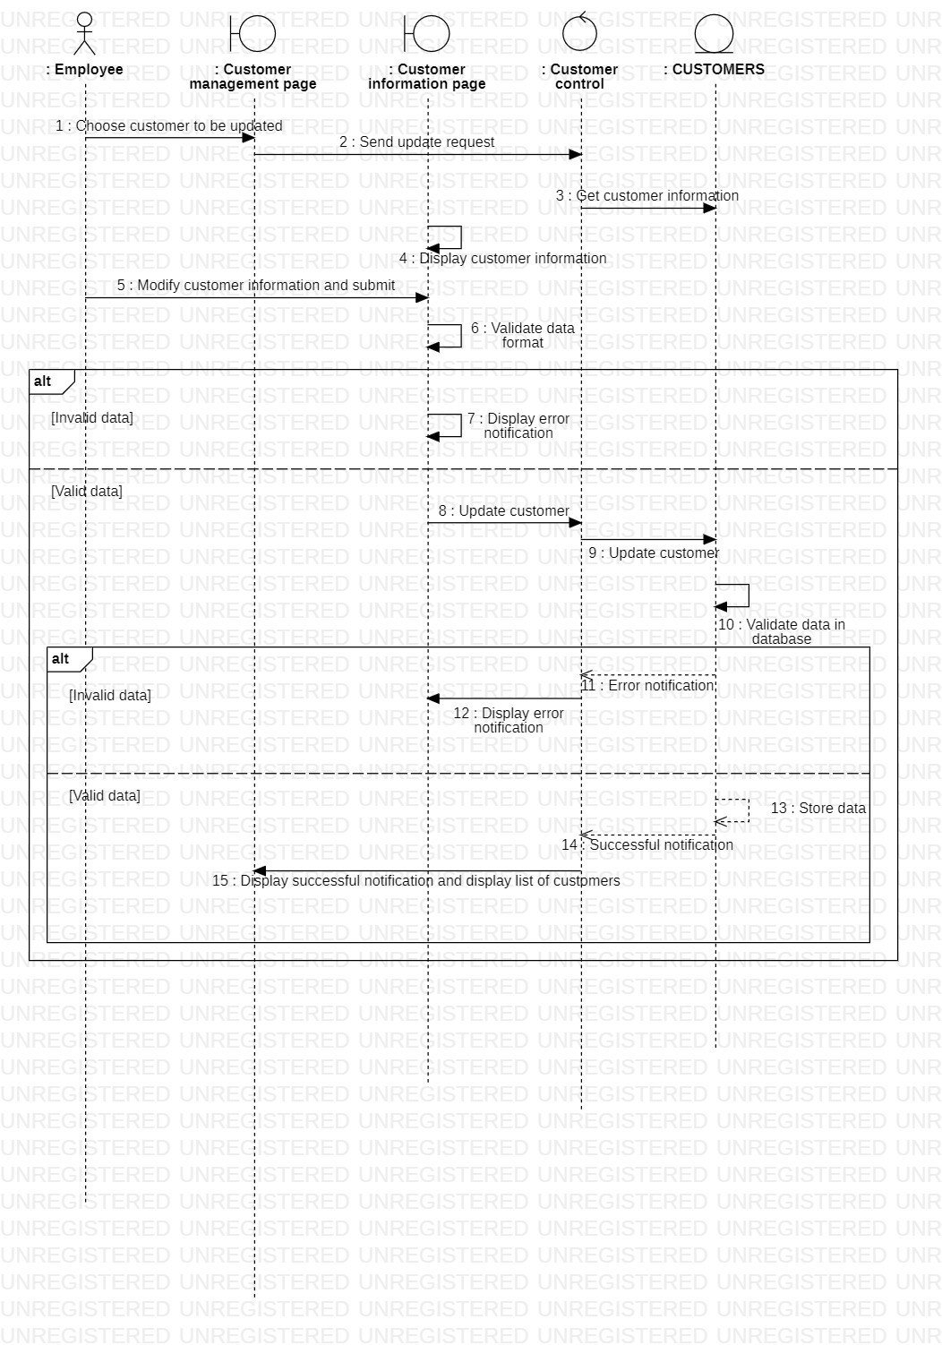

* + - * 1. Delete customer

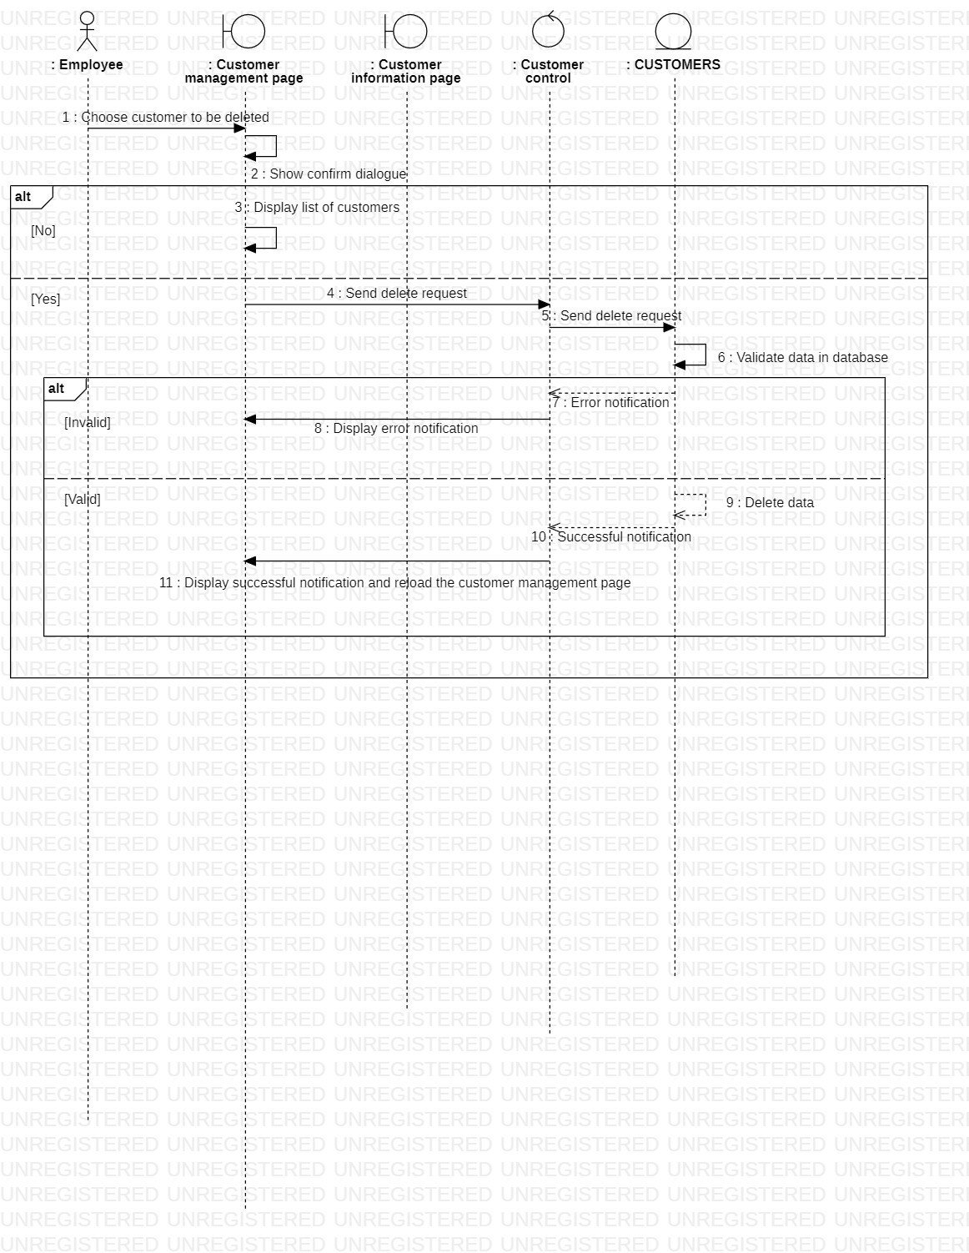

* + - * 1. Search customer

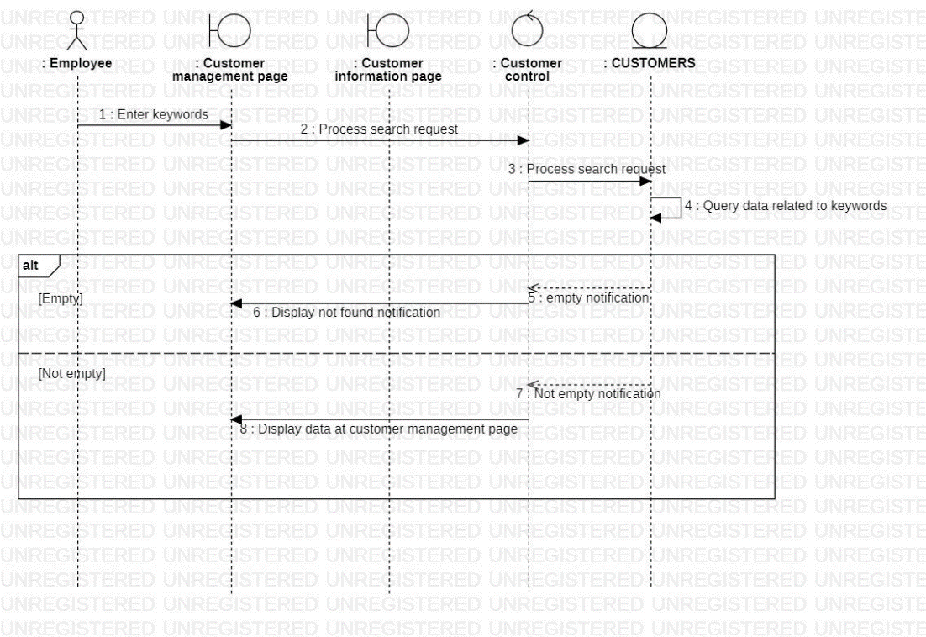

* + - 1. Activity diagram

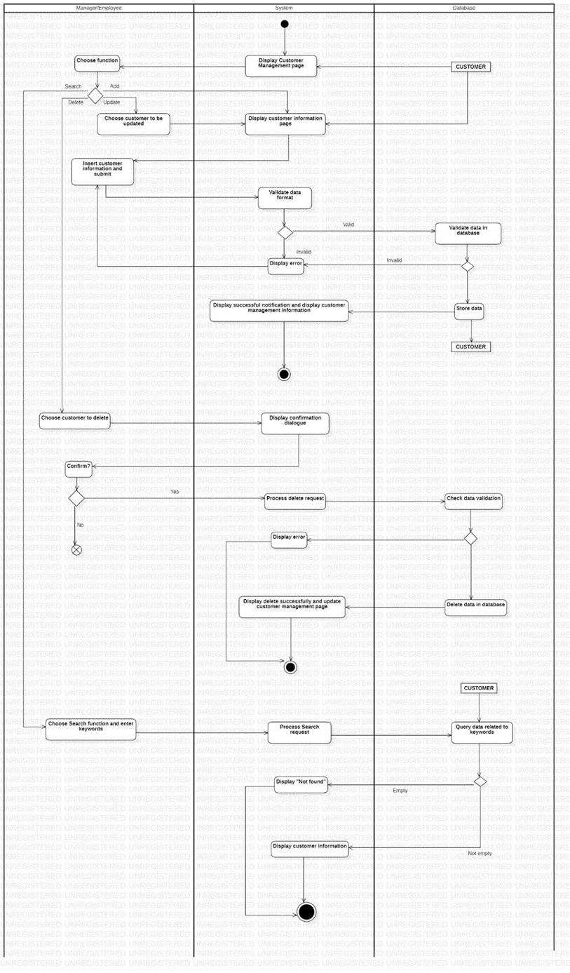

* + 1. Manage Discount code
       1. Sequence diagram

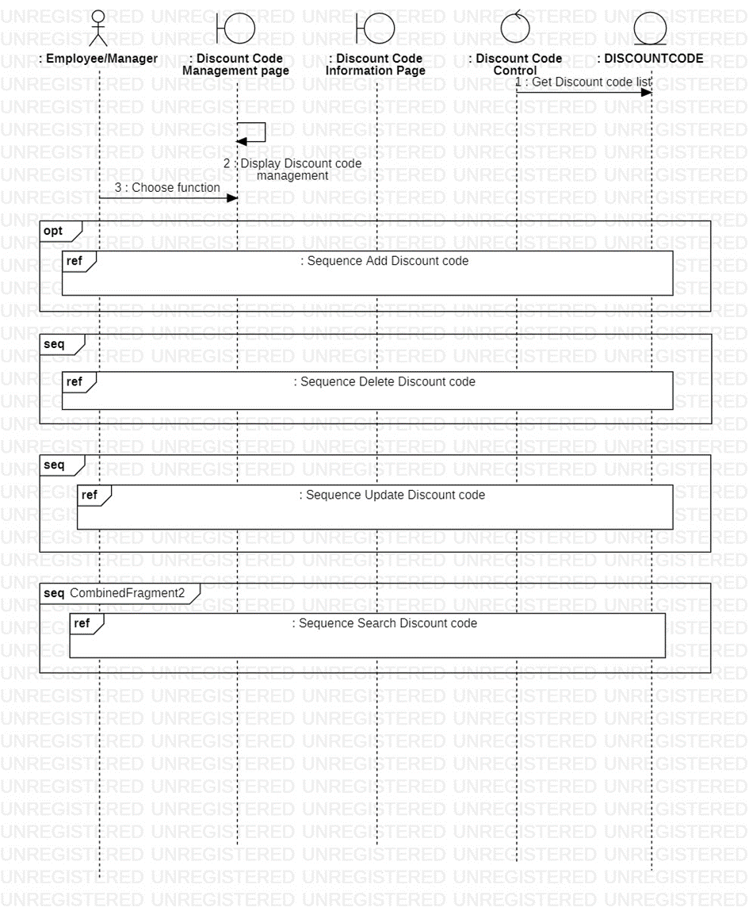

* + - * 1. Add Discount code

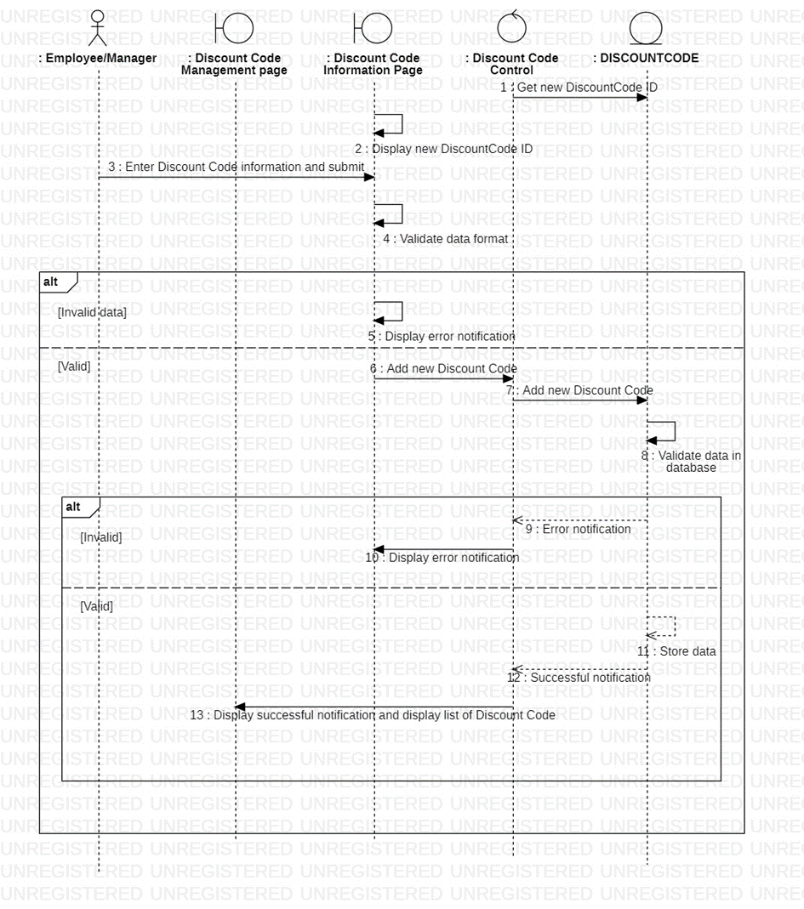

* + - * 1. Update Discount code

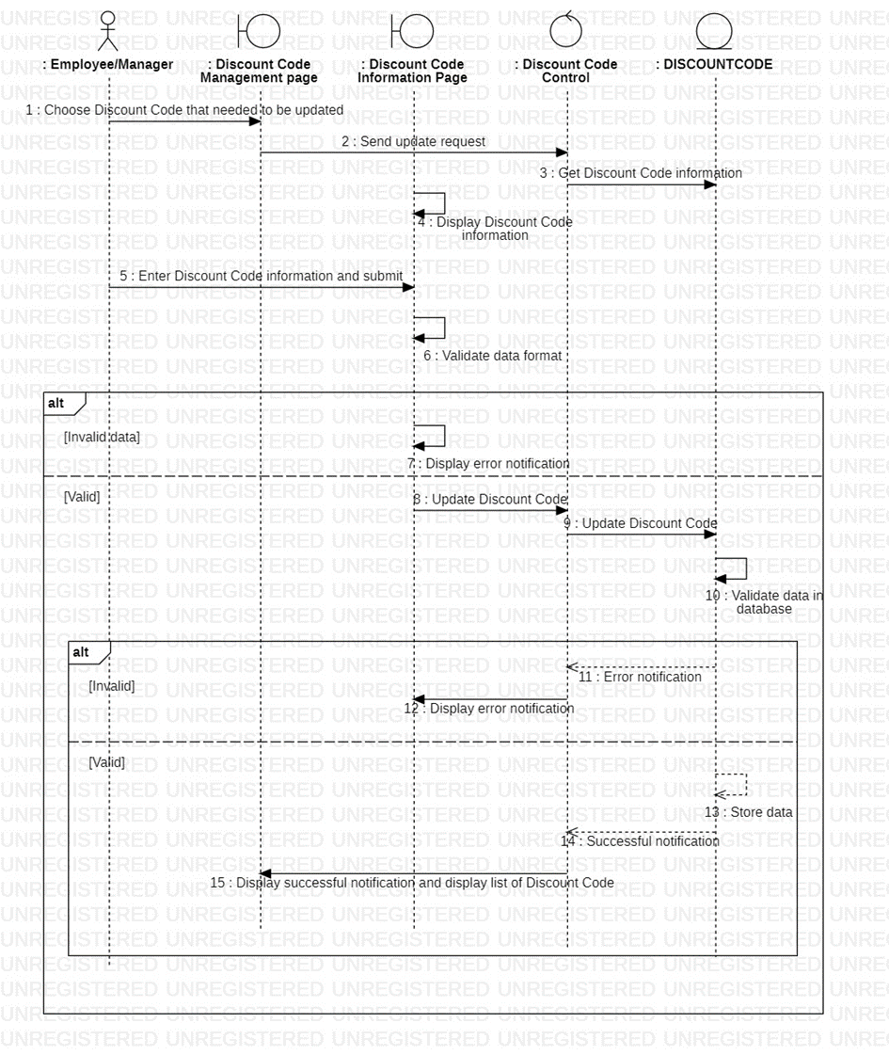

* + - * 1. Delete Discount code

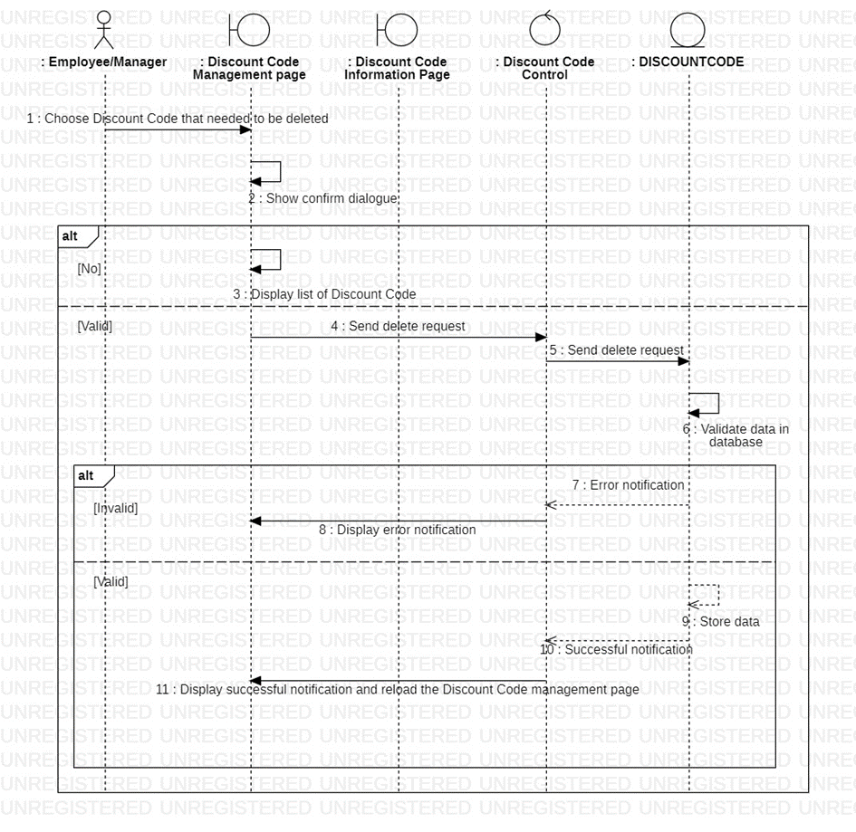

* + - * 1. Search Discount code

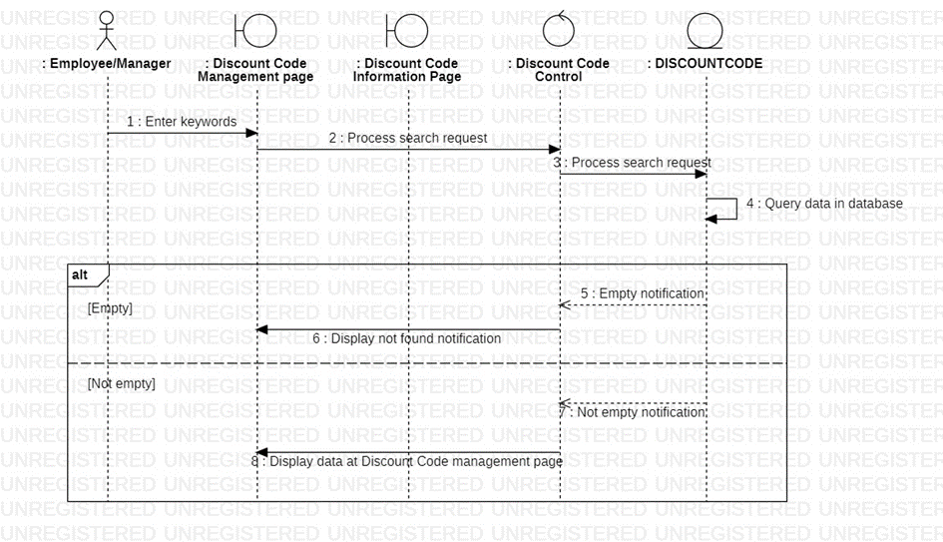

* + - 1. Activity diagram

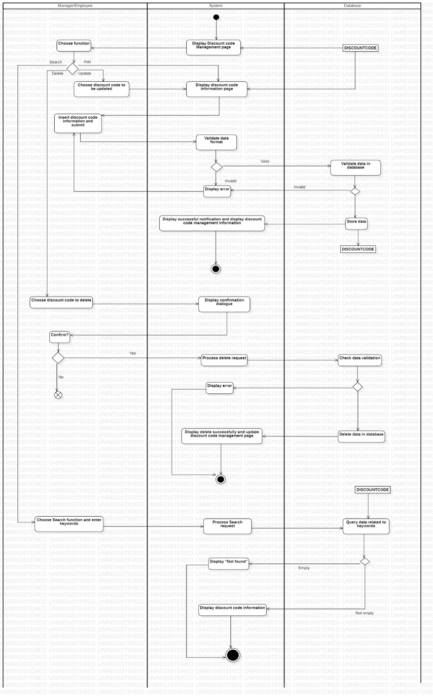

* + 1. Manage Supplier
       1. Sequence diagram

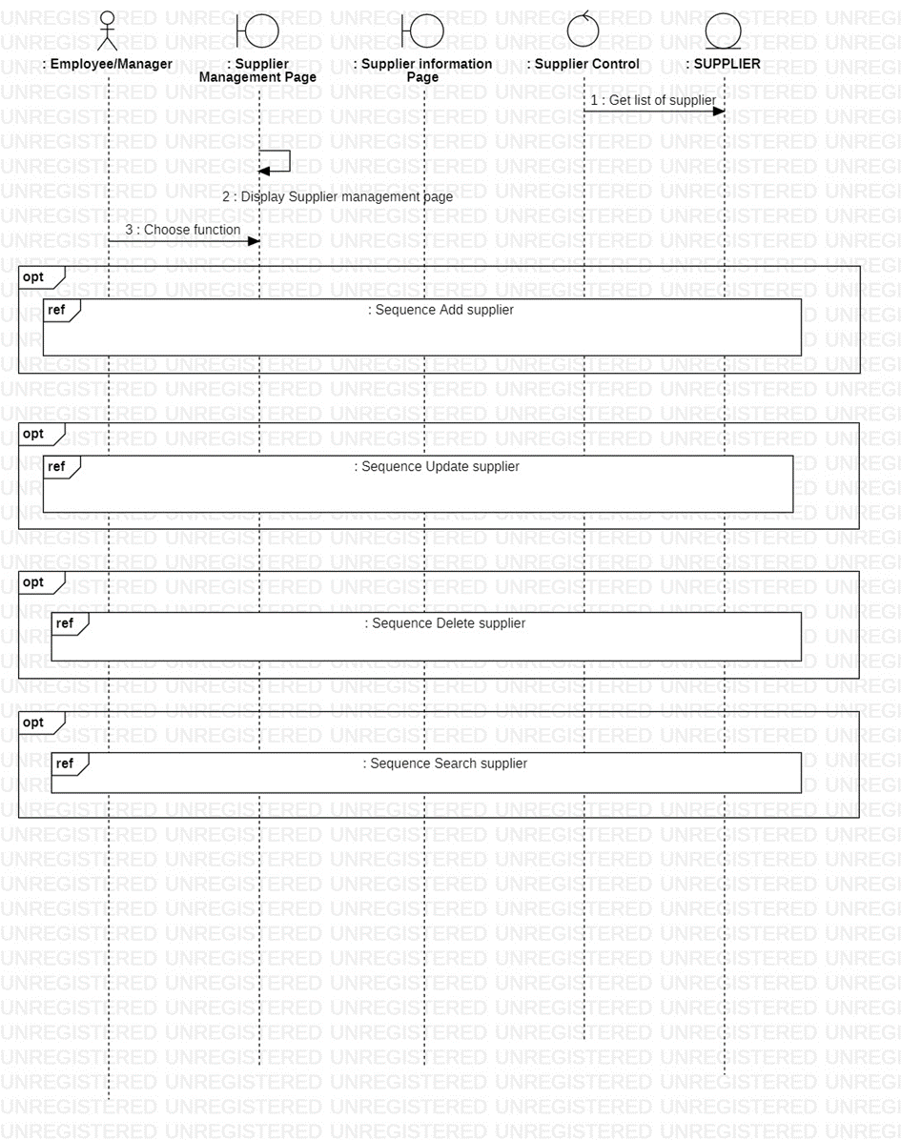

* + - * 1. Add supplier

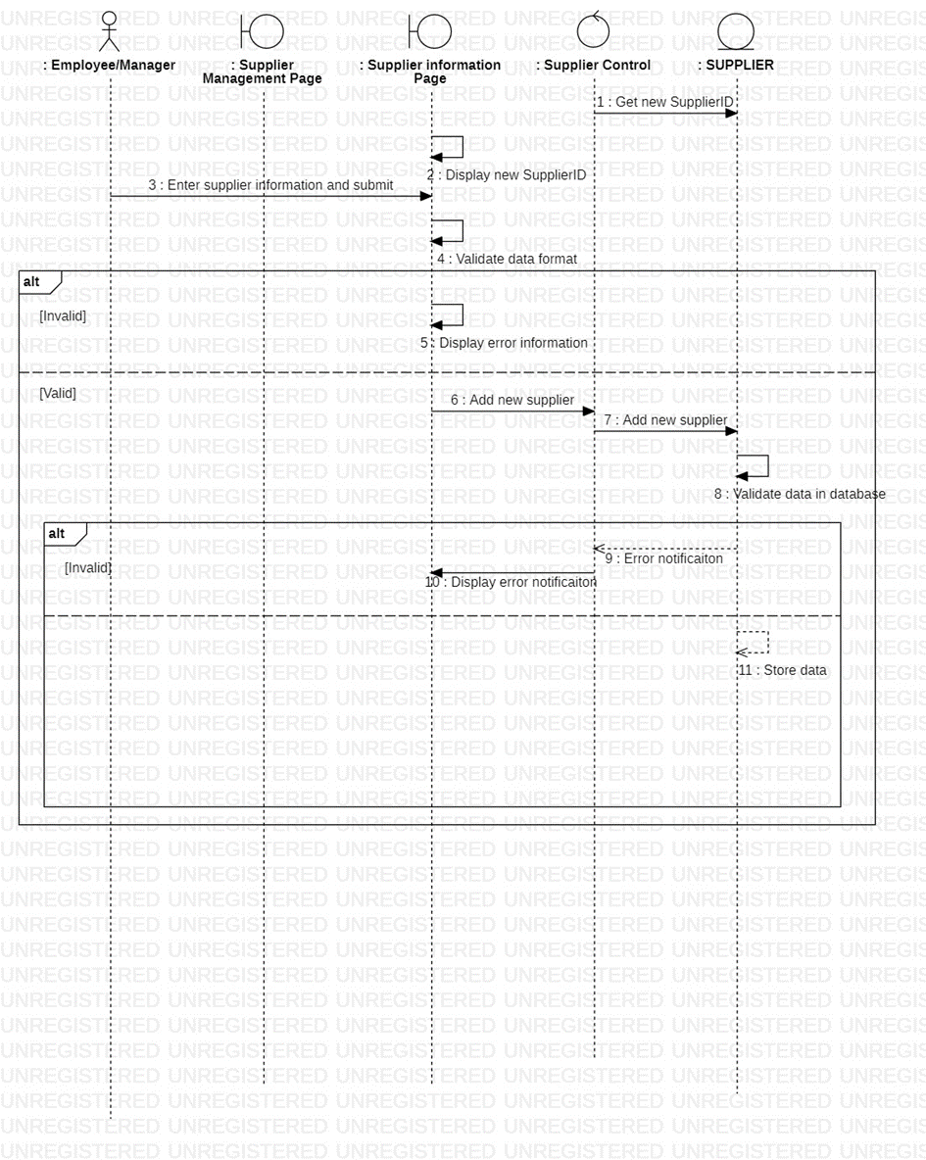

* + - * 1. Update supplier

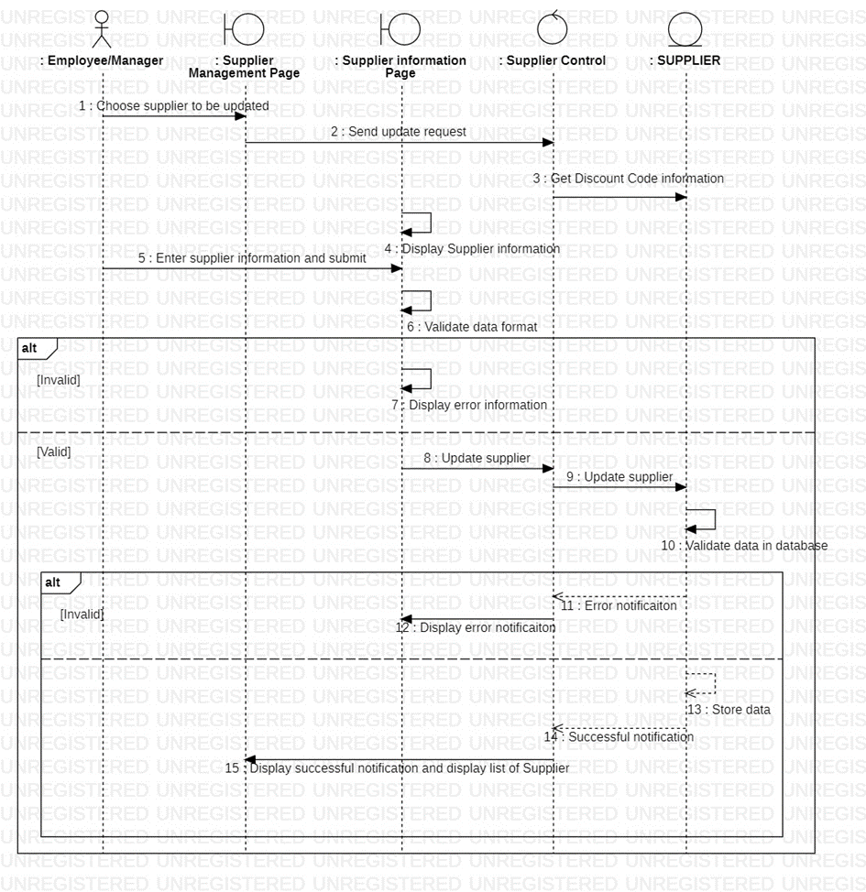

* + - * 1. Delete supplier

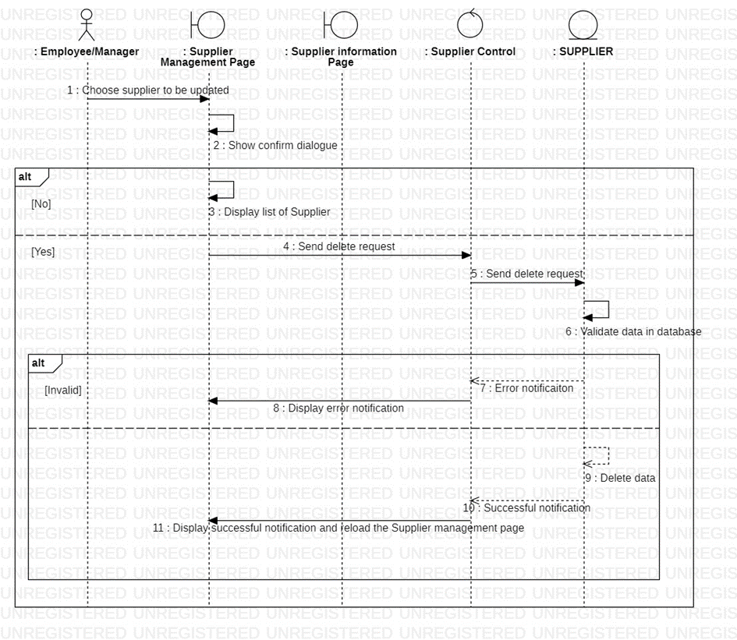

* + - * 1. Search supplier

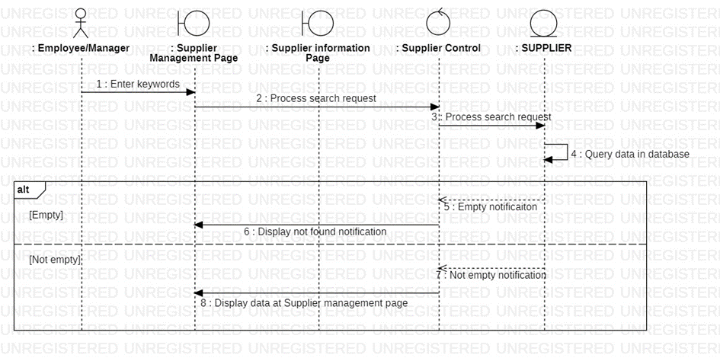

* + - 1. Activity diagram

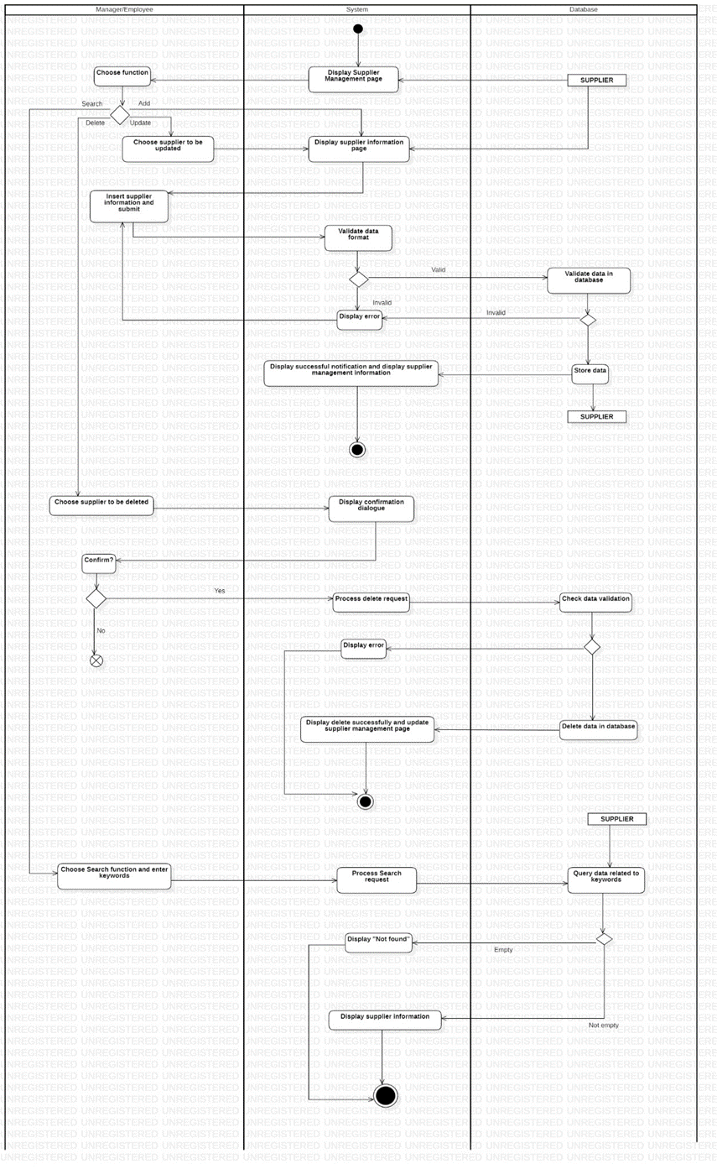

* + 1. Statistics
       1. Sequence diagram

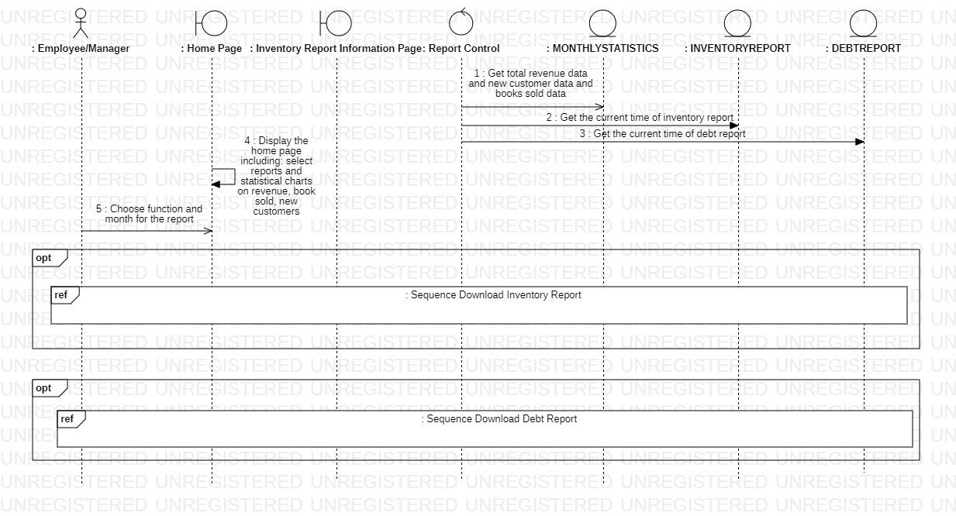

* + - * 1. Download Inventory report

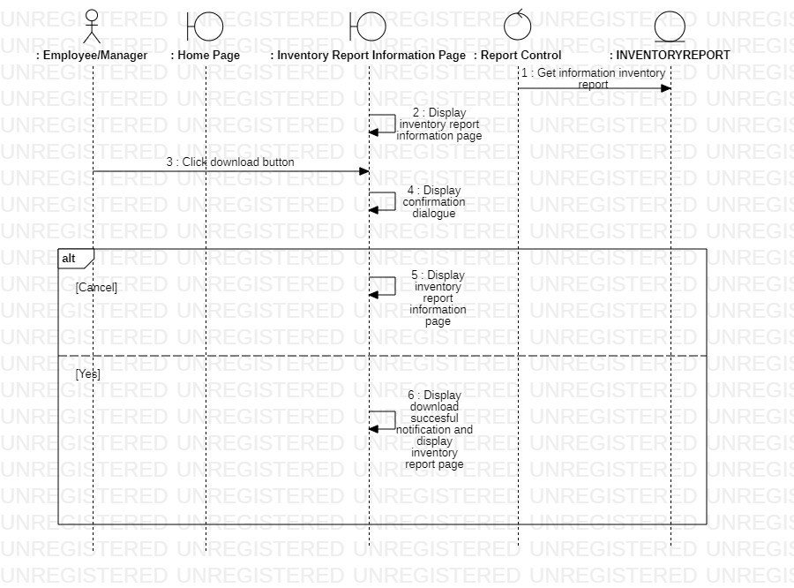

* + - * 1. Download Customer’s Debt report

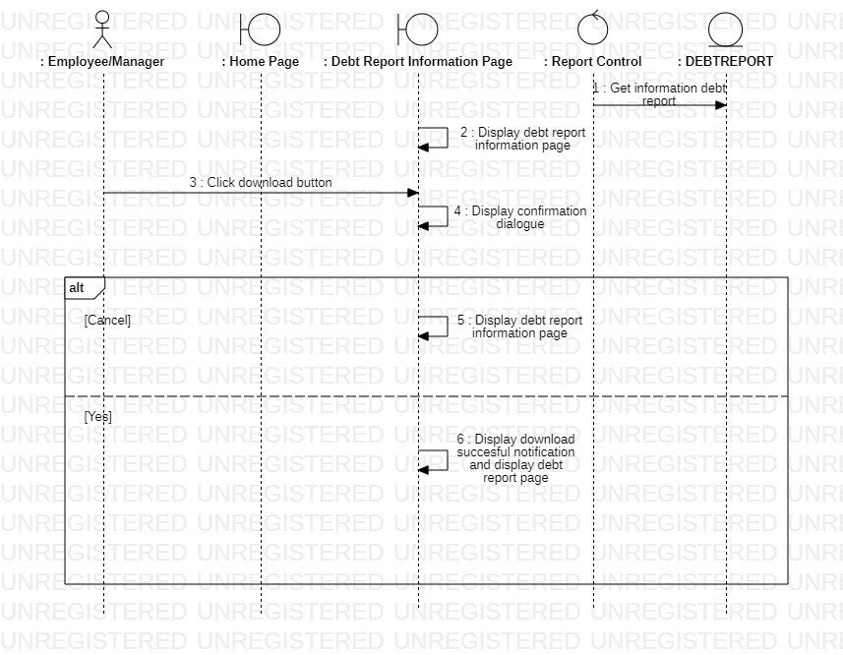

* + - 1. Activity diagram

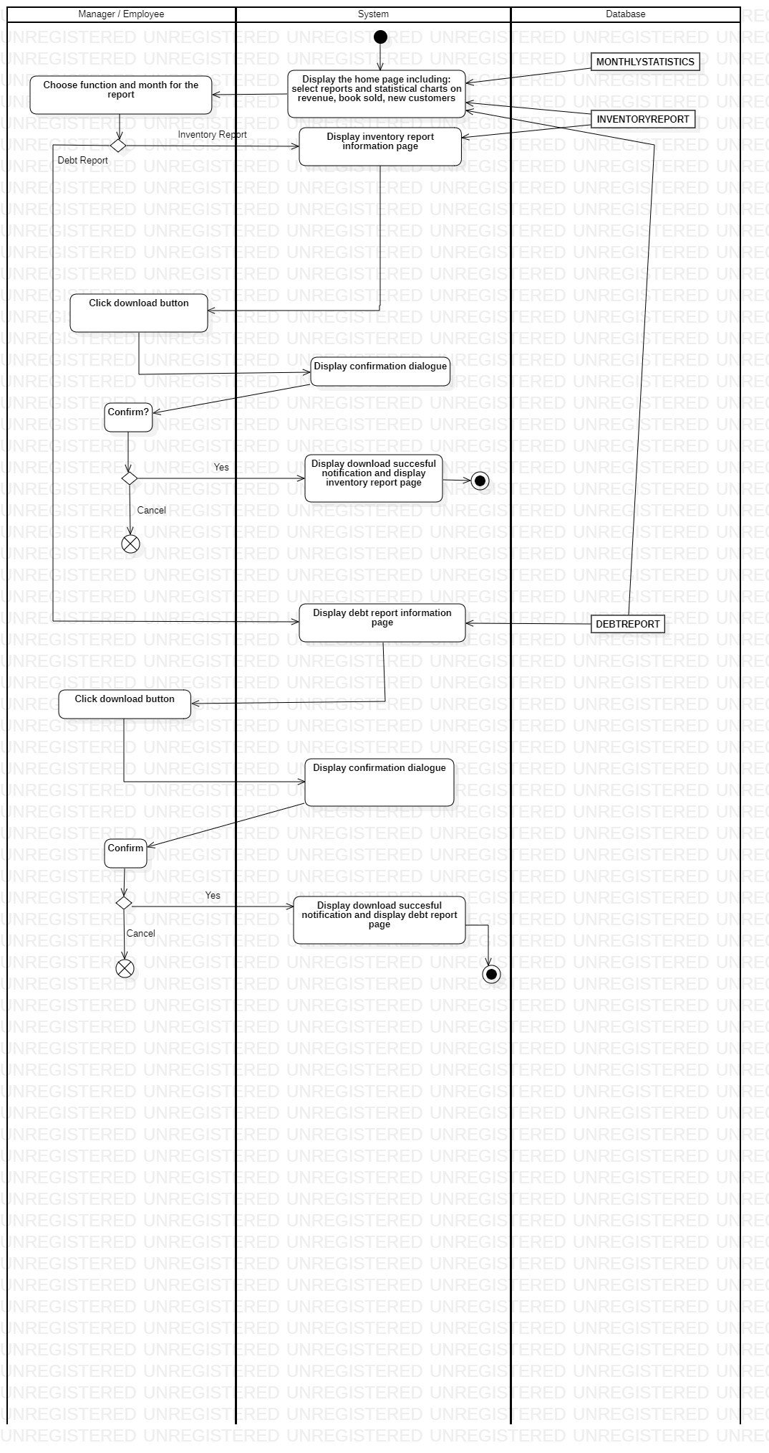

* + 1. Manage User
       1. Sequence diagram

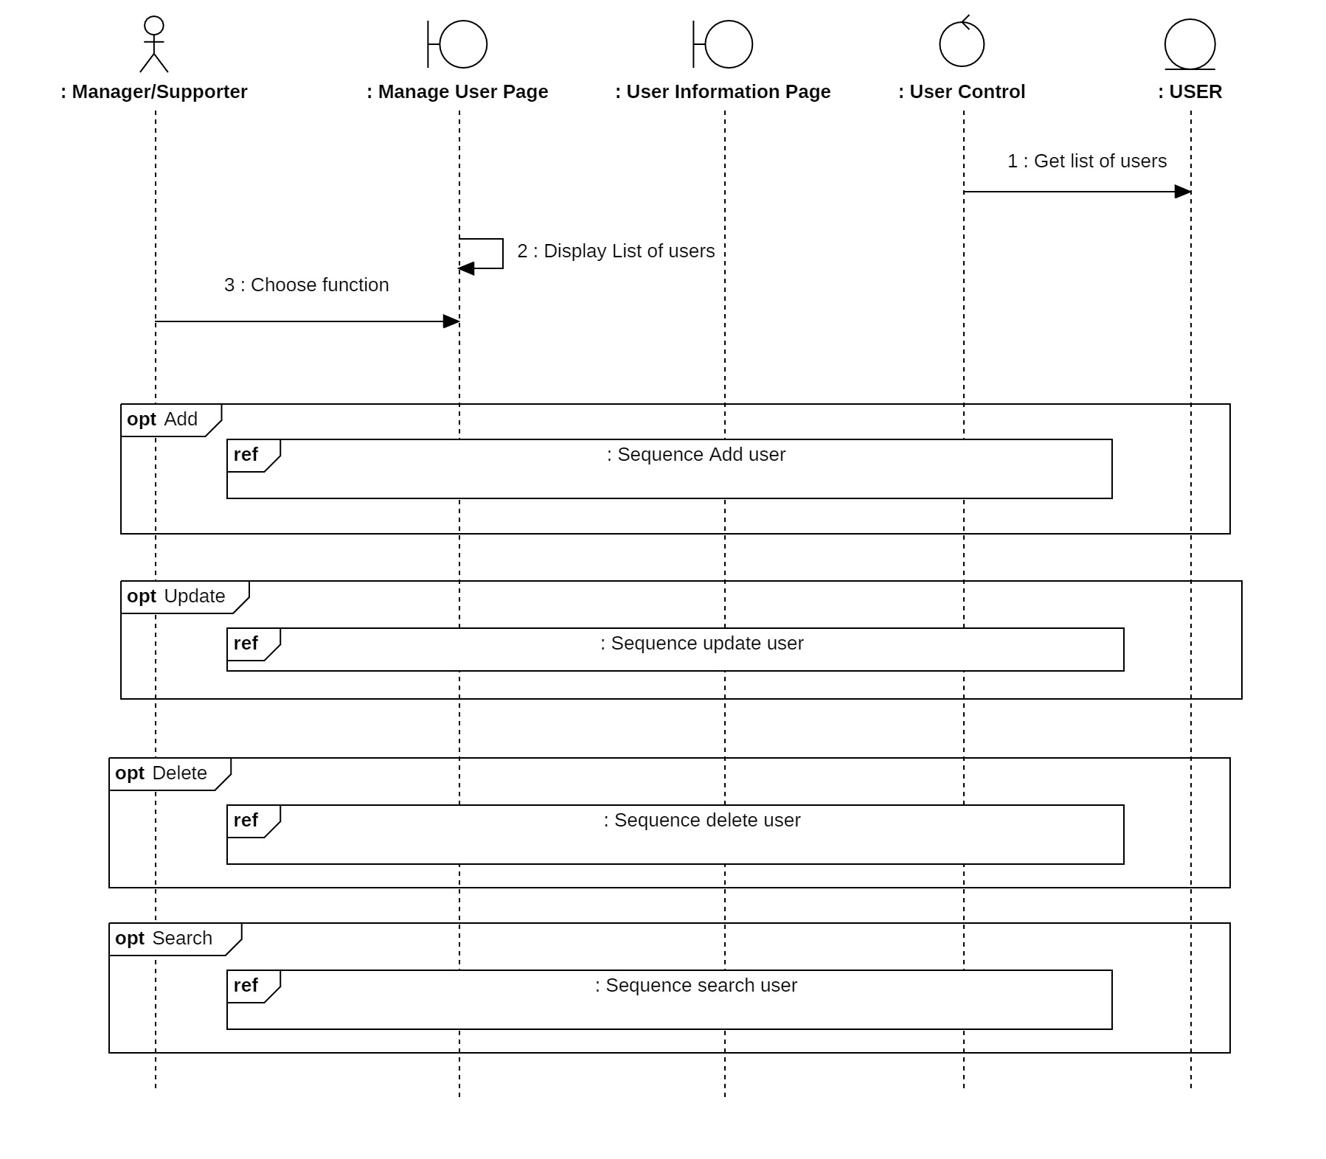

* + - * 1. Add User

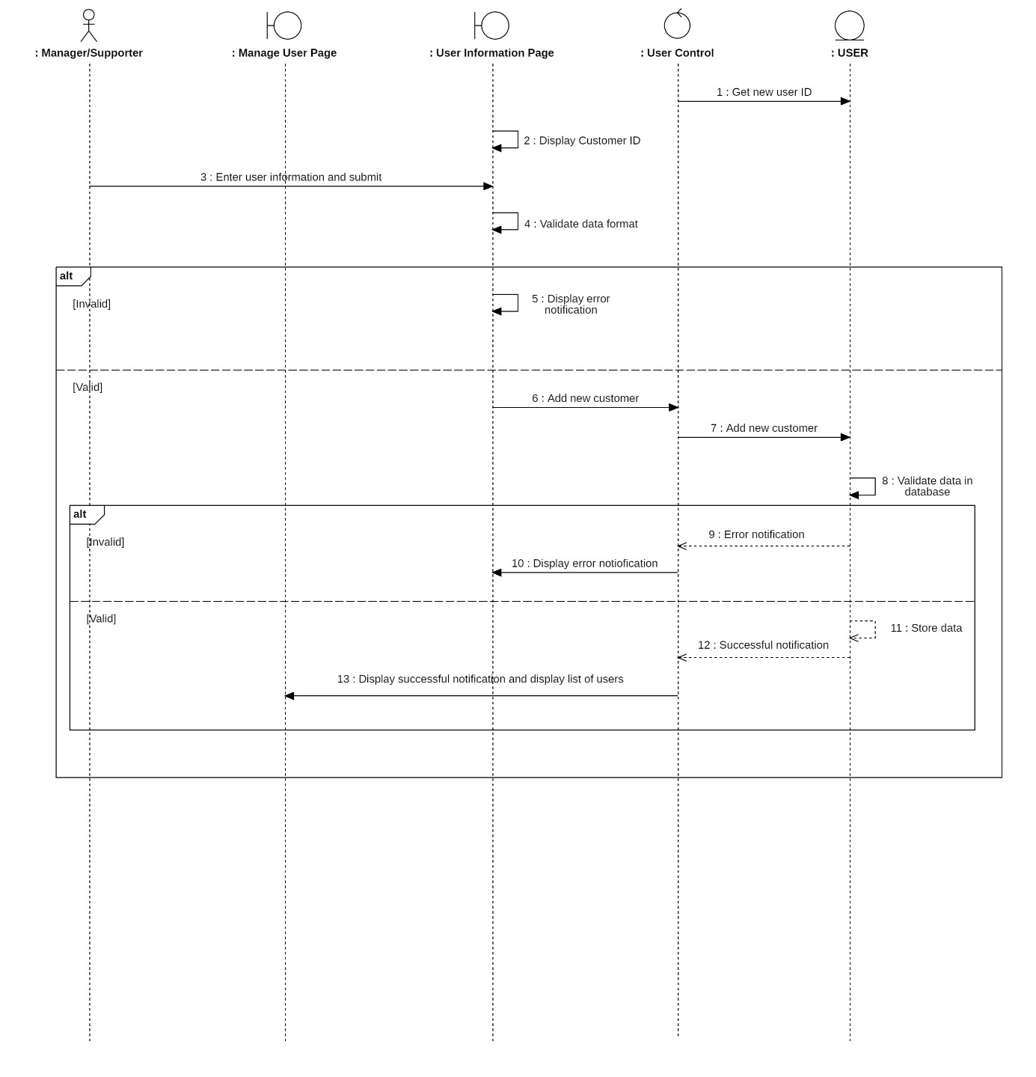

* + - * 1. 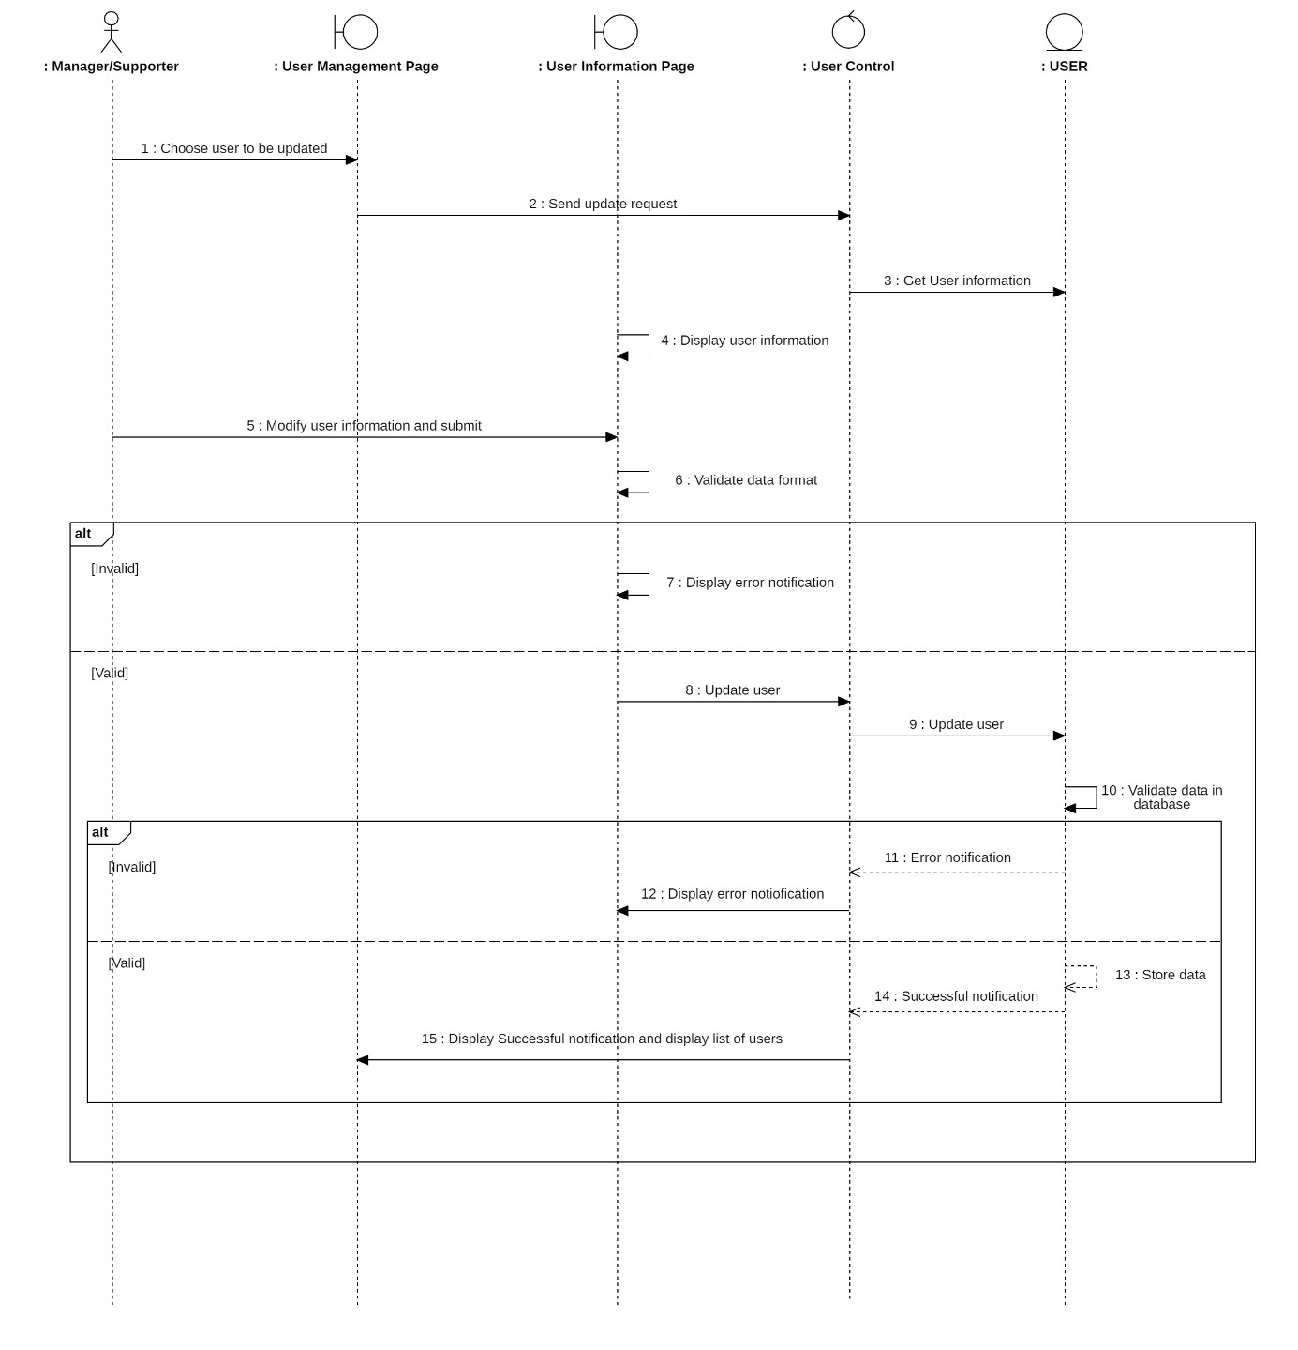Update User
        2. Delete User

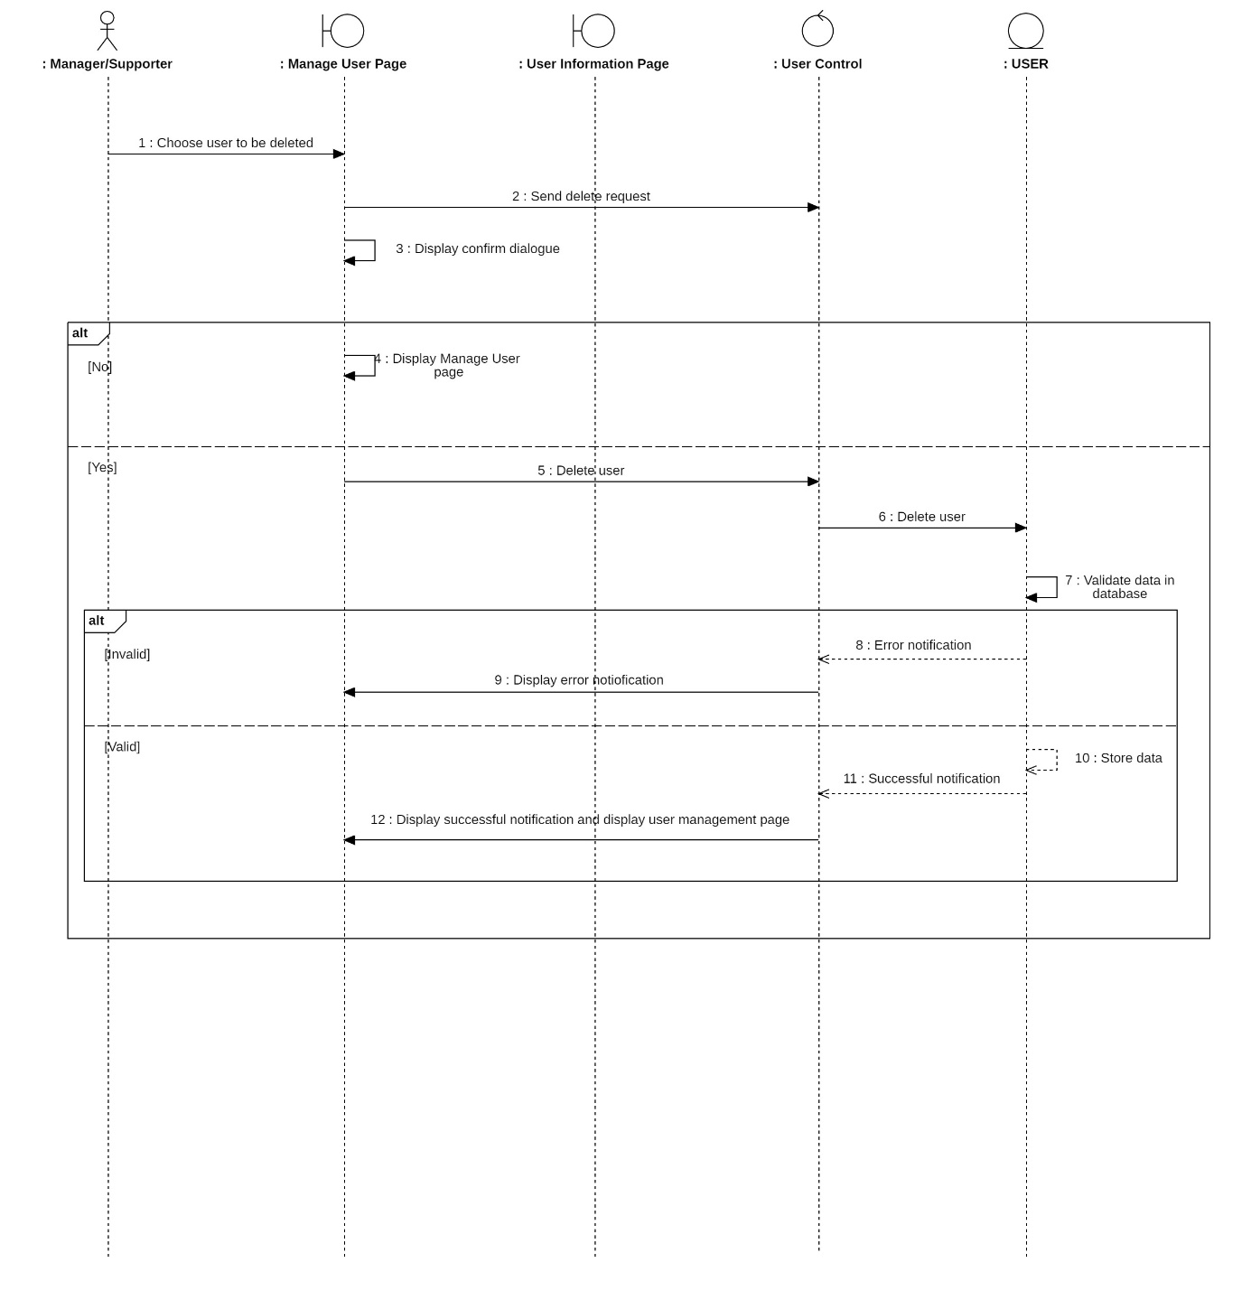

* + - * 1. Search User

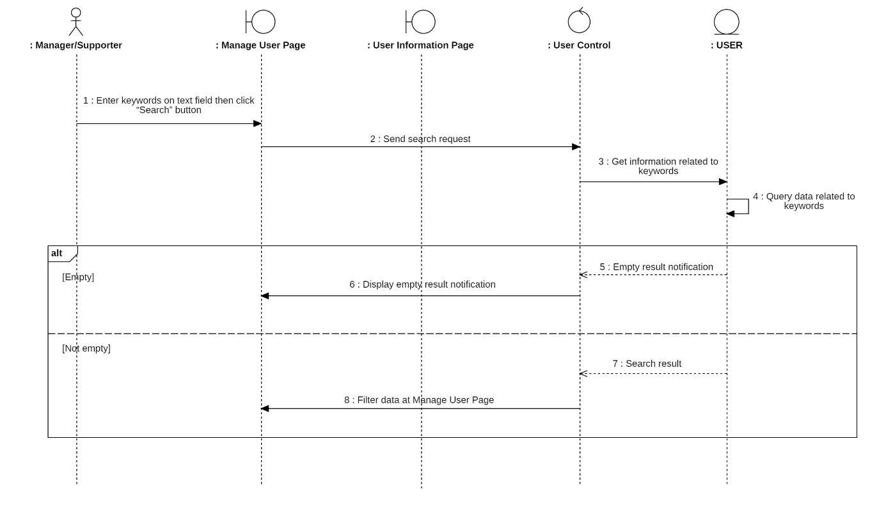

* + - 1. Activity diagram

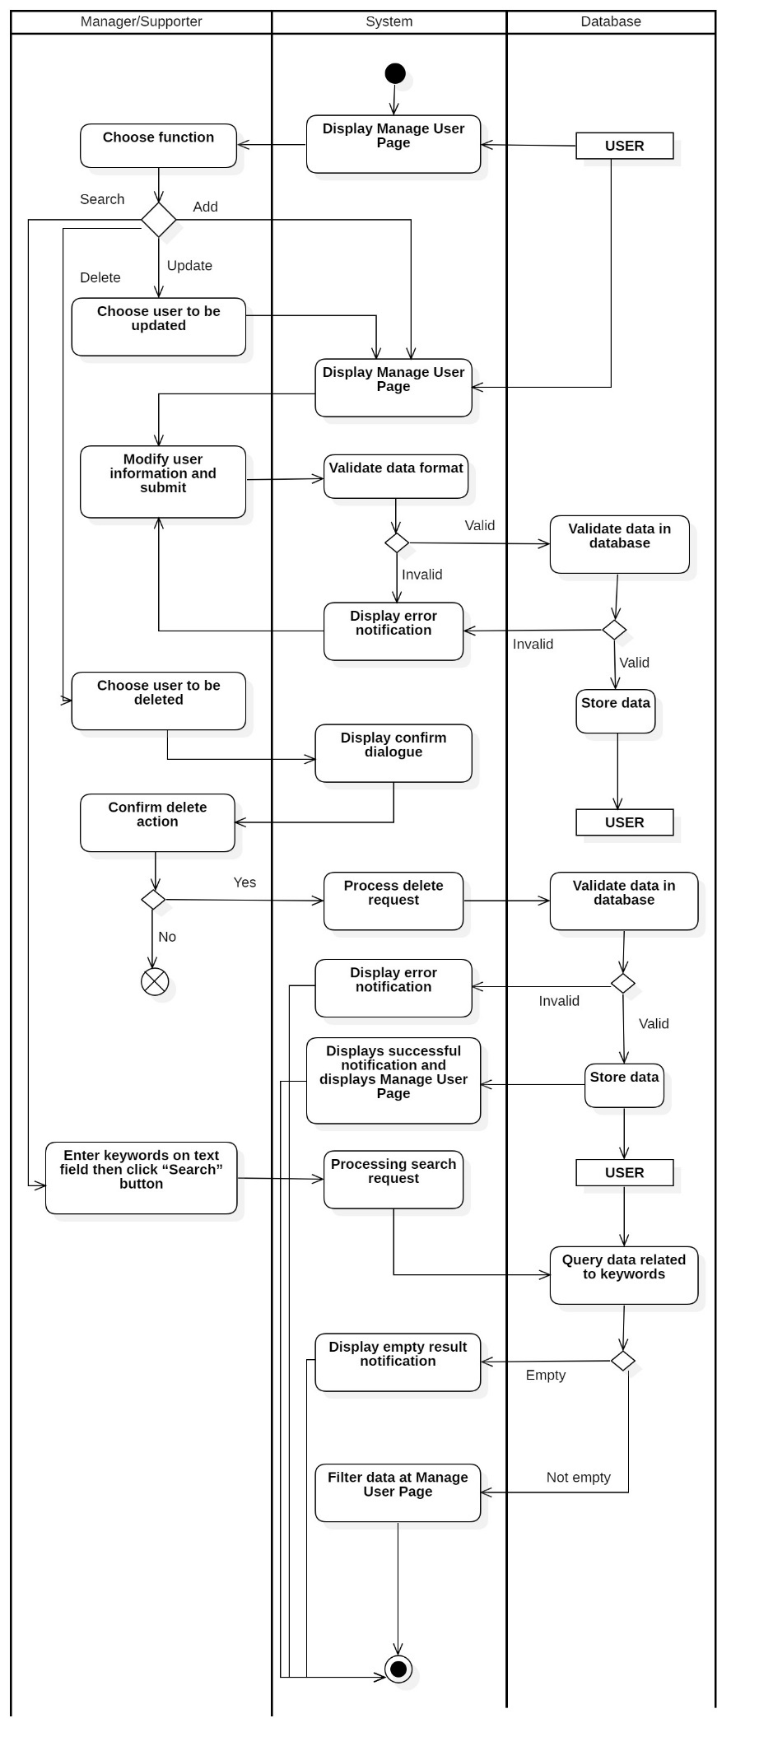

## State Diagram

* + 1. Discount Code status

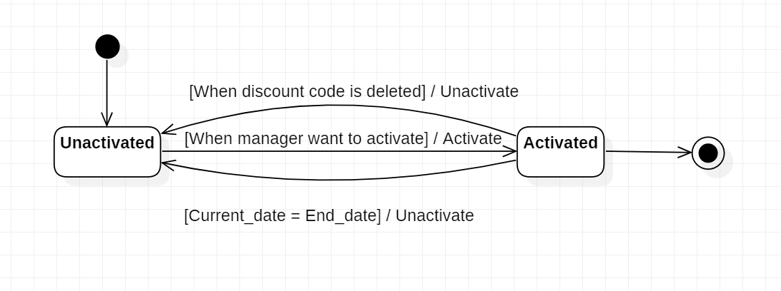

* + 1. Invoice status

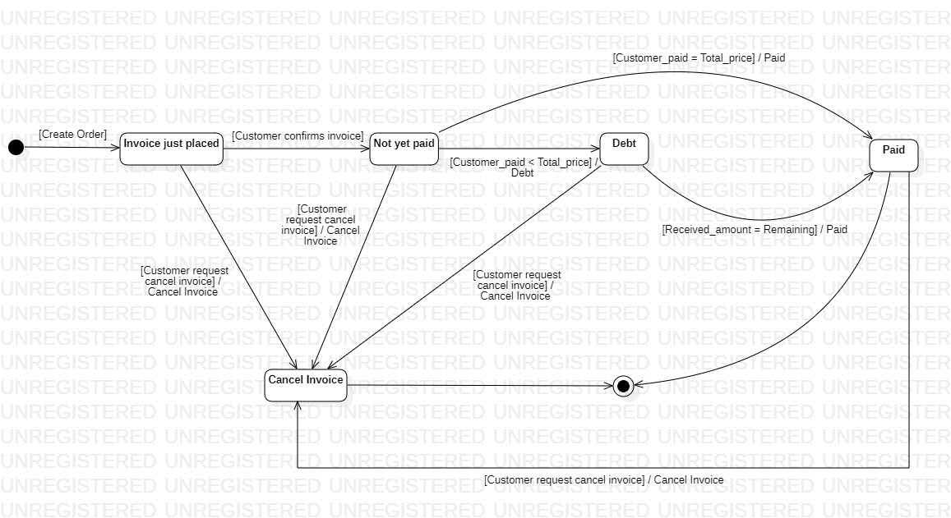

* + 1. Rent status

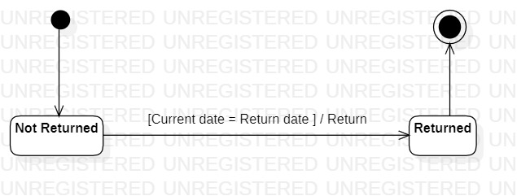

* + 1. Customer rank

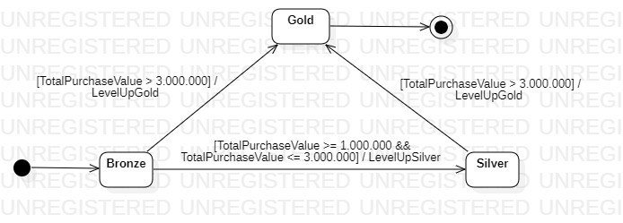

# DATABASE



## ERDs

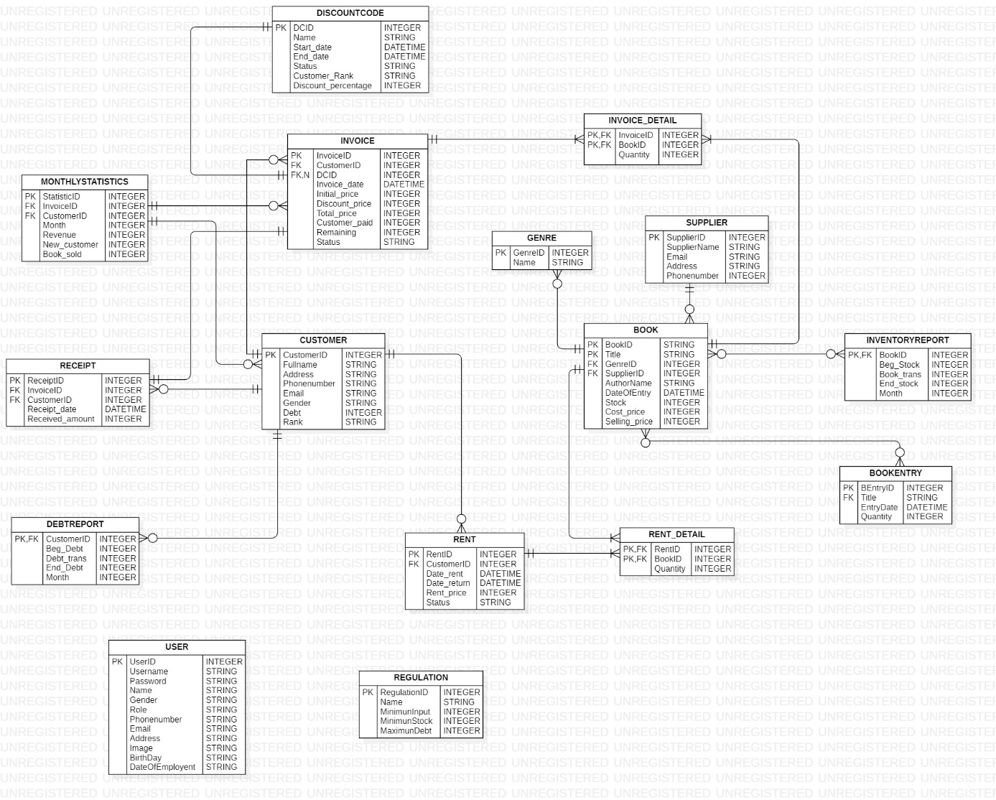

* List of table

|  |  |  |
| --- | --- | --- |
| No. | Table name | Description |
| 1 | BOOK | Contains Book information: BookID, Title, Genre,… |
| 2 | CUSTOMER | Contains Customer information: CustomerID, Name, Address |
| 3 | INVOICE | Contains Invoice information: InvoiceID, CustomerID, total Amount of bill,.. |
| 4 | INVOICE_DETAIL | Contains Invoice information in detail: InvoiceID, BookID, Quantity,… |
| 5 | RENTAL | Contains Rental information: RentalID, CustomerID, Start Rent date,… |
| 6 | RENTAL_DETAIL | Contains Rental information in detail: RentalID, BookID,.. |
| 7 | SUPPLIER | Contains Supplier information: SupplierID, Email, Phone number,… |
| 8 | USER | Contains User information: UserID, username, password, role,.. |
| 9 | INVENTORY_REPORT | Contains Information for Inventory report: Month, Begin Inventory, End Inventory,… |
| 10 | DEBT_REPORT | Contains Information for Debt report: Month, Begin Debt, End Debt,… |
| 11 | DISCOUNT_CODE | Contains Discount code information: DCID, Name, Start date, End date,… |
| 12 | STATISTICS | Contains Information for making statistic: Revenue, Amount of Book sold,… |
| 13 | REGULATION | Contains Regulation information: RegulationID, Name, Minimun Inventory... |
| 14 | GENRE | Contains Genre information: GenreID, name,.. |

## Table description

* + 1. BOOK table

|  |  |  |  |  |  |  |  |  |  |
| --- | --- | --- | --- | --- | --- | --- | --- | --- | --- |
| No. | Field name | Type | Length | Size | Null | Unique | P/F Key | Default | Description |
| 1 | BookID | int |  |  |  |  | P |  | ID of Book, auto number |
| 2 | Title | String |  |  |  |  |  |  | Name of the book |
| 3 | Genre | String |  |  |  |  |  |  | Genre of the book |
| 4 | authorName | String |  |  |  |  |  |  | Name of the author |
| 5 | Cost_price | int |  |  |  |  |  |  | Price when import book |
| 6 | Selling_price | int |  |  |  |  |  |  | Price when sell books |
| 7 | Stock | int |  |  |  |  |  |  | Quantity of books when import |
| 8 | DateOfEntry | int |  |  |  |  |  |  | The date when books when are imported |

* + 1. CUSTOMER Table

|  |  |  |  |  |  |  |  |  |  |
| --- | --- | --- | --- | --- | --- | --- | --- | --- | --- |
| No. | Field name | Type | Length | Size | Null | Unique | P/F Key | Default | Description |
| 1 | CustomerID | int |  |  |  |  | P |  | ID of Customer, auto number |
| 2 | CustomerName | String |  |  |  |  |  |  | Name of the customer |
| 3 | Address | String |  |  |  |  |  |  | Address of the customer |
| 4 | Phonenumber | String |  |  |  | x |  |  | Phone number of the customer |
| 5 | Email | String |  |  |  |  |  |  | Email of the customer |
| 6 | Gender | String |  |  |  |  |  |  | Gender of the customer |
| 7 | Debt | int |  |  | x |  |  |  | Total debt of customer |
| 8 | Rank | int |  |  |  |  |  |  | Quantity of books available in stock |
| 9 | Total_purchased | int |  |  |  |  |  |  | Total amount of customer purchased |

* + 1. INVOICE

|  |  |  |  |  |  |  |  |  |  |
| --- | --- | --- | --- | --- | --- | --- | --- | --- | --- |
| No. | Field name | Type | Length | Size | Null | Unique | P/F Key | Default | Description |
| 1 | InvoiceID | int |  |  |  |  | P |  | ID of the Invoice, auto number |
| 2 | CustomerID | int |  |  |  |  |  |  | ID of the customer |
| 3 | DCID | int |  |  | x |  |  |  | ID of the Discount code |
| 4 | Invoice date | int |  |  |  | x |  |  | The date when customer receive this invoice bill |
| 5 | Email | String |  |  |  |  |  |  | Email of the user |
| 6 | Gender | String |  |  |  |  |  |  | Gender of the customer |
| 7 | Invoice date | int |  |  |  |  |  |  | The date when customer receive this invoice bill |
| 8 | Quantity_inStock | int |  |  |  |  |  |  | Quantity of books available in stock |
| 9 |  |  |  |  |  |  |  |  |  |

* + 1. INVOICE_DETAIL

|  |  |  |  |  |  |  |  |  |  |
| --- | --- | --- | --- | --- | --- | --- | --- | --- | --- |
| No. | Field name | Type | Length | Size | Null | Unique | P/F Key | Default | Description |
| 1 | CustomerID | int |  |  |  |  | P |  | ID of Customer, auto number |
| 2 | CustomerName | String |  |  |  |  |  |  | Name of the customer |
| 3 | Address | String |  |  |  |  |  |  | Address of the customer |
| 4 | Phonenumber | int |  |  |  |  |  |  | Phone number of the customer |
| 5 | Email | String |  |  |  |  |  |  | Email of the customer |
| 6 | Gender | String |  |  |  |  |  |  | Gender of the customer |
| 7 | Quantity_Imported | int |  |  |  |  |  |  | Quantity of books when import |
| 8 | Quantity_inStock | int |  |  |  |  |  |  | Quantity of books available in stock |
| 9 |  |  |  |  |  |  |  |  |  |

* + 1. RENTAL

|  |  |  |  |  |  |  |  |  |  |
| --- | --- | --- | --- | --- | --- | --- | --- | --- | --- |
| No. | Field name | Type | Length | Size | Null | Unique | P/F Key | Default | Description |
| 1 | CustomerID | int |  |  |  |  | P |  | ID of Customer, auto number |
| 2 | CustomerName | String |  |  |  |  |  |  | Name of the customer |
| 3 | Address | String |  |  |  |  |  |  | Address of the customer |
| 4 | Phonenumber | int |  |  |  |  |  |  | Phone number of the customer |
| 5 | Email | String |  |  |  |  |  |  | Email of the customer |
| 6 | Gender | String |  |  |  |  |  |  | Gender of the customer |
| 7 | Quantity_Imported | int |  |  |  |  |  |  | Quantity of books when import |
| 8 | Quantity_inStock | int |  |  |  |  |  |  | Quantity of books available in stock |
| 9 |  |  |  |  |  |  |  |  |  |

* + 1. RENTAL_DETAIL

|  |  |  |  |  |  |  |  |  |  |
| --- | --- | --- | --- | --- | --- | --- | --- | --- | --- |
| No. | Field name | Type | Length | Size | Null | Unique | P/F Key | Default | Description |
| 1 | InvoiceID | int |  |  |  |  | P |  | ID of the Invoice, auto number |
| 2 | CustomerID | int |  |  |  |  |  |  | ID of the customer |
| 3 | DCID | int |  |  | x |  |  |  | ID of the Discount code |
| 4 | Invoice date | int |  |  |  | x |  |  | The date when customer receive this invoice bill |
| 5 | Email | String |  |  |  |  |  |  | Email of the user |
| 6 | Gender | String |  |  |  |  |  |  | Gender of the customer |
| 7 | Invoice date | int |  |  |  |  |  |  | The date when customer receive this invoice bill |
| 8 | Quantity_inStock | int |  |  |  |  |  |  | Quantity of books available in stock |
| 9 |  |  |  |  |  |  |  |  |  |

* + 1. SUPPLIER
    2. USER
    3. INVENTORY_REPORT
    4. DEBT_REPORT
    5. DISCOUNT_CODE
    6. STATISTICS
    7. REGULATION

# OTHER CONSIDERATIONS

# APPENDIX



1. : <https://www.geeksforgeeks.org/mvc-framework-introduction/>